San Juan County, Utah is sending the Following Notice to households

IMPORTANT INFORMATION FOR ALL UTAH REGISTERED VOTERS
READ CAREFULLY
- In 2024, for Utah, there will be partisan primary elections. Additionally, the Republican Party has chosen to hold a Presidential Preference Poll in conjunction with their statewide caucus meetings. According to Utah State Law, political parties set rules regarding who may participate in their primary elections and caucuses.
- Your party affiliation may determine which ballot you receive, and which primary or caucus you may participate in. The party of your choosing will remain in effect through the June 25th Primary election. Anyone can change their party affiliation from now until January 9, 2024. After that no one can change party affiliation until after the June 25th Primary Election. Please do not wait until the deadline to make any changes.
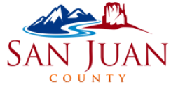
- Verify that your voter registration is current by going to voter.utah.gov. If you have any questions, please contact our office at 435-587-3223.

