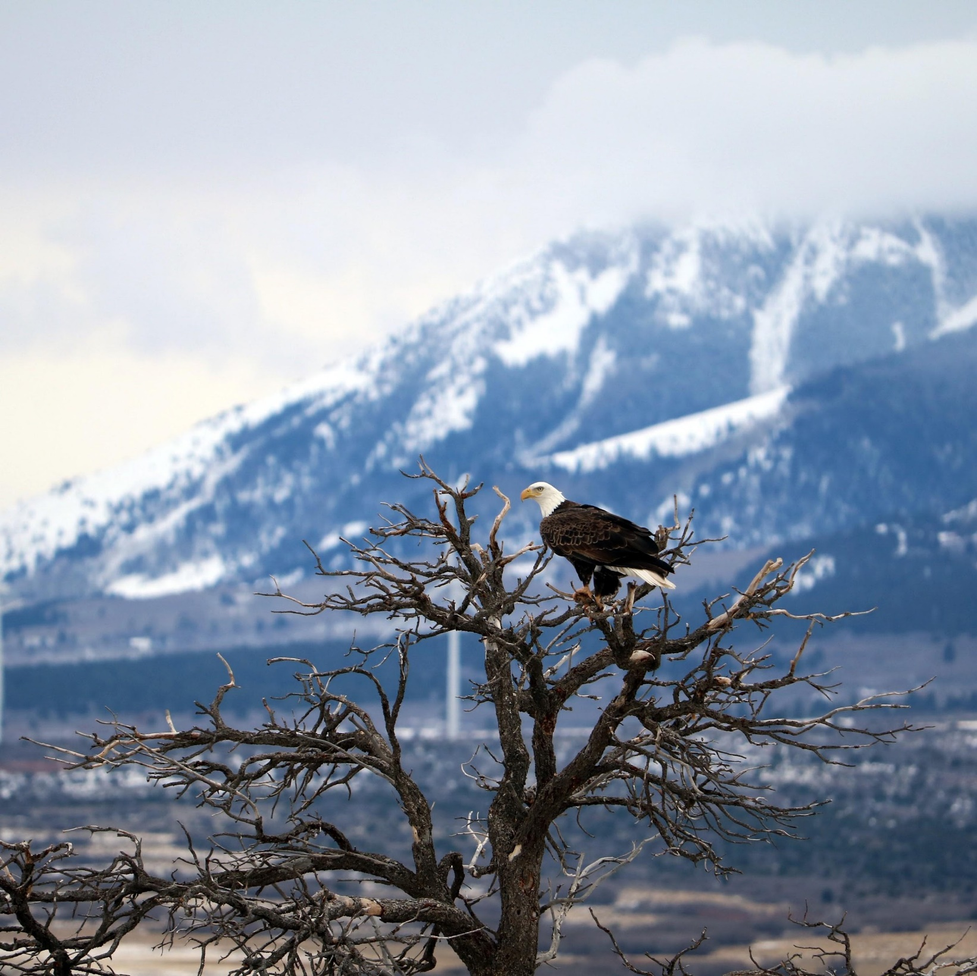

San Juan County
Resource Management Plan

GENERAL PLAN UPDATE
(as amended on August 16, 2022)

TABLE OF CONTENTS

INTRODUCTION 7
LAND USES
Land Use 12
Land Access 16
Wilderness 20
Forest Management 22
Fire Management 26
WILDLIFE RESOURCES
Fisheries 30
Wildlife 32
Threatened, Endangered, + Sensitive Species 35
Predator Management 37
WATER RESOURCES
Water Quality + Hydrology 40
Water Rights 43
Wetlands 45
Riparian Areas 46
Floodplains + River Terraces 48
Wild + Scenic Rivers 50
Ditches + Canals 52
Irrigation 53
MINERAL RESOURCES
Minerals 56
Mining 60
Energy 62
AGRICULTURAL RESOURCES
Agriculture 68
Noxious Weeds 71
Livestock + Grazing 74
ECONOMICS + SOCIETY
Recreation + Tourism 78
Economic Considerations 80
Air Quality 83
Cultural, Historical, Geological + Paleontological 85
Law Enforcement 89
Utility Corridors 91
Pipelines and Infrastructure 93

APPENDICES
Works Cited 97-105
Citizen Input 106-127
Maps 128-137

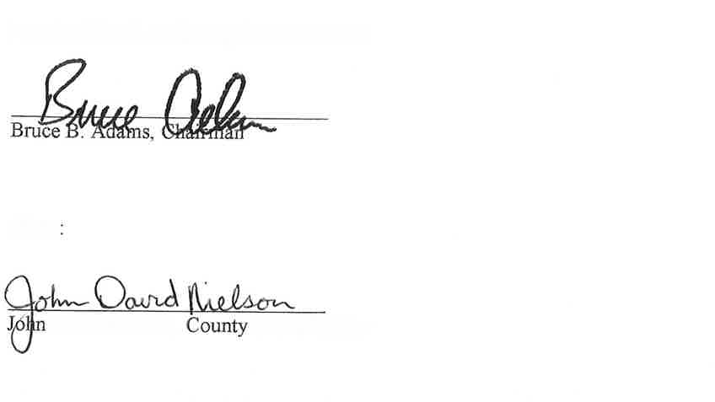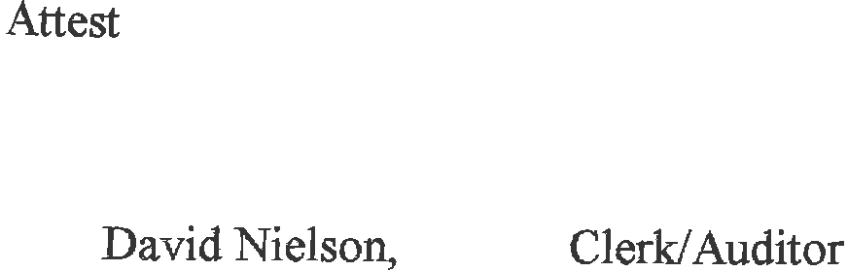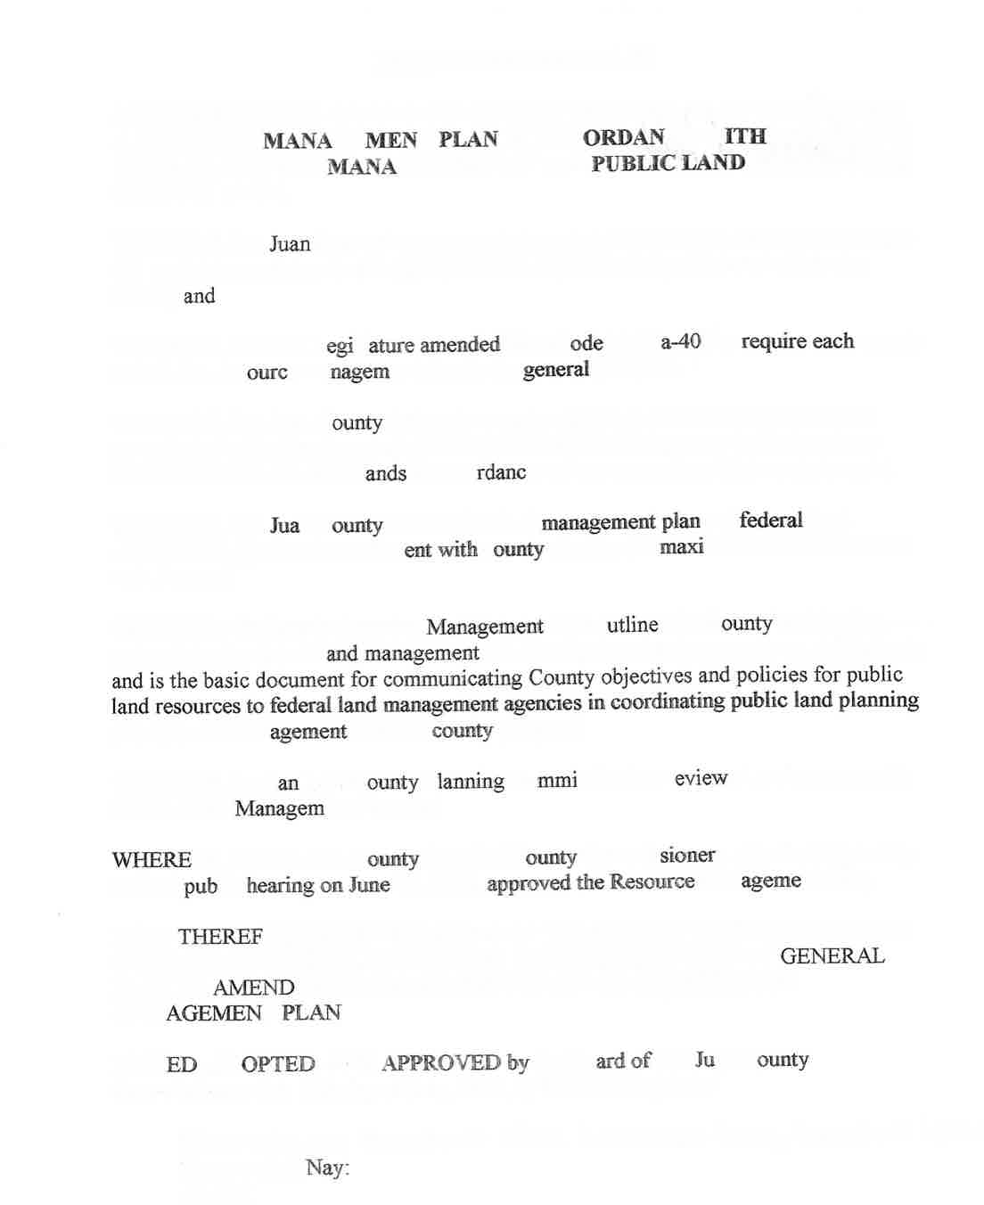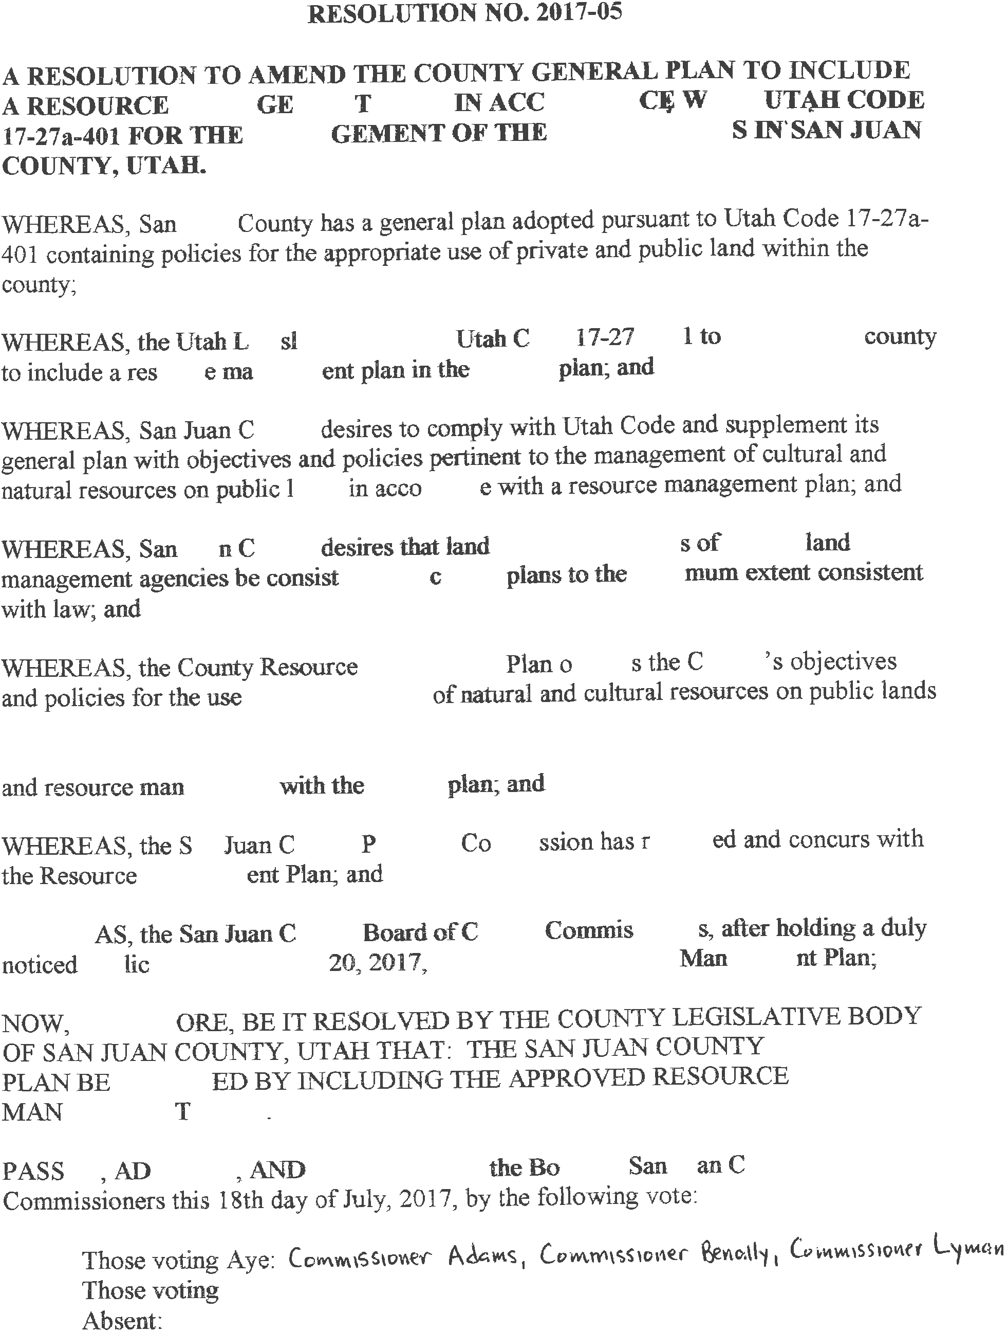ADOPTED BY RESOLUTION JULY 18th, 2017
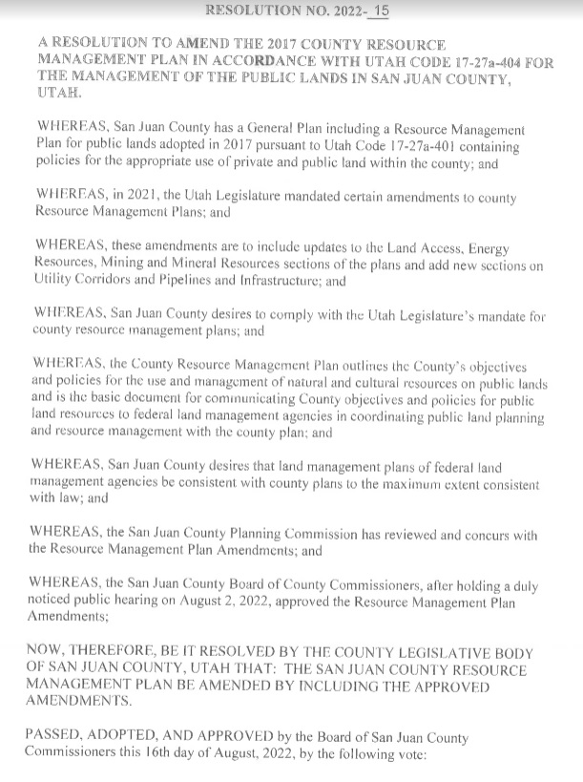

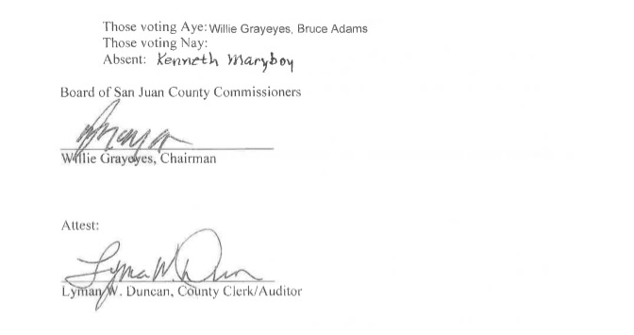

Acknowledgements Related to the 2017 Original Version

Nick Sandberg
John Fellmeth
Kelly Pehrson
Commissioner Bruce Adams Commissioner Rebecca Benally Commissioner Phil Lyman
and the San Juan County Planning & Zoning Commission
COMPLETED WITH

A Jones and DeMille Company

Acknowledgements Related to the 2022 Amendments

Nick Sandberg
Commissioner Bruce Adams Commissioner Willie Grayeyes Commissioner Kenneth Maryboy
and the San Juan County Planning & Zoning Commission
Technical assistance Provided
by Bio-West Consultants

INTRODUCTION
Background
The Utah State Legislature updated the state code regarding general plans (HB 323 in 2015, and HB 219 in 2016) and now requires every county to address natural resources on federal public lands within a county in a Resource Management Plan (RMP). This legislation put forth 28 items or resources that must be addressed in the RMP, and the requirement to develop findings, objectives and policies for the management of these items and resources. Many of these resources were addressed in the 1996 County Master Plan and the 2008 amendment to that plan but were not consolidated into a resource section in the plan. In many cases the guidance in the earlier plans was still relevant and was brought forward into the new RMP. Legislators allocated one-time funding for the initial county RMP process and San Juan County began the process in 2016.
In 2021 the Utah Legislature mandated that the State Resource Management Plan and County Resource Management Plans be updated on the topics of Public Lands Access, Renewable Energy, Critical Minerals and Rare Earth Elements and add two new topics: Utility Corridors and Pipelines and Infrastructure. The County began this updating or amendment process in 2022.
This RMP is a component of the county’s general plan. According to state code a general plan is an advisory document that establishes a vision, influences growth, justifies ordinances, protects private property rights, and anticipates capital improvements. The San Juan County RMP identifies local knowledge and develops management objectives and policies related to natural resources. The RMP is based on the needs and preferences of the county, the residents, and the property owners. It is the county’s basic document for management of the public lands and the basis for communicating and coordinating with land management agencies on land planning and resource management issues.
Best Available Information
The best available information was gathered in a combined effort by Bio-West and Jones & DeMille Engineering in 2016. The county recognizes that new data will always be forthcoming and future management and use decisions should be based on the latest, best available information. In using data to make evidence-based decisions it is in the best interest of San Juan County residents, the economy, and the environment to analyze resource condition trends rather than singular points of data.
Process
As previously described, in 2015 HB 323 was approved by the Utah Legislature mandating every county add to the general plan a resource management plan. In 2016 the South Eastern Utah Association of Local Governments contracted with BioWest and Jones & DeMille Engineering to gather environmental data for all four counties. Information on current local policy and on current environmental conditions was gathered and compiled into a database.
After the data was gathered, the county contracted with Rural Community Consultants to engage the public, develop policy, and draft the resource management plan. A widely- accessible, public-facing website (SanJuanCountyPlan.org) was developed for the initiative and included background information, a survey, and drafts of the plan. The availability of the website and plan development process was advertised through the county’s website and local newspaper articles and ads. The Planning Commission and County Commission held hearings and meetings that followed state noticing protocol. In the summer of 2017 the RMP was formally adopted by the San Juan County Commission as part of the general plan.
The 2022 plan amendment process was begun in 2022 with the assistance of the Utah Public Lands Policy Coordinating Office. The drafts of amended sections of the RMP were posted on the County website for public comment. The Planning Commission and County Commission held hearings that followed state noticing protocol. Public comment was limited but was used to finalize the amendments which were formally adopted by the County Commission on August 16, 2022, as part of the general plan.
Citizen Input
The opinions and values of San Juan County residents and property owners are extremely important to the county commission. Proper noticing procedures were followed throughout the process and two public open houses were held in Monticello to publicize the initiative and garner input on resource management. The consultant focused on creating access to the survey for all residents of San Juan County by utilizing electronic and paper surveys. The county feels that the sentiments and values of residents were well captured in the public engagement and outreach activities.
Purpose
This RMP outlines the county’s objectives and policies for the use and management of natural and cultural resources on public lands. It is the basic document for communicating county objectives and policies for public land resources to federal land management agencies in coordinating public land planning and resource management with the county plan.
Coordination & Cooperation
San Juan County expects that federal land management agencies will coordinate with San Juan County’s resource management plan, local officials and staff, and use the best available information in their planning and decision making. Coordination is the process by which federal land management agencies meet their legal responsibilities to coordinate their land use planning with local government plans. Coordination is mandated by the Federal Land Policy and Management Policy Act (FLPMA) for the Bureau of Land Management (BLM) and similarly by the National Forest Management Act (NFMA) for the Forest Service.
Coordination under FLPMA requires that BLM plans be consistent with county plans to the extent of federal law and agency regulations. Coordination under NFMA requires the Forest Service to review local (county) plans and where inconsistencies are found with the federal plan to consider alternatives for their resolution. Coordination also requires that federal agencies review and keep apprised of local government plans and provide local government with opportunities for meaningful involvement in the development of federal plans.
Cooperation derives from the National Environmental Policy Act (NEPA) which provides for a federal agency to invite a local government to be a “cooperating agency” in the preparation of an Environmental Impact Statement (EIS) for a project or plan. County government has jurisdiction by law and/or special expertise on environmental issues that should be addressed in an environmental analysis and therefore qualifies as a cooperating agency.
Because of the legal requirement for coordination of federal plans with local plans, the county’s status as a cooperating agency by legal jurisdiction and its expertise in specific activities and/or its local knowledge, it is San Juan County’s position that:
1) federal agencies shall conduct a consistency review and analysis of their plans with the county plan and strive for consistency as allowed by law, and
2) offer cooperating agency status to the county in all actions or efforts that are subject to compliance with NEPA.
Native American Resources and Activities
Protection and development of resources and activities important to Native American residents of the county are important considerations in land management. Native American activities are a significant piece of the cultural fabric of the county. Both current activities and resources as well as historic/archaeological resources need protection and careful management. Multiple use and sustained yield management approaches are required for these resources. Examples of these resources/activities include the following:
• Fuel wood gathering
• Medicinal and ceremonial herb gathering
• Ceremonial uses and sacred areas
• Pinon nut gathering
• Hunting and fishing
• Cultural resources (historic and archaeological)
Decision Making Criteria
The following is a summary of the guiding principles that the county will use in making decisions on public land resource use and management.
1. The citizens of the county are best served by applying multiple-use and sustained-yield principles in public land use planning and management, and
2. Management decisions directed at protecting one resource or activity should be designed to have the least possible negative impact on other resources and activities. The least impactful alternative would be the preferred alternative. This idea of conservative or least impactful management also relates to resource and activity priorities, when management decisions affect multiple resources/activities, higher priority resources/ activities should be given additional consideration.
3. Certain resources are part of the historic, cultural and economic fabric of the county. Such resources and uses include motorized access, livestock grazing, wildlife, minerals, recreation, tourism and cultural resources. Resource management decisions should give priority to these resources.
4. Certain other resources while important, are not currently threatened or the subject of significant concern in the county. Examples are air and water quality. These resources should be protected but they should not be used to justify excessive, unnecessary and heavy-handed conservation measures that adversely impact other higher priority resources and activities. Wild and Scenic River designations and regional air quality guidelines are examples of special designations and policies that should be carefully applied only after reviewing impacts on other resources and multiple uses.
5. Multiple-use and sustained-yield management means that federal agencies develop and implement management plans and make other resource-use decisions that:
a. Meet the needs of economic and/or community development.
b. Meet the personal, business-related and recreational transportation needs of the citizens of the county and state by providing access throughout the county.
c. Achieve and maintain in perpetuity a high-level annual or regular periodic output of mineral and various renewable resources (livestock and wildlife forage and habitat and watershed condition
d. Meet the traditional, customary and conventional needs of Native Americans. These needs are usually best identified from local input such as from the five chapters of the Navajo Nation in San Juan County and the White Mesa Ute Council of the Ute Mountain Ute Tribe rather than from tribal headquarters.
e. Support the specific plans, programs, processes, and policies of state agencies and local governments
f. Minimize negative impacts on local government, infrastructure and community services.
g. Provide for the preservation of cultural resources, both historical and archaeological.
h. Provide for the protection of water rights and water quality.
i. Are consistent with or complementary to the custom, culture and lifestyle of county residents.
j. Provide access through federal lands for private property owners to exercise their right to access, use and enjoy their property.
Transportation Framework and Motorized Access
The motorized transportation network in the county is one of its most valuable resources and an integral part of the historic, cultural and economic fabric of the county. Access to and enjoyment and protection of many important resources is dependent on the existence of an adequate transportation network. Maintaining and improving this important resource should be a priority in resource management.
When conflicts arise between motorized transportation and other resources, closing roads and trails should be a last resort after all other alternatives for mitigating the conflict have been thoroughly evaluated.
Infrastructure Policies
1. Provide for reasonable and responsible development of electrical transmission, commodities transportation, personal travel, water infrastructure, and energy pipeline infrastructure on the subject lands.
2. Support infrastructure that conveys energy resources, goods, or people, such as transportation corridors, pipeline development and public transportation services.
3. Allow continued maintenance and increased development of roads, power lines, pipeline infrastructure, and other utilities necessary to achieve the goals, purposes, and policies described in this section, the RMP, and the general plan.
4. Refrain from any planning decisions and management actions that will undermine, restrict, or diminish the goals, purposes, and policies for the San Juan County Energy Zones.

LAND USES
- Land Use
- Land Access
- Wilderness
- Forest Management
- Fire Management

LAND USE
Definition
The designation, modification and management of land for agricultural, environmental, industrial, recreational, residential, or any other purposes
Related Resources
Mining, Livestock & Grazing, Fire Management, Noxious Weeds, Forest Management, Wilderness, Recreation & Tourism, Energy, Land Access, Wild & Scenic Rivers, Law Enforcement, Water Quality and Hydrology, Water Rights, Floodplains & River Terraces, Riparian Areas, Predator Control, Wildlife, Fisheries, Energy Resources, Mineral Resources, Threatened, Endangered, & Sensitive Species, Cultural, Historical, Geological, & Paleontological, Economic Considerations.
Findings
Overview
The majority of San Juan County includes vast areas of “public” lands. These lands and the associated resources are managed by federal agencies including the U.S. Forest Service (USFS), Bureau of Land Management (BLM), Bureau of Reclamation (BOR), and National Park Service (NPS). Traditionally, the residents of the County have used public lands and resources for economic growth and stability. These local associations with, and dependence on, public lands continues today. Specifically, local use of public lands and resources include, but are not limited to minerals, recreation, oil and gas, timber, water, agriculture, fisheries and wildlife.
San Juan County has approximately 5.1 million acres making it the largest county in the state. The ownership of the county is vastly slanted toward the federal government. The Bureau of Land Management administers approximately 2.1 million acres (41%). This is followed by the Navajo Nation which has approximately 1.2 million acres (25%). The National Park Service is next with 589,000 acres (12%). The U.S Forest Service encompasses about 450,000 acres (9%). The State of Utah has 268,000 acres (5%), and State Parks has approximately 3,000 acres (less than 1%). Finally, private ownership totals 404,000 acres (just under 8%) (San Juan County 2015).
Due to the dependence of San Juan County on public lands and resources, decisions made by public land management agencies directly impact local interests and economy. Over the last several decades, San Juan has attempted to improve relationships with federal land managers and participation in agency planning and decision-making processes. These efforts have had mixed results (BioWest CRMP Toolkit n.d.).
The Resource Management Plans (RMPs) developed by the BLM and the USFS Land and Resource Management Plans (LRMPs) are the basis for nearly all natural resource management policy and decision-making activities that affect federal lands. Federal planning generally has become more protection oriented as plans are revised or created with more special designations and restrictions on uses which seriously limits the multiple use concept. Because the Federal Land Policy and Management Act (FLPMA) mandates that these RMPs are to be coordinated with state and local government plans and activities and be consistent with state and local plans “to the maximum extent…consistent with federal law…,” it is essential that counties develop their own resource management plans to reflect local perspectives and positions regarding these interests (Utah CRMP Toolkit n.d.). There is no similar consistency requirement for the Forest Service in the National Forest Management Act but the Act requires the Forest Service to coordinate land management planning with land management planning of state and local governments. County Resource Management Plans are likewise important to identify county positions and perspectives in Forest planning.
Since the county is 67% federal and state land, the land management policies of the agencies managing these lands have a tremendous effect on the economy of the county. San Juan County has a vital interest in the management and uses of these lands.
Control + Influence
Private Property: Private lands are regulated by land use ordinances and zoning districts, as approved by local and county governments. Zoning districts, and the regulations established within the zoning districts, are authorized by Utah Code § 17-27a-505 and municipalities 10-9a-505. Land use ordinance and zoning maps are legislative decisions and are established through planning processes open to public discussion and adopted by county and city councils.
San Juan County: Utah Code § 17-27a-401 requires counties to create a general plan that includes findings, objectives, and policy statements for the resources within its boundaries. It also allows San Juan County to “define the county’s local customs, local culture, and the components necessary for the county’s economic stability.”
US Bureau of Land Management (BLM): The Monticello and Moab Field Offices manage BLM lands in San Juan County. Land use decisions for all BLM lands are made according to mandates defined by the Federal Land Policy and Management Act (FLPMA) of 1976. FLPMA requires the BLM to manage lands under multiple-use and sustained yield philosophy. A component of FLPMA is the requirement for an open and public land use planning process in the development of resource management plans (RMP). Each BLM Field Office must develop a RMP to guide future land use activities on public lands. The RMP defines goals, objectives, and rules for commercial and extractive industries, transportation, recreation, and conservation for an approximate 15-year period. To complete an RMP, the BLM follows planning procedures outlined in BLM Planning Manuals and Handbooks. The Moab and Monticello RMPs were completed in 2008.
US Forest Service (USFS): The US Forest Service (USFS) develops land use decisions by developing forest plans under the National Forest Management Act of 1976 (P.L. 94-588) and by following procedures in the Forest Planning Manual. One objective of forest planning is to sustain multiple use of renewable resources. Forest plans provide strategic direction for management of land and resources on a National Forest for ten to fifteen years. The current plan for the Manti-La Sal National Forest was adopted in 1986. The Forest Service began a plan revision process in 2016 with a target completion date in 2020. Forest plans require consideration of alternatives and public input under the National Environmental Policy Act (NEPA) process (Council on Environmental Quality 2007). Forest plans describe the desired conditions and provide guidance for projects. They do not make site-specific decisions or require any specific actions, but all projects conducted on a National Forest must be consistent with the strategic direction in its forest plan.
National Park Service (NPS): The National Park Service prepares a variety of planning and environmental documents to help guide management of park resources and visitor use and activity. Plans follow Park Service planning procedures and comply with the National Park Service Organic Act of 1916 and the National Environmental Policy Act (NEPA).
State Institutional Trust Lands Administration (SITLA): Trust lands are parcels of land throughout our state that were granted by Congress to Utah at the time of statehood. Although trust lands support select public institutions, they are not public lands. Trust lands are managed to generate revenue to support designated state institutions, including public schools, hospitals, teaching colleges, and universities.
Custom + Culture
County industries and residents depend on the continued availability of public lands and accompanying resources for traditional uses, economic growth and community stability.
A History of San Juan County (1995) describes the controversy involved and results of the designation of Canyonlands National Park. The parties at that time were generally the federal land managers and democrats from the U.S. House of Representatives opposing the Republican governor and U.S. Senator. “Their main reason for opposition lay in their philosophy of resource development-mining, hunting, and grazing-which they believed would end if these lands became a national park. Compromises between the ‘scenery purists’ and the ‘resource hogs’ assumed many forms of give-and-take as each side offered to add or subtract lands, toyed with limited and full-blown multiple land use ideas, and appealed to various organizations for support. Finally, on 3 September 1964, Congress passed the bill creating the 337,258-acre Canyonlands National Park, with only limited grazing rights, which were later phased out… New management plans called for a decrease in development and an increase in restricting access to prevent “irreversible environmental damage’” (McPherson 1995).
Similar controversy developed in the late 1970’s and early 1980’s with BLM’s inventory of lands as to suitability for wilderness designation. Local government and county resident feelings ran high against such designation and this played into what has been called the “Sagebrush Rebellion”, a west-wide movement against federal control of public lands. Many in the County felt that the federal bureaucracy had gone too far toward supporting conservation and preservation agendas. As a result of this inventory effort, BLM designated approximately 396,000 acres in the county as “wilderness study areas” to be managed as defacto wilderness until Congress decides whether wilderness designation is warranted. These designations remain today creating uncertainty on the long-term management of these areas.
More recently, a proposal to create a Bears Ears National Monument of BLM and FS administered lands in the County has generated strong feelings for and against such a designation. Proponents of a monument have petitioned the President to designate a 1.9-million-acre national monument in the western half of the County under authority of the Antiquities Act of 1906. Rationale for designation includes the need for additional protection of cultural resource and Native American use areas and sacred sites from development and vandalism and increased participation of Native Americans in management of the area. Opponents counter with Congressman Bishop’s Public Lands Initiative which would designate two National Conservation Areas and several wilderness areas and include provision for more local and Native American participation in management.
The Bears Ears National Monument consisting of 1.35 million acres of BLM and FS lands was created by Presidential Proclamation in late December 2016. Since its creation, controversy has continued. County and state officials strongly recommended that President Trump repeal the monument proclamation so that a new process could be initiated to consider such or a similar designation through the Utah legislative process. Proponents of the monument were just as firm in their support of the current monument designation.
In December 2017, President Trump reduced the size of the monument to roughly 202,000 acres including an 11,200 acre addition in the Shay Mesa area. The new monument consisted of two areas: the Indian Creek and Shash Jaa units. The Forest Service and Bureau of Land Management completed a management plan for the new monument in 2020.
Proponents of a larger monument continued to push for restoration of the former monument boundaries. President Biden restored the monument to its original size plus the 11,200 acre Shay Mesa area in October 2021. The current monument is approximately 1.36 million acres. Work on a new monument plan is scheduled to begin in the summer of 2022 with completion planned in 2024.
“Changing issues have always faced county government officials as priorities concerning people, land, the economy, and legislation shift with the times. The general concern voiced by many residents recently, however, expresses a fear that the federal bureaucracy is growing beyond its constitutional powers; that many residents will not be able to derive an income from the land because of increasing government control; that those who live in an area have a greater right to land-use decisions than outsiders; and that the federal government has reneged on previous agreements such as building promised roads into Canyonlands or allowing the county to build highways on unreserved public domain, and so cannot be trusted. The result when the parties meet seems to be endless wrangling” (McPherson 1995).
Objectives
a. Public lands are managed under the multiple use concept. Multiple use is the management of public lands so that multiple resource uses (such as livestock grazing, mining, recreation, timber, oil and gas, wildlife, water use and development and scenic and cultural values) are utilized in conjunction and within close proximity to each other, as much as possible, in such a way that allows for the exploration, use and/or development of these resources in relative harmony. Multiple use is not every use on an area, but as many uses as are compatible with each other in as many areas as appropriate. Multiple use management is key to promote economic potential and resource development.
b. Effect maximum consistency of federal plans with County plans that are consistent with law.
Policies
1. Vigorously pursue multiple use management policies on public lands. The County generally opposes administration of public lands under single management schemes.
2. Support a balanced approach to resource utilization. Too often, the protection of a single resource severely restricts or prohibits the use of any other resources.
3. Ensure that federal agencies comply with their respective mandates for coordination of their planning efforts with County plans.
4. Fully exercise the county’s rights to coordination and cooperating agency status from federal agencies in federal agency land use planning and decision-making.
5. Work in cooperation with public land-management agencies to permit and promote special uses, events and activities, that support the local economy. Special uses, events and activities should reasonably mitigate adverse impacts they cause.

LAND ACCESS
Definition
Access to public and private lands.
Related Resources
Recreation & Tourism, Land Use, Livestock & Grazing, Energy, Law Enforcement, Fire Management, Mineral Resources, Mining, Agriculture, Noxious Weeds, Irrigation, Forest Management, Water Rights, Predator Control, Wildlife, Fisheries, Economic Considerations
Findings
Overview
San Juan County currently uses its network of roads and trails to access land within the county for ranching, farming, mining, prospecting for minerals, use of forest and agricultural products, hunting, fishing, camping, hiking and other recreational uses. In addition to these uses, access to the roads and trails throughout the county is crucial for Search and Rescue, Fire Protection, Health, Law Enforcement and Resource Management Personnel to be able to carry out their individual and important functions.
“The Utah State Department of Transportation (UDOT) has divided all roadways into four distinct classes of which Class A are highways, Class C are municipalities and Class B and Class D are considered “county” roads. The map entitled “Land Access” in the Appendix shows federal and state highways and the County’s Class B and Class D road system. The Class B and D road system constitutes the County’s Travel Plan which includes its ATV/OHV Trail System. County B roads total approximately 1979 miles and D roads total approximately 4881 miles exclusive of roads on the Navajo Nation.
The County B and D road systems might be likened to a cardiovascular system with the generally higher standard B roads as the main arterial system and the D roads the secondary vessels branching out from the arteries. Just as the whole cardiovascular system is necessary for the body to function properly, the whole Class B and D road system is necessary and each road is important for the County to function properly and provide the many services and needs of its citizens and visitors” (San Juan County 2014).
“These roads access not only rural private lands, but also serve as the arteries to access public lands within the county. Some of these roads are well serviced high standard roads, while others may be of lesser standard but serve to access such things as camping, hiking, scenic views, mines, or livestock facilities. Each road is necessary and each road is important” (San Juan County 2014).
San Juan County land ownership pattern is largely federal land and tribal lands with state and private lands checkerboarded or scattered within. Concerns arise where recreational users once had access but now do not, or where land owned by an entity is surrounded by or accessible only by crossing land owned by a different entity.
Access to land for recreational traveling is especially important. Motorized and non-motorized vehicle access, as well as pedestrian and equestrian access is an issue on and between, private, State, and federal lands.
To maintain access is to maintain economic stability in San Juan County. To ensure that county access needs are properly and adequately addressed, San Juan County is participating in all relevant Federal and State access decisions. These activities include federal land use and travel plans, RS 2477, Title V issues, and all other public land and tribal road access and closure discussions and decisions.
In recent years BLM’s trend has been to avoid granting Title V rights-of-way for the County’s applications for roads or trails. Instead, where BLM approves of a road or trail, it has approved it for inclusion to the BLM Travel Plan without a right-of-way. Since the County would have no BLM- recognized right to the road or trail, it would be difficult for the County to protest the elimination of such road or trail in future Travel Plan revisions.
Specific information and detailed maps depicting the County Travel Plan are on file in the County Surveyor’s Office, the Appendix of this document and on the County Surveyor and Public Lands Planning Department sections of the county website.
The State provides funding for county maintenance of Class B roads. Class D roads are only maintained upon specific request. Information concerning road maintenance, etc., is available in the San Juan County Road Department.
Public transportation is critical for economic development. Highways, railways, airports, bus services, etc. provide for the efficient transport of goods and services.
R.S. 2477 Roads
In 1866 the Revised Statute 2477 (commonly known as RS 2477) was enacted by the United States Congress. This revised statute encouraged the development of a highway network to facilitate western settlement. This formerly self- executed statute did not require a record of the roadway. Under the Federal Land Policy and Management Act (FLPMA) RS 2477 was repealed in 1976 subject to “valid existing rights”.
There is no formal administrative or judicial process under FLPMA to confirm the State and counties’ ownership of R.S. 2477 rights-of-way. Sometimes, the federal government may manage certain routes on its land without considering local, county, and State interests. Environmental groups with strong conservation interests also often want to participate in public land and route management decisions. The question of “who owns a road” becomes central when these interests are at odds.
“Utah has spent more than a decade negotiating in good faith with the federal government to settle its claims to these roads. Unfortunately, the negotiations were not successful. The United States’ position now is that Utah has to prove its title to R.S. 2477 roads in federal court. The federal government refuses to recognize or allow Utah to use any other avenues. In 2012, the Utah Attorney General’s Office filed 22 lawsuits in the federal court claiming title to R.S. 2477 rights-of-way. Utah and each county asked the court to rule that the claimed R.S. 2477 rights-of-way are valid because they existed prior to 1976 and have been open to public use and maintained by the counties. Utah must show continuous public use of each claimed right-of-way for a period of at least ten years before October 21, 1976, the effective date of FLPMA. For the rights-of-way claimed within National Parks or National Monuments established before 1976, the state must show ten years of public use before the date of the park or monument creation” (Utah Office of the Attorney General 2014).
“The uncertainty surrounding R.S. 2477 rights-of-way continues today and has implications for a wide range of entities, including Interior and other federal agencies as well as state and local governments who assert title to R.S. 2477 rights-of-way, and those who favor or oppose continued use of these rights-of-way” (Department of Interior 2010).
Best Management Practices (BMPs)
Gaining or maintaining access to lands is typically accomplished through right-of-way (ROW) acquisition. The process for obtaining a right-of-way is different for each land owner or management agency as each has unique administrative procedures and objectives.
US Bureau of Land Management (BLM): The BLM manages ROWs through resource management plans authorized by the Federal Land Policy and Management Act (FLPMA) established in 1976 and the NEPA process Prior to FLMPA, ROWs on BLM lands were enabled by Revised Statute 2477 (Section 8 of the Mining Act of 1866) and are generally considered to be available for accessing property within and across US Bureau of Land Management (BLM) administered lands, though this is not always the case. The Monticello and Moab Field Offices manage BLM-administered lands within San Juan County.
US Forest Service Roads (USFS): Rights of way on USFS lands are managed through the Forest Planning and National Environmental Policy Act (NEPA) processes.
State of Utah School and Institutional Trust Lands Administration (SITLA)
SITLA is mandated by state law to maximize financial gain from their properties through sale, lease, or exchange (Utah Administrative Code Title R850). Originally allocated to western states upon statehood by the federal government to support state institutions like schools and hospitals. Utah was given sections 2, 16, 32, and 36 in each township. The resulting checkerboard pattern of ownership means many SITLA parcels are surrounded by federal lands with limited or no access. Land transfers can be a solution to this situation. SITLA grants easements for roads on its lands. San Juan County has easements for most roads on SITLA lands.
Private Property
Counties can establish new ROWs through private lands in three ways. First, for developing lands, counties can identify ROWs on the transportation component of the General Plan. With ROW’s identified, counties can work with developers to construct ROWs as the land develops over time. Second, counties can work with willing landowners to negotiate a mutually beneficial solution to purchase a public ROW or easement across property. Finally, in cases where landowners do not want a public ROW or easement across their property, counties can use eminent domain to condemn private property. State law enables the right of eminent domain for roadways for public vehicles but not for recreational uses (78B-6-501 3f).
The County’s preference is to acquire and maintain ROWs or easements across property rather than have a road or trail recognized only on a federal travel plan which is subject to change. The County may also acquire and enforce access by participating in planning processes of federal and state agencies and via litigation.
The landowner or manager generally controls land access. In some instances, outside entities may influence access of lands that they do not control through federal planning processes and litigation. Federal land managers consider public as well as other government and special interest group concerns in developing plans for access to federally managed lands.
Economic Considerations
San Juan County’s economy is closely tied to accessing public lands for resource utilization and recreation. Physical access via roadways, especially for motorized vehicles, is required for the development and utilization of energy, mineral, livestock grazing, recreation and other resources. Of special concern are state inholdings managed by SITLA, and private lands surrounded by BLM-managed lands.
Custom + Culture
Access to public lands in San Juan County by motorized and other means is a significant component of local lifestyle and has been so since historic times. With the majority of land within the County being public lands, it is and has been imperative that access to these lands be available for their utilization and development including recreational uses. Motorized access for resource development and recreational purposes, including hiking, hunting, sight-seeing, motorized recreation and other purposes, is a high priority for San Juan County, local residents and visitors.

Objectives
a. An extensive and viable transportation network provides access for commercial and non- commercial uses of public and state lands. Access is critical to the management, development, protection, use and enjoyment of lands and resources and to maintain the culture and lifestyle of the County and help meet national security needs.
Policies
1. Promote and support public land management which provides a transportation network for the use, management, protection, development and enjoyment of lands and resources consistent with the culture and lifestyle of the County and national security needs.
2. Promote recognition of the importance of the infrastructure known as the Public Land Survey System (PLSS) to the health, safety and welfare of the citizens of the county. The surveys implemented to establish this PLSS are the foundation upon which rests title to all land that is now, or was once part of the Public Domain of the United States. The PLSS is the foundation for all land transactions and any acquisition, conveyance or exchange of property whether public or private depends on this PLSS infrastructure. Protect the Public Land Survey System as a vital resource for the protection of the property rights of the citizens of the county.
3. Assert RS2477 claims and maintain access to all roads and trails constructed over public lands prior to the passage of FLPMA.
4. Support efforts to have federal agencies recognize the State’s rights to and across federal lands.
5. Support and encourage the timely and efficient processing of transportation right-of-way applications by federal agencies.
6. Support the protection of traditional and cultural access to public and state lands.
7. Support the retention of existing access to SITLA lands and the creation of new access roads where necessary to increase the value and enjoyment of these lands.
8. Maintain road systems to appropriate standards for safe and convenient access to all users of public lands (commercial and non-commercial).
9. Maintain road systems for safe, convenient and equitable access for citizens of all ages and physical abilities
10. Assist County landowners to obtain rights-of-way or easements across federal lands when in the best interest of the County and/or landowner.
11. Support public lands management which provides opportunities for a range of motorized and non-motorized recreation experiences while protecting or minimizing impacts to resources and minimizing conflicts among various users.
12. Provide exemption from OHV decisions for fire, military, emergency, and law enforcement vehicles used for emergency or administrative purposes.
13. Support access rights to facilities or properties covered by valid existing rights.
14. Support and encourage additional road infrastructure where needed to accommodate the increasing need for safe and enjoyable outdoor recreation practices on public lands.
15. Support efforts to provide county-wide public transportation including daily ground and air service.

WILDERNESS
Definition
According to the Bureau of Land Management, wilderness areas are special places where the earth and interconnected communities of life have been left relatively undisturbed.
According to the Wilderness Act of 1964, federal lands must have specific characteristics to be considered by Congress for wilderness preservation:
- They must be in a generally natural condition.
- They must have outstanding opportunities for solitude or a primitive and unconfined type of recreation.
- They must be at least 5,000 acres or large enough to preserve and use as wilderness.
- They may also contain ecological, geological, or other features of scientific, scenic, or historical value.
Related Resources
Recreation & Tourism, Land Use, Livestock & Grazing, Fire Management, Noxious Weeds, Water Quality & Hydrology, Forest Management, Mining, Energy Resources, Wildlife, Mineral Resources, Land Access, Economic Considerations
Findings
Overview
Many people use “wilderness” to describe any remote, rugged and undeveloped land. The term wilderness is an administrative designation created under the Wilderness Act of 1964 applied to specific parcels of public lands with certain characteristics. Wilderness designation enables preservation and protection of “Federal lands retaining primeval character and influence” and as such severely limits consumptive, motorized, and mechanized uses. To qualify for wilderness designation, lands must be at least 5,000 acres of contiguous roadless area, primarily natural in character with human impacts substantially unnoticeable, provide opportunities for solitude, and after the first three criteria are met, may contain other supplemental values such as ecological, educational, geological, historical, scenic, or scientific values.
Other federal lands, not officially designated as wilderness, may be managed under similarly restrictive objectives. These include lands recommended for wilderness designation by the US Forest Service (USFS) as Recommended Wilderness Areas and the Bureau of Land Management (BLM) as Wilderness Study Areas (WSA). Other non-wilderness designations which have restrictive management objectives include USFS Roadless Areas (130,600 acres) and BLM wilderness character areas (694,760 acres).
The only Wilderness Area designated in San Juan County is the Dark Canyon Wilderness Area, 47,116 acres, administered by the Manti-La Sal National Forest (U.S. Forest Service 1986).
Wilderness Study Areas
Wilderness study areas (396,027 acres), include the following (Bureau of Land Management 2007, and Bureau of Land Management 2008):
• Mancos Mesa Wilderness Study Area
• Grand Gulch ISA Complex Wilderness Study Area
• Road Canyon Wilderness Study Area
• Fish Creek Canyon Wilderness Study Area
• Mule Canyon Wilderness Study Area
• Cheesebox Canyon Wilderness Study Area
• Dark Canyon ISA Complex Wilderness Study Area
• Butler Wash Wilderness Study Area
• Bridger Jack Mesa Wilderness Study Area
• Indian Creek Wilderness Study Area
• South Needles Wilderness Study Area
• Squaw and Papoose Canyons Wilderness Study Area
• Cross Canyon Wilderness Study Area
• Behind the Rocks Wilderness Study Area
Economic Considerations
The economic effect of wilderness designation is the subject of ongoing debate. For example, when several proposals were made in the early 1990s to increase acres of wilderness in Utah, a 1992 Government Accountability Office (GAO) study investigated a claim that designating 3.2 million acres of land as wilderness in Utah would cost the state $9.2 billion annually in future earnings (U.S. General Accounting Office 1992). The GAO study countered the claim made by a 1990 study that had cited adverse economic effects of wilderness designation in Utah (Leaming 1990). The debate over the economic impact of designating wilderness areas continues in Utah. A report published by Utah State University investigated contradictory claims about the economic impact of designating wilderness areas in Utah (Yonk et al. 2010).
Economic considerations of wilderness designation should include:
• Mineral and energy development potential
• Logging and forest products
• Grazing restrictions - grazing is allowed in wilderness areas but must meet wilderness guidelines.
• Private and State land inholdings
• Land transfers
• Motorized recreational uses
“Only when large scale federal transfers accompany the designation of wilderness does it appear that wilderness designation has a meaningful impact on the economic conditions of an area” (Yonk et al. 2010).
Federal wilderness designation is a legislative action by Congress that typically follows a comprehensive National Environmental Policy Act (NEPA) planning process. In general terms, wilderness designation begins with the adoption of agency planning documents.
Custom + Culture
Part of San Juan County’s culture is outdoor oriented with residents and visitors recreating in a variety of ways. This includes the use of motorized all-terrain vehicles where appropriate. Managing lands and providing adequate access for multiple uses has historically been, and continues to be, a tradition based on accommodating persons with disabilities and facilitating a diverse range of local values.

Objectives
a. Widespread wilderness designation in the County such as that proposed in recent years as the Red Rock Wilderness Act or HR1500 is not supported.
b. Designation of certain areas as wilderness that meet the criteria of true wilderness as described in the 1964

Wilderness Act may be considered.
Policies
1. Land use classifications that establish de facto wilderness management areas outside of the already-identified WAs and WSAs are not supported.
2. Managing lands primarily or exclusively for wilderness characteristics (such as per DOI Secretarial Order 3310 or the Forest Service Roadless Area Review and Evaluation I & II) other than Congressionally designated wilderness or Section 603 FLPMA wilderness study areas, is not supported.
3. Consideration of wilderness designation for certain “true wilderness criteria” areas shall include a full analysis of impacts to the local economy, culture. and stability of communities.
4. Management of lands adjacent to wilderness, wilderness study or wilderness character or similar areas with the same management restrictions or considerations as these special designation areas (buffer zones) is not supported.
5. Implement active management in wilderness, WSAs, IRAs and other areas managed for wilderness character to control insect infestations, disease, noxious weeds, fuel hazards, wildland fire etc. on a case by case basis.

FOREST MANAGEMENT
Definition
The actions for the regeneration, use, and conservation of forests.
Related Resources
Fire Management, Noxious Weeds, Wilderness, Wildlife, Water Quality & Hydrology, Livestock & Grazing, Recreation & Tourism, Agriculture, Land Access, Land Use, Economics, Cultural, Historical, Geological and Paleontological Resources
Findings
Overview
Forested lands are an important natural resource in the county, and contribute to quality of life by providing employment, forest products, open space, wildlife habitat, forage for livestock, recreation, and numerous other social and economic benefits.
“Forest stands in San Juan County are largely composed of Quaking aspen, Douglas-fir, Engelmann spruce, Blue spruce, Subalpine fir, and Ponderosa pine. The combinations of different forest types and exposures provide for diverse wildlife habitat. At lower elevations, woodland tree species include Gamble oak, mahogany, Pinyon pine, and juniper. Although there are relatively low levels (compared to other areas of the state) of bark beetle populations in this area of Utah, annual aerial surveys indicate that they are spreading. The high density of many forest stands may increase the susceptibility of trees to future beetle infestations.
“Currently, aspen stands are declining due to lack of disturbance, including the exclusion of natural, low-intensity wildfire, and are being replaced by shade-tolerant conifers. Aspen provides biological diversity and numerous resource benefits including wildlife habitat, forage, water retention, wood resources, and scenic beauty.”
Woodland Resources
Woodland resources are also described in this section. Woodland resources are generally defined as those tree species that are used as non-sawtimber products and are sold in units other than board feet.
Woodlands within the county consist primarily of pinyon pine (Pinus edulis) and Utah juniper (Juniperus osteosperma). It is estimated that pinyon and juniper woodlands have increased ten-fold over the past 130 years throughout the Intermountain West (Miller, and Tausch 2000). This is thought to be due to a combination of excessive utilization of understory by livestock and big game, reduced competition from diminished understory, subsequent reduction in chance of burning, conscious fire control, climatic trends favorable to tree establishment, and dispersal of tree seeds by livestock, birds, and small mammals (Anderson, Fralish, and Baskin 1999).
Inadequate harvesting or thinning of pinyon-juniper woodlands also creates conditions in which growth and succession of woodland stands are exceeding their carrying capacity, thus causing a decline in understory vegetation and creating stresses from competition that lead to tree mortality. Stressed trees are more susceptible to disease and insect infestations, further contributing to fuel loading of dead/down wood. These conditions also increase the potential for uncontrolled, catastrophic wildland fires (Bureau of Land Management 2007).
Past management practices to improve grazing habitat for wildlife and cattle included chaining of pinyon-juniper stands. Because of subsequent re-growth of pinyon- juniper stands, many of these project areas are now in need of re-treatment and additional management. Many of these projects have been maintained through the BLM fuels reduction program or livestock grazing and wildlife programs. Treatments consist of a variety of methods including prescribed burning, chemicals, hand cutting and mechanical treatments with heavy equipment (“bull hog” or other tree-shredding equipment) (Bureau of Land Management 2007). Usually reseeding with desired grass, shrub and forb species follows these treatments.
BLM manages woodland products by controlling harvests and sales. It sells woodland resources in informally- designated areas for fuel wood, fence posts, Christmas trees, and other uses as demand arises. Fuelwood harvests are limited to pinyon and juniper (Bureau of Land Management 2007). The Forest Service provides similar sales of woodland products.
Creation of wilderness study areas (WSAs) have closed these areas to woodcutting, prescribed burning, and other woodland management options, with potentially long-term, adverse impacts on woodland resources. The WSAs also preclude commercial harvesting and access trail construction. The WSAs are, in effect, woodcutting and prescribed burning exclusion zones. These conditions support the growth and succession of woodland stands that exceed their carrying capacity, which can cause a decline in understory vegetation, and create stresses from competition that lead to tree mortality (Bureau of Land Management 2007). Current agency interpretation of WSA management policy could allow fuels treatments in WSAs. However, such treatments are unlikely considering the long standing ‘hands off’ approach to management and the 2016 designation of the Bears Ears National Monument. Monument management will likely continue the ‘hands off ’approach or be more restrictive for those WSAs within the monument (BLM personal communication 2017).
Utah Forests
Utah forests are as diverse as the landscape itself. Over 15.1 million acres of forests are administered by federal, state, and local agencies. Another 3 million acres are privately owned (Utah Division of Forestry, Fire & State Lands 2014).
Several factors have contributed to the decline in forest health including a decline in historic logging, grazing patterns, fire exclusion, and invasive or noxious weeds. Drought conditions can negatively affect forest health causing detrimental changes in vegetative conditions, especially if combined with these other management practices (Utah Division of Forestry, Fire & State Lands 2014).
Proper forest management techniques, such as selective harvest and thinning projects, create healthier forests that are more resistant to insect damage and less likely to contain fuel loads that can result in catastrophic wildfire.
Federal Management
The La Sal or southeastern section of the Manti-La Sal National Forest is located just west of Monticello and in the northeast corner of the County. The La Sal Forest includes 449,923 acres in the County.
“Both the Manti and La Sal National Forests were created at the request of local communities who depended on the forests for livestock forage, lumber, minerals, and water. At the turn of the century, water sometimes came in the form of catastrophic summer floods that tore through towns below the forests. Communities recognized that overgrazing was causing soil erosion and subsequent flooding, and that thoughtful management was needed to ensure continued resource use” (U.S. Forest Service n.d.).
The La Sal Forest Reserve was originally established in 1906 in parts of San Juan County and western Colorado followed by the creation of the Monticello Forest Reserve in 1907 (Davis 1983).
“Due to shrinking budgets and related consolidations, the Manti National Forest was joined with the La Sal National Forest of Grand and San Juan counties in 1949-50. This was described as more of a “shotgun wedding” than a consensual union” (U.S. Forest Service n.d.).
The National Forests were originally set aside to provide a continuous supply of timber and for the protection of water sources for local communities and agricultural needs. Later, through the adoption of the Multiple-Use Sustained Yield Act (1960), Congress determined that the forests should be ‘administered for outdoor recreation, range, timber, watershed, and wildlife and fish purposes,’ which purposes were declared to be ‘supplemental to, but not in derogation of the original purposes.
The Forest Service began a revision of its 1986 Forest Plan in 2016. This revision process is expected to be completed in 2020.
The National Forest administers lands within its jurisdiction including the Manti-La Sal National Forest. Forestry, Fire, and State Lands manages state lands and forests in Utah, while Utah State University contributes forestry research and the developing best practices for private landowners.
Economic Considerations
Visitors from around the world, together with Utah locals, enjoy Utah’s renowned forests that span from Canyonlands to the alpine zone. While Utah is only 29% forested, these forests have high scenic, recreation, wildlife and other forest use values that make forest health very important (Utah Division of Forestry, Fire & State Lands 2014).
Timber harvest in Utah decreased 70% from 1974 to 2012 largely due to the decline in National Forest timber harvest. In San Juan County, timber harvest in 1974 was 5000 MBF (8% of the total state harvest) and in 2012 it was 1400 MBF (7.2% of the state harvest). Lodgepole pine was the leading species harvested in Utah in 2012, a change from 2002 when Engelmann and blue spruce were the leading species harvested. Ponderosa pine was the leading species harvested in the 1960s and 1970s. This was likely the case during this same period in San Juan County (USDA 2012).
The non-extractive products and benefits that come from Utah’s forests, such as recreation, water quality, wildlife habitat, and aesthetics are valuable and sometimes unquantifiable. These contribute to the quality of life in Utah and should be considered valuable.
Disease, wildland fire suppression policy and encroachment of woodland species (pinyon and juniper) has led to unhealthy, less productive and unnatural forest and woodland ecosystems which affect county economics and opportunities (San Juan County, personal communication).
Custom + Culture
“Thirty to forty miles to the north on Blue Mountain and in the canyons that led from it grew Douglas fir and white fir, Engelmann spruce, and western yellow (ponderosa) pine. The latter was economically most important, but all of these trees, with their long straight trunks, were ideal for construction. Although the settlers traveled to the mountain within weeks of their arrival, it was not until 1882 that the county government established an official road for the express purpose of obtaining lumbers. Shortly after, Willard Butt and George Ipson whipsawed the first boards from timber at the head of Devil’s Canyon. With this type of system, two good men at the handles could saw an average of 150 board feet of lumber a day” (McPherson 1995).
“From these humble beginnings sprang more and larger itinerant logging camps on both the Blue/Elk Ridge complex and the La Sal mountains. It is conservatively estimated that at least twenty-eight mills had been at work on the two mountain ranges by 1940; in 1925 alone, seven had processed lumber simultaneously” (McPherson 1995).
“Approximately 2,000,000 board feet were harvested [in 1979] from the Blue and La Sal mountains” (McPherson 1995).
In summarizing more than 100 years of forest and water development in San Juan County, one finds increasing government control of these resources. With the exception of a few minor timber sales on Blue Mountain, Elk Ridge, and the La Sals, the logging industry has ground to a halt” (McPherson 1995).
Many Native Americans, particularly the Navajo, depend on pinyon and juniper as fuelwood for both cooking and heating purposes. This is especially true of those who practice a traditional lifestyle. Cedar Mesa is a popular area for fuelwood collection by Native Americans. Many Navajo Reservation residents travel from as far as Kayenta, Arizona to gather fuelwood on Cedar Mesa. This demand conflicts with the management of WSAs (covering most of Cedar Mesa), which does not allow for firewood collection (Bureau of Land Management 2007).
It is the custom and culture of San Juan County to use and manage landscapes and resources, including forests, for multiple uses. Logging, gathering firewood, recreation, grazing, water quality and water source protection have been a part of the custom and culture of the County.
Livestock and grazing in forests has always been part of the tradition of San Juan County. To continue the overall agriculture industry in the region requires the use and good stewardship of forests in San Juan County.
Objectives
a. Forests, woodlands, rangelands, watersheds, and habitats are healthy and resilient and are managed for multiple use.
Policies
1. Support the use of mechanical, chemical, biological, prescribed fire, or controlled wildland fire to alter or perpetuate timber stands and increase herbaceous forage yield or cover as appropriate in areas where harvest methods are impractical or demand does not exist.
2. Support the use of various vegetation manipulation tools (such as mechanical, chemical, biological, prescribed and controlled wildland fire and livestock grazing) to enhance production of wildlife and livestock habitat and forage and improve watershed and water quality conditions on woodland areas with potential for improved ecological condition.
3. Encourage, where feasible, the harvest of forest products in areas of proposed or existing vegetation treatments to lessen the need for additional treatment or land disturbance, and in areas that need restoration for ecological benefits.
4. Support the agencies in permitting sustainable harvest of woodland and forest products (including cutting of green willows, and cottonwoods) for Native American traditional and ceremonial uses.
5. Encourage the use of alternative energy sources to help alleviate demand for fuelwood.
6. Actively manage forests and woodlands to reduce the potential for catastrophic wildfire.

FIRE MANAGEMENT
Definition
The actions to control, extinguish, use, prevent, or influence fire for the protection or enhancement of resources as it pertains to wildlands.
Related Resources
Recreation & Tourism, Land Use, Land Access, Energy, Law Enforcement, Air Quality, Floodplains & River Terraces, Water Quality & Hydrology, Wildlife, Noxious Weeds, Forest Management, Livestock Grazing, Mineral Resources, Cultural, Historical, Geological & Paleontological Resources, Threatened, Endangered and Sensitive Species
Findings
Overview
The major cities within San Juan County have fire departments, as does the county itself. Each has its own area of jurisdiction, and many mutual aid agreements have been created to best distribute resources, including a statewide agreement.
In less developed areas at lower elevations a key management concern is the spread of cheatgrass that predominantly invades semi-desert shrub communities. Cheatgrass has been blamed for much of the shortening of fire return intervals and the occurrence of larger fires (Utah State University 2009).
Response to fire incidents, especially wildland fires, relies on proper oversight, guidance, and partnership among a variety of trained professional organizations. Establishing a fire management system is a critical step to the protection of both urban and rural communities. Fire management refers to the principles and actions to control, extinguish, use, or influence fire for the protection or enhancement of resources as it pertains to wildlands. It involves a multiple- objective approach strategy including ecosystem restoration, community preparedness, and wildfire response (U.S. Forest Service 2016). Response to a wildland fire can involve a basic monitoring status placed on a remote wilderness fire, or involve multiple agencies overseen by an incident- management team encompassing hundreds of firefighters to manage. Numerous personnel are trained to respond to wildfires throughout the San Juan area and the services they provide are dependent upon the role of their organization as assigned during an incident. At a basic level, firefighting resources can be grouped into two broad categories: ground resources and air resources. Often times, both types of resources are dispatched to a fire.
There are two main fire fighting groups that fall within the “ground resources” category; they include hand crews and engines. Hand crews are specifically trained to fight wildfires. Wildland engines are specially equipped fire engines, often with all-terrain capabilities, to transport water to fire lines. Both hand crews and engine crews are sponsored by federal land management agencies such as the Forest Service, BLM, National Park Service, US Fish and Wildlife Service, and the US Bureau of Indian Affairs. In addition to having access to federal crews, the State of Utah trains and provides both hand crews and engine crews.
Past logging and grazing practices, invasion by exotic species and fire exclusion have resulted in wildlands which are more dense and less diverse (greater abundance of late successional species), with accumulation of large amounts of woody debris and increased fuel loads. These conditions have created the severe wildfires we have seen over the last few decades. Residents of San Juan County remember the large Hang Dog, Hammond, Nizhoni, Woodenshoe and Willow Basin fires. These intense fires burn more acreage, damage plants and soil, and are more costly to suppress. They also create conditions which allow invasion by noxious and exotic weed species, which pose additional long-term environmental and fire management issues.
Much of the vegetation on county wildlands is decadent and over-mature. These conditions affect federal, state and private lands. In recent years, the federal land management agencies have been hindered by litigation based on environmental rules and regulations; this has prevented or hindered useful management practices such as logging, grazing and prescribed fires. These conditions have all contributed to a long-term buildup of volatile fuels.
Around 137,000 acres of Utah’s wildlands have been developed for housing. In San Juan County, there are 104 homes built inside the wildland-urban interface (WUI), 48 of which are listed as “second homes” (Economic Profile System 2017). There are very strong indications this trend will continue and probably accelerate. Essentially, we are placing more lives and property into vegetation which is more prone to destructive wildfire.
In Utah, the state legislature tasked the Utah Division of Forestry, Fire, and State Lands to devise a comprehensive statewide wildland fire prevention, preparedness, and suppression policy, which is now known as SB-56 (2015). Under this plan, a master cooperative wildland fire management and Stafford Act response agreement is signed each year between numerous federal land management agencies and the State of Utah for cooperation during wildland fire incidents that occur throughout the state (Utah Division of Forestry, Fire, & State Lands 2013).
Economic Considerations
The Southeastern Utah Association of Local Governments (SEUALG) Pre-Disaster Mitigation Plan (2003) was created to manage risks and hazards for counties involved. While most of the county is not at risk, the plan identifies wildfire risk zones and describes the homes, businesses and infrastructure particularly vulnerable, including Monticello High School, Gary-Williams Energy Facility, and the Unocal Lisbon Plant. The cost of replacing these structures ranges into the hundreds of millions of dollars, which is why the county’s fire management teams are crucial.
Fire suppression is expensive to taxpayers. In the past 30 years money spent by federal agencies nationwide on firefighting has increased from $2.5 million in 1985 to well over $2 billion in 2015 (National Interagency Fire Center 2015). With climate change and expected increase in temperatures and drought periods, fires suppression costs are projected to rise. In Utah, fire suppression costs averaged
$33.4 million per year during the 10-year period of 2003– 2012 (University of Utah, Bureau of Economic and Business Research 2014). One area of major concern is the wildland- urban interface. As development in this interface continues, firefighting costs will increase (Utah Division of Forestry, Fire, & State Lands 2013).
Wildfires come with serious costs; the cost of fire suppression is only a fraction of the true, total costs associated with a wildfire event. Some of the costs associated with wildfire suppression include the direct costs (resources lost and structures burned), rehabilitation costs (post-fire floods and land restoration), indirect costs (lost sales and county taxes), and additional costs (loss of life and damage to air quality). A synthesis of case studies reveal a range of total wildfire costs anywhere from 2 to 30 times greater than the reported suppression costs (Western Forestry Leadership Coalition 2009).
Custom + Culture
A History of San Juan County (1995) describes how the logging industry expanded rapidly in the 1900s, and sawmills became a fire hazard. “Usually, logging and milling were an individual or family operation affected by economic fluctuations, dependent on local sales, plagued by equipment failure, [and] prone to destruction by fire.”
Objectives
a. Impacts of wildfire on the health, safety and property of County residents as well as valuable natural and cultural resources are prevented or minimized.
b. Natural fuel load conditions benefit or improve watersheds and forage conditions and are appropriately maintained by natural and prescribed fire.
Policies
1. Work cooperatively with the Utah Division of Forestry, Fire and State Lands and the Forest Service, BLM and National Park Service to implement the Comprehensive Statewide Wildland Fire Prevention, Preparedness and Suppression Policy known as SB-56.
2. Support the use of prescribed and natural fire to avoid catastrophic fire, encourage aspen regeneration, remove dead standing trees, manage bark beetle impacts, and increase vegetation and diversity in plant communities. Prescribed fires should be coordinated with the State Smoke Coordinator prior to ignition and follow the requirements of the State’s Enhanced Smoke Management Plan.
3. Use fuel reduction techniques such as conifer reduction, grazing, prescribed fire, chemical, biological, and mechanical treatments appropriate for site characteristics.
4. Continue the use of a closed fire season in years when drought and vegetation conditions increase the danger of wildfire. Any planned outdoor burning during a closed fire season would require a permit from the appropriate fire official.

WILDLIFE RESOURCES
- Fisheries
- Wildlife
- Threatened, Endangered, and Sensitive Species
- Predator Management

FISHERIES
Definition
Game and nongame fish species. The term also includes the places where fish breed and live.
Related Resources
Canals & Ditches, Irrigation, Floodplains & River Terraces, Riparian Areas, Water Quality & Hydrology, Water Rights, Wetlands, Wild & Scenic Rivers, Wildlife, Recreation & Tourism
Findings
Overview
Statewide Utah’s current fish and wildlife resource is highly diverse. Approximately 647 vertebrate species inhabit the state; of these, 381 are considered permanent residents, including 78 species of fish (Powell 1994).
Federally Protected Species
“In 1988, the Governors of Colorado, Utah and Wyoming; the Secretary of the Interior; and the Administrator of Western Area Power Administration entered into a cooperative agreement to initiate the Recovery Program. The Recovery Program is a cooperative partnership involving Federal and State agencies, environmental groups and water and power user organizations. Pursuant to the Endangered Species Act of 1973 (16 USC 1531 et seq.), the Recovery Program seeks to recover four species of endangered fish (Colorado pikeminnow, razorback sucker, humpback chub, and bonytail) while water development proceeds in accordance with Federal and State laws. Recovery is defined as achieving and maintaining natural self-sustaining populations of the species” (U.S. Department of the Interior 2004).
Large portions of the Colorado and San Juan River contain endangered fish. These are the Colorado pikeminnow, humpback chub, bonytail chub and razorback sucker. Efforts to recover these species are overseen by the Recovery Implementation Program (RIP) for the San Juan River. “Ten hatchery facilities and multiple riverside ponds produce the fish used to stock wild razorback sucker populations. Since 1996, about 197,100 subadult razorback suckers have been stocked in the Upper Colorado River system, and since 1994, about 52,700 subadult or adult razorback suckers have been stocked in the San Juan River.” Management of this species is an ongoing effort, but the restocking is showing signs of success, and fish numbers have been on the rise (Felker et al. 2012).
Sport Fishing
Sport or recreational fishing is an important part of the outdoor recreation industry. The Utah Division of Wildlife Resources (UDWR) is responsible for managing fisheries in Utah with the primary goal of providing quality recreational fishing opportunities (Utah Division of Wildlife Resources n.d.). Assisting the UDWR in decision making and establishing management priorities are five Regional Advisory Councils (RACs) who provide local input on fisheries-related issues. Rivers, lakes, and reservoirs that provide exceptional angling experiences are given Blue Ribbon Fisheries (BRF) status (Utah Code § 23-14-2.6).
There are currently no designated Blue Ribbon fisheries inside San Juan County. New areas to be included are analyzed biannually by the advisory council. “Criteria used for the designation of a water as a BRF include items related to water quality, water quantity, angler access, sustainability, management intensity, level of use, unique setting, unique regulation, and unique species or fish assemblage” (Blue Ribbon Fisheries Advisory Council 2009).
In Utah, sport fish species are usually grouped into 1) cold water species, which typically include whitefish, trout, char, and salmon; and 2) warm water-cool water species, which include sportfish such as bass, pike, walleye, perch, catfish, bluegill, and crappie. Rare fish species and those subject to federal listing under the Endangered Species Act (ESA) are referenced more fully in the Threatened, Endangered, and Sensitive Species section. In general, sport fishing for these species is not permitted.
“During calendar year 2011, DWR issued 483,806 Utah resident and non-resident fishing or combination hunting and fishing licenses, a 17% increase over the number of licenses sold in calendar year 2005 – the last year in which a statewide angler activity survey was conducted. [The data] estimated a total of 2,448,299 fishing trips by resident and non-resident anglers over the 2011-2012 study period. Statewide, trip numbers were highest during July and August, with over 350,000 trips estimated for each of those months” (Krannich et al. 2012).
UDWR stocks fish in many waters around the state. Utah’s system of state fish hatcheries makes it possible to supply more people with a better-quality fishing experience involving higher catch rates and/or larger fish specimens than would otherwise be possible given the capacity of our waters to produce fish and the population’s demand for fishing opportunities.
Aquatic Invasive Species
Aquatic Invasive Species (AIS), also referred to as Aquatic Nuisance Species, are defined by the UDWR as nonnative species of aquatic plants and animals that cause harm to natural systems and/or human infrastructure. Not all nonnative fish species are considered AIS, such as those that are desirable for sport fishing. These may include nonnative Rainbow Trout, Largemouth Bass, and catfish (Utah Division of Wildlife Resources 2009).
Invasive mussels in Utah waters have no natural competitors, so once they are established, they spread quickly, colonizing nearly any and all underwater surfaces. They are currently impossible to remove from contaminated water bodies and are easily spread to other waterbodies. The mussels can clog water transmission and power generation infrastructure, harm water- based recreational equipment, and out-compete both native and nonnative game species for nutrients. All these impacts can have profound impacts on sportfish populations (Utah Division of Wildlife Resources 2009).
Preventing the spread of AIS is currently the most effective management action. The UDWR has a statewide system of boat cleaning/decontamination stations, inspection check- points, and angler education efforts.
About three miles north of Blanding, the UDWR operates an AIS decontamination station at Recapture Reservoir. The reservoir is also stocked with about 9,000 trout and monitored for pollution levels. It offers swimming, boating, fishing, and other recreation (Utah Department of Environmental Quality 2006)
The UDWR is responsible for managing fisheries in Utah. Fish habitats (that is the state’s streams, rivers, lakes, ponds, and reservoirs) are managed by the underlying landowner, which can include state and federal agencies (Utah Division of Wildlife Resources n.d.).
Economic Considerations
Fishing of over 78 species in Utah represents a significant sector of Utah’s tourism economy. Almost $400 million was spent in association with fishing, hunting, and wildlife appreciation activities in 1985 (Powell 1994).
“Although very arid with few lakes and streams, fishing is an important outdoor recreational activity in San Juan County. More than 5270 days were expended fishing in the county in 1990. This data does not include Lake Powell nor Kens Lake. Recapture Reservoir and Monticello Lake received the most pressure. Based on a value of $55.00 per angle day this generated more than $289,000.00 in revenue” (San Juan County 2008).
Custom + Culture
Recreational fishing has been part of the local custom and culture for more than one hundred years.
“The dammed waters of Lake Powell also backed up the flows of the Colorado and San Juan rivers 186 miles and 72 miles respectively, creating 1,960 miles of shoreline in the process. It is one of the largest man-made lakes in the United States. Forecasters estimated during the 1950s that the lake would have as many as half a million visitors a year; it now boasts that number on a Labor Day weekend alone. In 1962 the total visitation to the entire Glen Canyon National Recreation Area was 9,282; thirty years later, the annual visitation was 3,620,558 people.39 Marinas located at Wahweap, Bullfrog, Hall’s Crossing, and Hite serve the tourists who come to boat, swim, fish, and generally enjoy the red rock, sand, and sun for which the lake is famous.” (McPherson 1995).
Objectives
a. Fisheries are healthy and support biodiversity, recreation and tourism.
Policies
1. Support reasonable efforts to maintain healthy fisheries within the county.

WILDLIFE
Definition
Undomesticated animals usually living in a natural environment, including both game and nongame species.
Related Resources
Threatened, Endangered, & Sensitive Species, Predator Control, Agriculture, Livestock and Grazing, Land Use, Fisheries, Forest Management, Recreation & Tourism, Mining, Energy Resources, Economic Considerations
Findings
Overview
San Juan County’s size and biological diversity increase the importance of wildlife issues and the impact of management decisions.
“Populations of many species of wildlife have declined over the past 30 years due to a variety of manmade and natural factors. Unless adequate measures are taken to recover and conserve species populations and habitats, some of these species may become federally listed in the future” (Sutter et al. 2005).
Best management practices for wildlife focus on principles and actions that allow people and wildlife to coexist, and on creating or maintaining healthy wildlife populations and habitat.
Species management plans provide guidance and direction for a number of species in Utah. These plans are taken through a public process to gather input from interested constituents and then presented to the Utah Wildlife Board for approval. Statewide plans for species in San Juan County include wild turkey, chukar, mule deer, elk, pronghorn, bighorn sheep, Gunnison prairie dog, beaver, black bear, cougar, and bobcat.
Deer and Elk
In the case of mule deer (Odocoileus hemionus) and elk (Cervus canadensis nelsoni), in addition to the statewide plans required by state law, herd unit plans also have been developed for each mule deer and elk herd unit across the state. Each of these unit plans have been reviewed and approved by the Utah Wildlife Board. In many cases, herd unit plans have been revised multiple times since their initial development in the mid-1990s. The plans establish target herd-size objectives for each herd unit, which DWR and the Utah Wildlife Board then strive to meet through harvest adjustment and other mechanisms. Habitat needs and other local management considerations are also addressed in these unit plans. Deer herd unit #14 is the main guiding document for herds in San Juan County (UDWR 2015).
According to the UDWR Unit #14 document, seasonal herd sizes and habitat targets have been laid out. It seeks to, “Balance deer herd goals and objectives with impacts on human needs, such as private property rights, agricultural crops and local economies” (UDWR 2015). To hit these targets, the DWR plan seeks to enhance forage production through prescribed fire, pinion-juniper chaining, and conifer thinning and to protect habitat using tools such as conservation easements, conservation agreements, and cooperative wildlife management units (UDWR 2015). Utah Code 23-21-2.5 (2) states that “When changing any existing right to use the land, the division shall seek to make uses of division-owned land compatible with local government general plans and zoning and land use ordinances.”
“Three Deer Herd Units are found in San Juan County. Herd unit 33 includes the LaSal Mountains. About half of the unit is found in San Juan County. Harvest and population results were multiplied by 0.5 to estimate results in the county. Revenue generated on the LaSal Mountains mainly benefits Moab, although some expenditures are made in the town of LaSal and further south in the county. Deer Herd Unit 35 encompasses the Abajo Mountains. The communities of Monticello and Blanding benefit from expenditures made by hunters on this unit, many of whom are nonresident. Deer Herd Unit 36 is on Elk Ridge. This unit has been a limited entry unit since 1984 in order to provide a quality hunt” (San Juan County 2008).
“Annually, over 4000 hunters harvest about 1,500 Mule deer on the Abajo Mountains and the La Sal Mountains. Private lands in the eastern and northern parts of the county play an important role in providing habitat for a significant portion of the Abajo and La Sal Mountains deer herds. Approximately 500 elk are harvested by over 1,500 hunters in the San Juan and La Sal Mountain units in San Juan County each year. The San Juan unit is nationally renowned for the trophy- quality bull elk that are hunted there. Management of the elk herd on private lands in the county is both complex and controversial in providing economic benefits to some landowners and causing crop damage problems for others” (San Juan County Conservation District 2011).
Pronghorn Antelope
DWR administers a Pronghorn Herd Management Plan for non- tribal lands. It is the purpose of this plan to “Manage for a population of healthy animals capable of providing a broad range of recreational opportunities, to include hunting and viewing. Balance the pronghorn population with human needs, such as authorized livestock grazing rights, private land development rights, and local economies. Maintain the population at a level that is within the long-term habitat capability” (Utah Division of Wildlife Resources 2009).
San Juan County contains a state big-game management unit where pronghorn populations are measured and occasionally transplanted. The Hatch Point unit has approximately 150 pronghorn.
Bighorn Sheep
DWR through its Utah Wildlife Board adopted a Utah Bighorn Sheep Statewide Management Plan on June 4, 2013 (Utah Division of Wildlife Resources 2013). This plan is effective for 5 years. The plan notes that bighorn sheep are one of the most sought-after and highly prized big-game animals in North America. Demand for hunting opportunities far exceeds the supply of hunting permits. There is also great demand for bighorn sheep viewing opportunities. Bighorn sheep are an important part of fragile ecosystems in San Juan County. An effort to reintroduce individuals into the system is underway, and the San Juan river has been identified as a potential site to establish new populations (Utah Division of Wildlife Resources 2013).
One of the key management issues associated with bighorn sheep is the prevention of disease that can result from contact with domestic sheep. There is also the potential for bighorn sheep to compete with domestic sheep for resources.
According to the state Bighorn Management Plan (2013), desert bighorn sheep were transplanted into the San Juan area during the late 90s to augment existing populations and meet management objectives.
Other species present in San Juan county that are part of statewide management plans include the golden eagle, burrowing owl, peregrine falcon, prairie-dog, American pika, razorback sucker, and many more (Utah Division of Wildlife Resources 2015). For more information on threatened and endangered species, see the corresponding resource section.
Another tool for wildlife management is a cooperative wildlife management unit (CWMU). They can be created by the state as contiguous areas of land open for “hunting small game, waterfowl, cougar, turkey, or big game which is registered in accordance with... the Wildlife Board.” CWMUs can span over private, public, and state land, in an effort to manage based on an animal’s range, rather than man-made borders. These small management areas rely on local knowledge and stakeholder involvement to conserve wildlife and associated habitat. There are three CWMUs entirely inside of San Juan County, and an additional two that share land in Grand County (Utah Division of Wildlife Resources n.d.).
Primary control of wildlife management and planning is held by the State of Utah. The Utah Division of Wildlife Resources conducts wildlife studies and issues hunting permits. BLM and USFS manage wildlife habitat on their respective lands.
Economic Considerations
The US Fish and Wildlife Service found that Utah residents and non-residents spent over $1.5 billion dollars in 2011 in Utah on recreation activities associated with wildlife (U.S. Fish and Wildlife Service, U.S. Department of Commerce, and U.S. Census Bureau 2011).
Revenue from hunting and other wildlife recreation is generated for San Juan County through harvest permits, pursuit permits, guide fees and gas, motel, restaurant and grocery expenditures.
The current harvest of deer in San Juan County is about 1800 deer with an estimated value of $1,315,000 based on 1991 figures. If population objectives are achieved, San Juan County will support a harvest of 3200 deer in about nine years. The estimated value of this harvest is more than $1,900,000 (San Juan County 2008).
Big game, historically deer and more recently elk, has been and is an important driver to county economics, providing hunting and viewing opportunities. Although deer herds have declined from historic highs, the elk herd (introduced in the late 1980s) has increased raising concerns over competition for forage with livestock and depredation on agricultural crops. The recent listing of the Gunnison sage- grouse is expected to have effects on uses of private lands as 96% of the habitat is on these private lands (San Juan County, personal communication).
Custom + Culture
It is believed the first inhabitants of the San Juan region hunted animals and gathered edible plants. Pictographs of bighorn sheep, elk, deer, and other animals show their importance to indigenous cultures. Mormon settlers lived off the land and hunted for food, fiber or clothing, predator or nuisance control, and sport. These traditions are part of the custom and culture of San Juan County and are honored today.
Wildlife watching has grown in popularity in recent years. Additionally, hunting has always been a popular pastime in the area. San Juan is known for excellent hunting grounds for many species.
Objectives
a. Wildlife is appropriately managed by the State and is an important part of the ecology, beauty, and economy of the County.
b. Game and non-game hunting and trapping is supported and is a part of the custom and culture of the County.

Policies
1. Agencies should coordinate with the County before eliminating, introducing or reintroducing any species onto public lands. Agencies must address potential impacts of such an action on private lands and their uses, customary use and private property interests in the public land, and the local economy.
2. Manage wildlife populations at levels consistent with population goals and healthy habitat capabilities consistent with other uses of these habitats.
3. Generally oppose the introduction of exotic or non- native species to the County.
4. Support continued management of wildlife by Utah Division of Wildlife Resources.

THREATENED, ENDANGERED, & SENSITIVE SPECIES
Definition
Species of plants, animals, and other living organisms which are, to some degree, threatened by extinction.
Related Resources
Wildlife, Land Use, Fisheries, Livestock & Grazing, Noxious Weeds, Fire Management, Predator Control
Findings
Overview
The Endangered Species Act (ESA) directs all federal agencies to work to conserve endangered and threatened species and to use their authorities to further the purposes of the ESA. Animal or plant species are classified as endangered, threatened, candidate, or study species.
“Under the Endangered Species Act, the U.S. Fish and Wildlife Service is required to identify species of plants and animals that are endangered of becoming extinct or threatened by their potential for becoming endangered….
BLM and USFS work with their partners like the US Fish and Wildlife Service (USFWS), the Division of Wildlife Resources (UDWR), universities, non-profits and native plant partnerships to conserve and recover federally-listed species and their habitat on public and forest lands. The program also provides support for conservation of non- listed rare plant species with a goal of avoiding the need to list them in the future.
The BLM, and the USFS both maintain their own lists of sensitive species for the lands they administer, using their own criteria. These agencies have their own policies and objectives for managing wildlife habitat and plant populations.
The State of Utah sensitive species list is prepared pursuant to Utah Administrative Code R657-48 (2016). By rule, wildlife species that are federally listed candidates for federal listing, or for which a conservation agreement is in place, automatically qualify for the list. The additional species on the Utah sensitive species list—wildlife species of concern— are those species for which there is credible scientific evidence to substantiate a threat to continued population viability. It is anticipated that wildlife species of concern designations will act as an “early warning” system to identify species for which conservation actions are needed. Species on the State of Utah sensitive species list are not protected by any special state regulations.
According to the UDWR, there are 141 species of birds, fish, reptiles, mammals, and plants considered “sensitive” in the County. 33 of these sensitive species are specifically addressed in the Utah Wildlife Action plan (Utah Division of Wildlife Resources 2015).
In 1997, as part of the state water tax, the Utah Legislature created the Endangered Species Mitigation Fund (ESMF) which significantly expanded the funding base for conservation of wildlife species which are designated as Utah Sensitive Species or are ESA-listed. The purpose of this fund is to avoid, reduce, and/or mitigate impacts of ESA listings on the people of Utah (Utah Division of Wildlife Resources 2015c).
A small satellite population of Gunnison sage-grouse is found in sagebrush habitat northeast and east of Monticello.
The San Juan County Gunnison Sage-grouse Working Group (SWOG) was organized in 1996 for the purpose of developing a conservation plan that could be implemented by state and federal wildlife resource agencies, private landowners and local government to benefit and conserve sage-grouse populations in the county. The conservation plan was finalized and signed in November 2000 (SWOG 2003). Radio telemetry studies of radio-collared grouse, habitat improvements and improved grazing systems were implemented and certain conservation easements were formed to study and benefit the sage-grouse population and hopefully lead to conservation of the species. A Rangewide Conservation Plan for Gunnison Sage-grouse was completed in 2005 (U.S. Fish and Wildlife Service 2005). The San Juan Conservation Plan is consistent with this plan.
The Gunnison sage-grouse was listed as a threatened species in 2014 and critical habitat was designated in San Juan County as well as in parts of southwestern Colorado. A recovery plan has not yet been completed for this species.
The U.S. Fish and Wildlife Service have published specific recovery plans for many of the listed species in the state, including Mexican spotted owl, Southwestern willow flycatcher, razorback sucker, bonytail chub, Colorado pikeminnow, and Humpback chub.
Designated Species
The following are threatened or endangered species that may be found in San Juan County:
• Southwestern willow flycatcher (Empidonax traillii extimus) - Endangered
• Humpback chub (Gila cypha) - Endangered
• Bonytail chub (Gila elegans)- Endangered
• Colorado Pikeminnow (Ptychocheilus lucius) -
Endangered
• Razorback sucker (Xyrauchen texanus)- Endangered
• Navajo Sedge (Carex specuicola)- Threatened
• Mexican spotted owl (Strix occidentalis lucida) - Threatened
• Gunnison Sage-grouse (Centrocercus minimus) - Threatened
Source: (Utah Division of Wildlife Resources 2015)
Plant Species
“Utah is home to at least 600 rare vascular native plant species (and subspecies/varieties) including some 25 species that are federally listed as endangered or threatened under the Endangered Species Act of 1973. The 600 taxa represent almost 19% of our currently known flora. Of those, some 180 or almost 6% have been ranked by our rare plant committee as of “extremely high” or “high” concern. Many of these are highly restricted endemics (Utah has 475 endemics, i.e. geographically restricted, with 420 of those only occurring in Utah). Only a handful of states (Hawaii, California, Arizona, Florida, Texas and Oregon) are believed to have as many or more rare plant species as Utah. And this number is growing, since every year new species are still being discovered or recognized” (Utah Native Plant Society n.d.).

Economic Considerations
Much of the funding for conservation activities comes from hunter and angler license fees and habitat stamps, as well as federal excise taxes on shooting, boating, and fishing equipment. These sources may indirectly benefit some “non- game” species, but in general funding is harder to come by for these species (Utah Division of Wildlife Resources 2015c).
The ESA prohibits consideration of economic impacts when determining whether to list a species, but it does require consideration of economic impacts when designating critical habitat.
Custom + Culture
Species extinctions in the late 19th century and early 20th century triggered national awareness and response in the form of active wildlife management.
For more than a century, local farmers, ranchers and hunters have managed the lands of San Juan County for long term biological diversity
Objectives
a. Threatened, endangered, and sensitive species are
reasonably protected. These practices must be based on best available science and site-specific scientific analysis.
b. Local solutions are utilized to conserve and protect sensitive species in an effort to prevent federal listing.
Policies
1. Support long term conservation of Gunnison sage grouse in appropriate suitable habitat areas where a viable population exists.
2. Support the development and implementation of range- wide conservation efforts for threatened, endangered and sensitive species.
3. Cooperate with the USFWS, other agencies, and universities to develop plans for federally listed T&E plant and animal species.

PREDATOR MANAGEMENT
Definition
The strategies and practices to control the actions of predators, or bringing into natural ecological balance predator populations, or reduce the number of conflicts with predator animals.
Related Resources
Agriculture, Livestock & Grazing, Threatened, Endangered, Sensitive Species, Wildlife, Land Use, Land Access
Findings
Overview
Predators in Utah include raptors, mountain lions, bears, wolves, coyotes, foxes, and weasels.
The USDA established a program in 1895 called Wildlife Services (WS) to assist land managers. WS focuses on predator control activities for the protection of livestock. “Currently, WS operational activities include conducting rabies control and eradication efforts, managing invasive species, completing wildlife disease surveillance, reducing the impact of predation on livestock, preventing wildlife strikes at airports, protecting transportation infrastructure, and protecting threatened/endangered species, rare habitats, and ecosystems” (Animal and Plant Health Inspection Service 2009).
One primary focus of predator control in Utah is protecting mule deer from coyotes. In 2012, the State established the Mule Deer Protection Act which pays hunters a bounty fee for coyotes that are harvested. Predators can also be a significant threat to endangered species, and counties often support open hunting and taking by other means of predators as a support to other protection efforts.
San Juan County has bear and cougar habitat. Bear and cougar harvesting and pursuit (chasing, no-kill) are permitted in Utah and are managed by the Division of Wildlife Resources (Utah Division of Wildlife Resources 2011, Utah Division of Wildlife Resources 2015).
In Utah, the primary agent for predator control is the Division of Wildlife Resources. They manage predator populations through hunting permits and reimbursement for livestock damaged by predators.
The Animal and Plant Health Inspection Service (APHIS) Wildlife Services (WS) also contributes to livestock resource protection. “WS personnel recommend and conduct wildlife damage management activities to protect many types of resources… WS personnel use an integrated wildlife damage management approach, in response to requests for assistance to protecting agriculture, natural resources, property, and human health & safety” (USDA 2015).
All over the West, crows and ravens have affected sage- grouse populations by finding their nests and preying on their chicks. “Direct effects of nest predation on nesting productivity of birds are widely recognized, and even in high-quality sage-grouse habitat, most sage-grouse nests are lost to predators” (Dinkins et al. 2012). “An effort is underway to remove ravens from the Migratory Bird Treaty Act, which bans harming or killing the birds” (Gurrister 2014).
Economic Considerations
Losses due to predation can be significant. According to the APHIS (USDA 2015), in Utah, 5,200 sheep and 12,100 lambs were killed by predators for a total value loss of nearly
$3 million
• Coyotes were by far the largest contributor to predation deaths (2,800 sheep and 8,500 lambs), bears were second (1,100 sheep and 1,700 lambs), and mountain lions third (700 sheep and 900 lambs).
Utah cattle are also killed by predators, though not in as many numbers. According to the APHIS (USDA 2011), in Utah, 300 head of cattle and 2,300 calves were killed by predators for a total value loss of $1.1 million.
• Coyotes are responsible for the majority of cattle predation, including 58% of calf losses and 44% of cows.
• Bears were responsible for 43% of the cow losses.
Custom + Culture
Hunting and predator management has always been a way of life in San Juan County. Early pioneers and Native Americans hunted predators for various reasons. This custom and culture is continued and celebrated today within State regulations.
When the pioneers arrived in Utah, wildlife represented both benefits and problems. Fish became a significant part of the pioneer diet, particularly when crop failures occurred. At times, hunting parties were formed to rid the early settlers of “pest” species.
Two of the principles that drove for the establishment of the Forest Reserve Act (1891) and Taylor Grazing Act (1934) were to address predator control and overgrazing.
Objectives
a. Predators are managed and controlled as vital components of the ecosystem with due consideration given to private property rights and economic needs of the County.
Policies
1. Promote predator management to protect agriculture profitability and minimize depredation.
2. Support the DWR predator-control program, which provides incentives for hunters to remove coyotes. Primary goal of the program is to remove coyotes from areas where they may prey on mule deer. Participants receive $50 for each properly documented coyote that they kill in Utah.
3. Any proposed introduction of a new predator into the ecosystem must have the consent of the County Commission.

WATER RESOURCES
- Water Quality + Hydrology
- Water Rights
- Wetlands
- Riparian Areas
- Floodplains + River Terraces
- Wild + Scenic Rivers
- Ditches + Canals
- Irrigation

WATER QUALITY + HYDROLOGY
Definition
Water quality is the condition of water based on biological, chemical, and physical properties. Hydrology is the science of the distribution, effects, and properties of water.
Related Resources
Land Use, Fire Management, Wild & Scenic Rivers, Wetlands, Water Rights, Canals & Ditches, Irrigation, Livestock & Grazing, Riparian Areas, Recreation & Tourism, Fisheries, Threatened, Endangered & Sensitive Species, Agriculture
Findings
Hydrology
The hydrologic cycle describes movement of water on earth. Some of the processes by which water moves include: precipitation, infiltration (soil moisture and groundwater), and streamflow. In order to account for the distribution of water within a specific area, it is necessary to consider these processes. The watershed is one measure used to quantify and analyze water and its effects at a specific location. A watershed, or drainage basin, is an area of land in which all water within drains to the same outlet.
“The Colorado River, San Juan River and Lake Powell are the largest bodies of surface water in San Juan County. They are fed by springs, storm runoff, and snowmelt from the surrounding mountains and foothills, and by groundwater discharge. Lake Powell and numerous smaller reservoirs in the watershed provide for irrigation water, power generation, recreation, stock water, and flood control. Water for domestic use in towns is supplied mainly from mountain runoff and storage, with a small portion coming from wells” (San Juan County Conservation District 2011).
“The total water supply comes from precipitation, mostly in the higher elevations. Up to 90 percent of the precipitation in the upper watersheds is consumed by native vegetation and evaporation. This need must be met before there is surface water runoff or infiltration to the groundwater aquifers that feed springs and provide groundwater inflow. Because of this relationship, a small change in precipitation can cause a large change in water yield. Water has been and still is a scarce resource in this area” (San Juan County Conservation District 2011).
“Averages of rainfall and temperature can be misleading. Blanding, for instance, receives twelve inches of precipitation and has an average annual temperature of fifty degrees Fahrenheit. Twenty-five miles to the south lies Bluff, which receives an annual rainfall of about seven inches and has an average temperature five to ten degrees warmer than that of Blanding. Important storms generally come from the southwest or west, bringing water from the Pacific Ocean in the form of clouds that leave their most significant loads of moisture on the cooler higher elevations” (McPherson 1995).
“San Juan County has a semiarid climate; as a result, there are few clouds, little water, and scarce vegetation. The rocks and soil absorb and release the heat from the sun quickly” (McPherson 1995).
The annual precipitation ranges from 6 to 30 inches depending primarily on elevation. Because of the County’s mountains and valleys, there are five climatic zones, each with their own level of rain: High Mountain, Mountain, Upland, Semidesert, and Desert. These different climates can support different soils and vegetation types (Utah Division of Water Resources 2000).
“Reservoirs and lakes in the county contain approximately 20,000 acre-feet of water. Recapture Reservoir and Lloyd’s Lake make up the majority of this total. Nearly all reservoirs and lakes within the county are used for irrigation, with other uses being municipal and industrial, recreation, and flood control,” (San Juan Conservation District 2011).
Water Quality
In Utah, water quality is regulated by the state based on the source of pollutants entering waterways, defined as either “point source” or “nonpoint source” pollution. Point sources (PS) discharge pollutants directly into a waterbody, usually through pipes or ditches originating from industries or waste treatment plants. Nonpoint sources (NPS) are pollution sources that do not originate from distinct locations and tend to vary in time and space. Nonpoint source pollution occurs when runoff from rainfall or snowmelt pick up pollutants from the human and natural landscape and transport them indirectly to a waterbody.
Water quality characteristics include:
• Conductivity
• Dissolved oxygen
• Nutrients
• pH
• Suspended sediment
• Water temperature
• Turbidity
“Historically, the Southeast Colorado River Basin has been relatively free of major water quality concerns or problems, primarily due to the isolated nature of the smaller streams and the low population densities. This water supply is limited and its quality should be protected. Most of the water quality problems are in the larger Colorado and San Juan rivers” (Utah Division of Water Resources 2000).
“The surface waters within the [county] are generally of suitable chemical quality for agricultural, municipal and industrial uses, although treatment is required for drinking water. The total dissolved-solids (TDS) increase as the water flows downstream because of lower quality groundwater inflow and return flows from irrigation... Although the long-term average salinity in most streams is below state standards, there are periods when total dissolved-solids are high, especially during low flows” (Utah Division of Water Resources 2000).
Point source pollutants are highly regulated under the Clean Water Act of 1972 and Water Quality Act of 1987 through the issuance of permits and possible fines if permit requirements are not met. The United State Environmental Protection Agency (EPA) issues discharge permits within the National Pollutant Discharge Elimination System (NPDES). In Utah, the State of Utah was granted primacy by EPA to manage the NPDES permitting program as the Utah Pollution Discharge and Elimination System (UPDES) and is operated by the Utah Department of Environmental Quality (DEQ) Division of Water Quality (DWQ).
The DWQ has initiated an intensive monitoring program in the area, designed to set benchmarks for future studies which will define sources of pollutants entering rivers and streams. There are 23 water quality monitoring stations in San Juan County, and eight wastewater treatment facilities operated by city, county, or federal entities” (Utah Division of Water Resources 2000).
Not all drainages have been assessed for impairment of water quality. However, of those drainages assessed the following have been determined to be impaired: Westwater Creek, South Cottonwood Wash (above U-95), Johnson Creek, Montezuma Creek, Kane Spring Wash, San Juan River north side tributaries from John’s Canyon to vicinity Chinle Wash and North Cottonwood Creek (UDEQ 2016).
Economic Considerations
In 2011, recreational fishing in Utah’s lakes, streams, and rivers brought in $259 million. This includes the cost of equipment and multipliers like lodging, retail purchases, and dining in restaurants. Fishing relies on good water quality and hydrology (Kim and Jakus 2013). In 2012, a study of outdoor recreation found that $1.2 billion was spent for water related activities in Utah (Southwick Associates 2013). It is more cost effective to protect the water resource at its source and prevent contamination than to treat it in a wastewater treatment plant. “Nationwide, every $1 spent on source water protection saves an average of $27 in wastewater treatment costs” (Utah Division of Water Quality 2013).
Prepare60, a center established by four water conservancy districts in Utah, published a 2014 report illustrating that
$17.9 billion spent on water infrastructure maintenance alone enables $5.4 trillion in ongoing economic activity. An investment in water resources of $15 billion would create 930,000 new jobs, $93 billion in incremental economic output, and $71 billion in additional personal income (Aguero 2014).
Custom and Culture
“Dozens of small tributaries pour off the mountains each spring, swelling the waters of the Colorado River as it meets the Green in Canyonlands National Park, or the San Juan River moving westward to Lake Powell. Known as “exotic” rivers because their major source lies outside of the dry land through which they run, these bodies of water push heavy loads of pebbles, rocks, and boulders; carry large suspended loads of clay, silt, and sand; and transport dissolved loads of minerals. As rain, snow, and irrigation waters pass over the land, they accumulate more salts and other minerals, making the water less desirable for human use” (McPherson 1995).
“In summarizing more than 100 years of forest and water development in San Juan County, one finds increasing government control of these resources. The watersheds are protected from livestock and human pollution, but what comes to the cities in the form of culinary and irrigation water still depends upon what falls from the sky. The San Juan River is controlled at each end by dams that affect its flow. Even the groundwater pumped from its subsurface aquifer is controlled by a state regulated permit system” (McPherson 1995).
“Because so much of this area is underlain by salt deposits, the water is more likely to dissolve those salts as it passes through them for recharge. Hence, water quality is an important consideration in San Juan County” (San Juan County 2008).
Water quality, hydrology, and watershed systems are essential to sustain life, and industry, as well as the built and natural environments in San Juan County. This precious resource has been, and always will be, the lifeblood of the County.
Objectives
a. Quality of all water resources is protected.
b. Water resources are developed and used responsibly.
c. Sufficient water resources and systems are available to support future growth of the County.
Policies
1. Protect and enhance the quality and quantity of usable water by promoting the inclusion of stipulations to protect and/or mitigate impacts to water quality and quantity in project proposals, efficient management of water resources and the protection of individual water rights.
2. Support the development of downstream and off-stream storage facilities that would allow excess spring runoff to be captured and utilized later in the growing season. An alternative and/or supplement to additional water storage facilities would be improved coordination between water users and existing storage facilities.
3. Support land management practices that contribute to or maintain healthy watershed conditions.

WATER RIGHTS
Definition
The legal right to make use of water from a stream, lake, canal, impoundment, or groundwater.
Related Resources
Water Quality & Hydrology, Canals & Ditches, Irrigation, Land Access, Agriculture, Livestock & Grazing, Wildlife, Fisheries, Mining, Wild & Scenic Rivers
Findings
Overview
Water is a finite, but renewable resource, and because of varying annual supplies of water, its availability is subject to competition between stakeholders. The coordination of demand to supply water to San Juan County’s various interests is expected to always be a complex issue for stakeholders. Water is a resource taken from a dynamic, natural system resulting from a fluctuating cycle. Networks of moving water, above and below ground, extend beyond obvious topographic or political boundaries. Therefore, management and use of water supplies requires coordination between the various jurisdictions of local, state, and federal entities.
Watersheds shared with other states provide a portion of the water available to San Juan County because rivers flow into Utah from those states. The Colorado River Compact (1922) and the Upper Colorado River Basin Compact (1948) define the relative volume of water for use in Utah and each surrounding state, and these compacts also define how much water must remain in the Colorado River as it leaves Utah’s borders.
“All waters in Utah are public property. A “water right” is a right to divert (remove from its natural source) and beneficially use water. The defining elements of a typical water right will include:
• A defined nature and extent of beneficial use;
• A priority date;
• A defined quantity of water allowed for diversion by flow rate (cfs) and/or by volume (acre-feet);
• A specified point of diversion and source of water;
• A specified place of beneficial use” (Utah Division of Water Rights 2011).
“Rights for water diversion and use established prior to 1903 for surface water or prior to 1935 for ground water can be established by filing a “diligence claim” with the Division. Such claims are subject to public notice and judicial review and may be barred by court decree in some areas of the state” (Utah Division of Water Rights 2011).
“All other rights to the use of water in the State of Utah must be established through the appropriation process administered by the Division of Water Rights. The steps to this process for an “Application to Appropriate Water” are as follows:
1. “An Application to Appropriate Water is filed with the Division.
2. “The application is advertised and protests may be received and a hearing may be held.
3. “The State Engineer renders a decision on the application based upon principles established in statute and by prior court decisions.
4. “If the application is approved, the applicant is allowed a set period of time within which to develop the proposed diversion and use water. When the diversion and use are fully developed, the applicant retains the services of a professional engineer or land surveyor who files “proof” documentation with the Division showing the details of the development.
5. “Upon verification of acceptably complete proof documentation, the State Engineer issues a Certificate of Appropriation, thus “perfecting” the water right”
(Utah Division of Water Rights 2011).
“Many areas of the state are administratively “closed” to new appropriations of water. In those areas, new diversions and uses of water are established by the modification of existing water rights. Such modifications are accomplished by the filing of “change applications.” These applications are filed and processed in a manner very similar to that described above for Applications to Appropriate Water” (Utah Division of Water Rights 2011).
“Water appropriation issues in specific geographic areas of the state are often administered using policies and guidelines designed to address local conditions. These policies and guidelines are generally developed for all or part of a defined Drainage Basin” (Utah Division of Water Rights 2011).
As water supplies fluctuate from year to year, any water right is subject to available supply. The State of Utah follows the Prior Appropriation System, which grants priority to water rights based upon that water right’s chronologic seniority.
“The State Engineer has adopted procedures for enforcing water rights violations. Under the new enforcement procedure, an action is initiated by the Division of Water Rights (DWR) after a violation has been observed by an official working in the DWR or another capacity for the state, or after a complaint is received from a water user, government agency, or other interested party. Private water users can report violations” (Donaldson 2007).
Economic Considerations
Although water rights are the right to use appropriated water within the requirements of a given beneficial use, water rights are classified as “real property” in the State of Utah and are bought and sold much like real estate.
Custom + Culture
“The Utah pioneers, in the late 1840’s, were the first Anglo- Saxons to practice irrigation on an extensive scale in the United States. Being a desert, Utah contained much more cultivable land than could be watered from the incoming mountain streams. The principle was established that those who first made beneficial use of water should be entitled to continued use in preference to those who came later. This fundamental principle was later sanctioned in law, and is known as the Doctrine of Prior Appropriation. This means those holding water rights with the earliest priority dates, and who have continued beneficial use of the water, have the right to water from a certain source before others with water rights having later priority dates” (Utah Division of Water Rights 2011).
“In the early territorial days, rights to the use of public streams of water were acquired by physical diversion and application of water to beneficial use, or by legislative grant. A “county courts” water allocation system was enacted in 1852 and was in effect until 1880 when it was replaced by a statute providing for county water commissioners” (Utah Division of Water Rights 2011).
It is the custom and culture of San Juan County to protect and preserve water rights.
Objectives
a. State water law and policy is supported for waters on public land as well as other land ownerships.
Policies
1. Recognize water resources that derive on public and forest lands as the property of the State of Utah owned exclusively by the State in trust for its citizens.
2. Support the State prior appropriation and beneficial use principles of water right allocation.
3. Recognize water rights as a private property right that can be owned separately from the land by individuals, partnerships, corporations, organized irrigation districts or non-profit corporations.
4. Support the protection of private water rights from federal and state encroachment and/or coerced acquisition.
5. Promote cooperation between water user groups, energy development companies, land use agencies, and citizens to protect water rights, conserve available water, and ensure opportunities for development.

WETLANDS
Definition
A wetland is a land area that is saturated with water, permanently or seasonally, such that it takes on the characteristics of a distinct ecosystem.
Related Resources
Livestock & Grazing, Land Use, Noxious Weeds, Wildlife, Water Quality & Hydrology, Wetlands, Wild & Scenic Rivers, Canals & Ditches, Irrigation, Riparian Areas, Recreation & Tourism, Agriculture, Water Rights
Findings
Overview
Wetlands have been defined in different ways by numerous entities and agencies. However, the US Army Corps of Engineers (Corps) and the US Environmental Protection Agency (EPA) jointly define wetlands as: “Those areas that are inundated or saturated by surface or groundwater at a frequency and duration sufficient to support, and that do under normal circumstances support, a prevalence of vegetation typically adapted for life in saturated soil conditions. Wetlands generally include swamps, marshes, bogs, and similar areas.” This definition of wetlands is perhaps the most relevant to local land managers and planners because the Corps and the EPA are the agencies that have legal jurisdiction over wetlands, including those wetlands on private property. Wetlands provide numerous benefits including wildlife habitat, aquifer recharge, and water quality improvements (U.S. Environmental Protection Agency 2015).
According to the Utah Wetland Information Center, 1% of Utah’s landscape is wetlands (Utah Geological Survey. n.d.). Wetlands are among the most productive ecosystems in the world, comparable to rainforests (U.S. Environmental Protection Agency 2015). The primary factor that distinguishes wetlands from other land forms or water bodies is the characteristic vegetation of aquatic plants, adapted to the unique hydric soil. Wetlands have the ability to improve water quality by acting as filters. In addition, wetlands can lessen the effects of flooding by containing stormwater and releasing it gradually. Because these critically productive systems are a scarcity in the region, special emphasis is necessary for their management.
San Juan County has a total of 74,622 acres of wetland area, making up over 1% of its land cover (U.S. Fish & Wildlife Service 2016).
Best management practices for wetlands include protection of existing wetlands through zoning and other land-use designations, restoration of historic wetlands, proper management of wetlands, creation of new wetlands in appropriate areas. The Army Corps of Engineers and the EPA have strict guidelines for any activities occurring on or near a wetland. Impacts to wetlands can require permits from federal, state, and local agencies.
Economic Considerations
Wetlands provide recreational value as well as ecological, social or economic value. Possibly the most significant economic and social benefit of wetlands is flood control, but wetlands also provide essential functions in filtering water/ improving water quality and providing habitat for waterfowl and other wildlife (World Wildlife Fund 2004). Wetlands also recharge aquifers, securing future water supplies.
From a regulatory standpoint, certain bodies of water and associated wetlands are regulated by the EPA and the US Army Corps of Engineers (Corps) under Section 404 of the Clean Water Act (1972), even on private property. Activities that involve excavation or placement of fill in jurisdictional waters or wetlands require a permit issued by the Corps and may be reviewed by EPA. The extent of jurisdiction is determined on a project-by-project basis in consultation with the Corps.
Custom + Culture
Wetlands are an integral part of San Juan County. Culturally wetlands are important beyond these traditions for the ecological and water quality value they add to the environment.
Objectives
a. Wetland areas are managed practically and function properly.
Policies
1. Manage, maintain, protect, and restore wetland areas to proper functioning condition.
2. Maintain wetlands through responsible grazing and active vegetation management.
RIPARIAN AREAS
Definition
Riparian areas are ecosystems formed between the land and a stream or river, often composed of dense vegetation.
Related Resources
Livestock & Grazing, Wild & Scenic Rivers, Ditches & Canals, Irrigation, Agriculture, Water Rights, Water Quality & Hydrology, Wetlands, Floodplains & River Terraces, Wildlife, Noxious Weeds, Fisheries, Recreation & Tourism, Fire Management, Land Use, Land Access
Findings
Overview
Riparian zones are important in ecology, environmental management, and civil engineering because of their role in soil conservation, their habitat biodiversity, and the influence they have on fauna and aquatic ecosystems, including grasslands, woodlands, wetlands, or even non- vegetative areas.
According to the Utah Wildlife Action Plan (2015), “riparian areas are the richest habitat type in terms of species diversity and wildlife abundance”. These areas provide habitat to a range of wildlife including amphibians, birds, mammals, fish, and insects. Riparian areas also play a significant role in the erosion processes by slowing water, trapping sediment, and stabilizing banks. Finally, riparian areas provide quality forage for livestock and are valued within grazing allotments.
“Along streams, riparian vegetation is used by a variety of wildlife for nesting, feeding and hiding. These plants also provide the shade needed to keep water temperatures suitable for coldwater species of fish and aquatic invertebrates. Riparian zones increase habitat diversity and are used by wildlife as travel and migration corridors” (Utah Division of Water Resources 2000).
Riparian areas should be managed for ecological diversity, soil stability, desired vegetation and for properly functioning condition. Conservation efforts include preserving existing riparian areas as well as restoring damaged ones. Preservation should also include the dedication of sufficient water and groundwater to support vegetation. Limiting the removal of water from the system is essential in maintaining the integrity of the riparian area. Restoration efforts must consider factors like hydrology, floodplain, and adjacent land use. Restoration design of riparian areas should follow a protocol that accounts for stream hydrology, soil characteristics, vegetation, adjacent land use, recreation, and other influences. Stream or river modifications may require permits.
Federal agencies manage riparian areas and floodplains under Executive Orders 11988 and 11990, Sections 303 and 404 of the Clean Water Act, and also the Endangered Species Act. Riparian areas are also managed under individual resource management plans and other agency policies and guidelines, such as the US Bureau of Land Management’s Riparian Area Management Policy.
The Utah Comprehensive Wildlife Conservation Strategy prioritizes habitat categories based on several habitat criteria important to the species of greatest conservation need. The top key habitat statewide is Lowland Riparian (characterized by riparian areas <5,500 ft elevation; principal vegetation: Fremont cottonwood and willow), while the third most key habitat is Mountain Riparian (characterized by riparian areas >5,500 ft elevation; principal vegetation: narrowleaf cottonwood, willow, alder, birch and dogwood) (Sutter et al. 2005).
The Utah Division of Water Rights processes stream alteration permits in conjunction with the US Army Corps of Engineers.
Economic Considerations
It is difficult to quantify the economic benefits of riparian areas. They are intertwined with nonmarket ecosystems and services like clean water, wildlife habitat, recreation, and tourism. Pre- or post-water treatment methods that utilize passive bioengineering techniques, including riparian area management, can significantly reduce water treatment costs, thereby avoiding some of the costs associated with engineered water treatment plants, which are extremely expensive.
Custom + Culture
It is the custom of the people in San Juan County to conserve riparian areas for the good of natural ecosystems, and for the people that use and enjoy them.

Objectives
a. Riparian areas are in proper functioning condition.
b. Management is modified to provide for existing and proposed reasonable uses, particularly where there are no reasonable alternatives.
c. Riparian areas are healthy and are protected for their ecological, biological and aesthetic values
Policies
1. Use appropriate methods and practices to maintain, protect and restore riparian areas to proper functioning condition.
2. Generally suppress wildfires where woody riparian vegetation would be destroyed by wildfire. This policy may be modified to adapt to site specific situations and management prescriptions.
3. Allow limited collection of woodland products in riparian areas on a site-specific basis including limited uses by Native Americans for traditional purposes.

FLOODPLAINS + RIVER TERRACES
Definition
A floodplain is the low-lying area near a river, stream, or drainage which floods when the water level reaches flood stage. A river terrace is the bench or step that extends along the side of a valley and represents a former floodplain.
Related Resources
Fire Management, Livestock & Grazing, Land Use, Noxious Weeds, Fisheries, Wildlife, Water Quality & Hydrology, Wetlands, Wild & Scenic Rivers, Canals & Ditches, Irrigation, Riparian Areas, Recreation & Tourism, Agriculture
Findings
Overview
Rivers are dynamic systems. River channels can migrate laterally as a result of bank erosion and deposition, and vertically as a result of bed aggradation or degradation. Floodplains, terraces, and other features are formed by these processes, and are therefore part of the river system.
When a river channel reaches its maximum capacity, often during times of heavy rain or snow melt, water overflows the river’s streambanks and floods into nearby areas that would otherwise remain dry land. This is especially true when water is delivered at a rate faster than the associated soils can absorb. Floods also occur when a bank or dam gives way and large amounts of water are released. Under most circumstances, flooding is a natural process. Floodplains support rich ecosystems, in quantity and biodiversity. Nevertheless, floods can cause severe human impacts and therefore must be among resource planning considerations. Worldwide, floods are one of the leading causes of natural disaster deaths.
Flooding most often occurs from two distinct event types:
(1) spring runoff from melting snowpack at high elevations (both local and regional), and (2) summer rainstorms (Hylland and Mulvey 2003). While either event can trigger flooding, the dynamics of each are different. Snowmelt is a relatively predictable occurrence dependent on the amounts of winter snowpack and rising spring temperatures. Snowpack melting in spring contributes to some localized flooding, but more commonly flooding happens along the region’s larger rivers. In contrast, summer cloudburst events cause sporadic flooding events on otherwise dry washes. Both kinds of events can have impacts on the communities within the area (Southeastern Utah Association of Local Governments 2003).
Heavy amounts of precipitation from rain or snow can result in flash flood events. Historically, this region has been susceptible to these types of storms. Major winter storms can produce five to ten times the amount of snow in the mountains than in the valley locations. Most of the valley’s development occurs on old alluvial fans from the canyon mouths. During heavy precipitation flood waters and debris will occur on these same alluvial fans, damaging residential and commercial property along with infrastructure (Southeastern Utah Economic Development District 2015).
The annual precipitation ranges from less than 8 inches to more than 30 inches. Most of the winter precipitation is produced by frontal storms that approach the area from the west. Most of the summer moisture is deposited by thunderstorms as air from the Gulf of Mexico moves across the area from the south and southeast or as moisture is brought into the area from the Pacific Ocean (Utah Division of Water Resources 2000).
At the federal level, the Federal Emergency Management Agency (FEMA) provides flood data that classifies areas based on their different flood hazards through the National Flood Hazard Layer (NFHL) and National Flood Insurance Program (NFIP). This enables elected officials, emergency responders, and the public to be informed and to reduce, or avoid altogether, impacts from floods, guide development, and reduce risk of floods.
Flooding along major rivers is sometimes controlled at the discretion of the dam operators. Individual cities have floodplain ordinances that are supported by the county.
Economic Considerations
Best floodplain and river terrace management practices typically focus on avoiding structures and other development within these dynamic and sensitive areas. For flood hazards in these areas, officials often resort to designating setbacks between potential floodplains and the built environment.
Higher development costs to mitigate flood risks are the major economic consideration for floodplains. Flood-control costs may be passed on to municipal and county governments during emergencies. Another economic consideration is the cost of floodplain insurance to homeowners. Floods also have the potential to cause severe financial impacts in the form of damages to structures, transportation systems, and other infrastructure.
Custom + Culture
Preventing floods and mitigating natural disasters has always been a priority for landowners in San Juan County. Neighbors help neighbors when these disasters occur. The custom and culture of the area is to be responsible about structure and infrastructure placement, and respect the inevitable changes in flowing water.
“Flood control on the San Juan River was a perpetual problem until the Navajo Dam regulated stream flow beginning in 1962. This 1,000-foot riprap dam...provided partial protection for Bluff but did not influence the runoff coming down Cottonwood Wash, which also could flood the city” (McPherson 1995).
“The dammed waters of Lake Powell also backed up the flows of the Colorado and San Juan rivers 186 miles and 72 miles respectively, creating 1,960 miles of shoreline in the process. It is one of the largest man-made lakes in the United States” (McPherson 1995).
Objectives
a. Storm water is appropriately managed on public lands, and within County and city limits.
b. Life and property are protected from damaging flood and storm-water runoff.
Policies
1. Work with federal, state, local and tribal agencies and property owners to ensure use of best management practices on floodplains and river terraces on public lands so as to protect life and minimize or prevent damage to adjoining or downstream private lands and property.
2. Work with federal and state agencies to identify floodplains for inclusion in federal and state emergency lists to protect financial interests of landowners.
3. Federal agencies consult with the County and cities where storm water, run off, or flooding could impact these

WILD + SCENIC RIVERS
Definition
An administrative designation created under the National Wild and Scenic Rivers Act of 1968 applied to preserve certain free-flowing rivers that “possess outstandingly remarkable scenic, recreational, geologic, fish and wildlife, historic, cultural or other similar values”.
Related Resources
Recreation & Tourism, Land Use, Livestock & Grazing, Irrigation, Canals & Ditches, Water Rights, Water Quality & Hydrology, Wetlands, Floodplains & River Terraces, Riparian Areas, Fisheries, Wildlife, Threatened, Endangered & Sensitive Species, Economic Considerations
Findings
Overview
The Wild and Scenic Rivers Act is notable for preserving the special character of rivers, while also recognizing the potential for their appropriate use and development. It encourages river management that crosses political boundaries and promotes public participation in developing goals for river protection (Bureau of Land Management 2012).
Section 5(d)(1) of the Wild and Scenic Rivers Act (1968) directs federal agencies to identify potential additions to the National Wild and Scenic Rivers System through federal agency plans. Under these provisions, federal agencies study the suitability of river sections they manage for designation under the Wild and Scenic Rivers Act. Sections that are determined to be suitable may be managed to preserve their suitability by an agency land management plan while awaiting congressional designation (National Wild and Scenic Rivers System 2017).
Under the National Wild and Scenic Rivers Act, Public Law 90-542, October 2, 1968 as amended, rivers are classified into three categories:
• Wild rivers are free of impoundments and are generally inaccessible except by trail, with watersheds or shorelines essentially primitive and waters unpolluted. They represent vestiges of primitive America.
• Scenic rivers are free of impoundments, with shorelines or watersheds still largely primitive and shorelines largely undeveloped but accessible in places by roads.
• Recreational rivers are readily accessible by road, may have some development along their shorelines and may have undergone some impoundment or diversion in the past.
“Wild rivers are free of impoundments and are generally inaccessible except by trail, with watersheds or shorelines essentially primitive and waters unpolluted. They represent vestiges of primitive America. Scenic rivers are free of impoundments, with shorelines or watersheds still largely primitive and shorelines largely undeveloped but accessible in places by roads. Recreational rivers are readily accessible by road, may have some development along their shorelines and may have undergone some impoundment or diversion in the past.
The Forest Service has found 79 miles of creeks throughout the Dark Canyon complex eligible for Wild and Scenic status, including: Upper Peavine, Kigalia and Horse Pasture canyons in Upper Dark Canyon; and Poison, Deadman, Woodenshoe and Cherry canyons in Lower Dark Canyon. None were determined to be suitable (U.S. Department of Agriculture 2007).
The Bureau of Land Management has identified 37.9 miles of the Colorado and San Juan Rivers and Dark Canyon as suitable for either scenic or wild traits ((BLM 2008a, 2008b).
Designating river segments as wild, scenic, or recreational may restrict many activities related to the stream and other uses within 0.25 mile of it, and in some cases, these designations could be detrimental to users’ ability to develop and manage water resources necessary to meet future growth needs. The ability to obtain approval for water right change applications on, or upstream of, designated streams by existing water users may also be limited. Similarly, federal permits cannot be issued for uses on a stream segment that would be in conflict with the wild and scenic designation.
Designation of wild and scenic rivers may result in non- use, restricted use, or environmental impacts on public and private lands. These restrictions may prohibit future uses that are necessary to continue to assure economic prosperity or may adversely affect the operation, management, and maintenance of existing facilities.
Wild and Scenic Rivers are designated by Congress or the US Secretary of the Interior. To be eligible for designation, a river must be free-flowing and contain at least one “outstandingly remarkable” value (scenic, recreational, geologic, fish and wildlife, historic, cultural, or other similar value). Designated rivers are typically managed by federal agencies, but can also be managed by partnerships of adjacent communities, state governments and the National Park Service allowing communities to protect their own outstanding rivers and river-related resources (Partnership Wild and Scenic Rivers 2016).
Economic Considerations
At present the economic implications of Wild and Scenic River designation are not totally understood, nor quantifiable. The tradeoff between increases in recreation and tourism sectors and the potential economic loss of future river development should be considered. An analysis of Wild and Scenic River designation done by Utah State University, made some observations: primary impacts of designation relate to a reduction in the grazing in riparian areas; and other impacts include further regulations on adjacent public and private land uses (Keith J., et al. 2008).
Custom + Culture
Where citizens of San Juan County are not responsible for the designation or management of Wild and Scenic Rivers, and as there is only a short history (since 1968) of this designation in the US, no custom or culture can be associated with the federal designation “Wild and Scenic Rivers” at this time; however, county residents maintain that rivers in general are an integral element of sustaining and improving the health of the regional economy and ecology. Citizens of San Juan County have always prized rivers for their aesthetic, ecological, recreational, and hydropower value. Managing rivers for multiple uses has historically been, and continues to be, a tradition based on facilitating many users and values.
Objectives
a. Utah policy on wild and scenic river designation is followed [Utah Code annotated Sec. 63-38d-401 (8)(a)] [...water is present and flowing, the water-related value is outstandingly remarkable within the region, designation is consistent with county plans, effects of designation are analyzed in detail...and other stipulations].
Policies
1. Federal agencies should work with State, local and tribal governments, and other involved agencies to coordinate decision making on wild and scenic river issues and to strive for consensus.
2. Support a proposed Wild and Scenic River designation for the Colorado River located in Township 26 South, Range 20 and 21 East; Township 27 South, Range 20 and 21 East further described as State lands near river mile 44.5 to mile 38.5 for a total of 6.8 river miles with a classification of Scenic; and river mile 37.5 at State land boundary to mile 31 near Canyonlands National Park boundary for a total of 6.5 river miles with a classification of Scenic. Any other proposed Wild and Scenic River designations would need the consensus of San Juan County before going forward.

DITCHES + CANALS
Definition
A man-made depression created to channel water where there is lack of water.
Related Resources
Land Use, Land Access, Livestock and Grazing, Irrigation, Agriculture, Water Rights, Water Quality and Hydrology, Wetlands, Riparian Areas, Fisheries, Recreation and Tourism, Wild and Scenic Rivers, Wildlife, Fire Management, Threatened, Endangered, and Sensitive Species.
Findings
Overview
Water deliveries are an essential component of agricultural production, and may also be relied upon for urban landscape watering and gardens.
Canal and irrigation companies are outside of the County’s control but could be influenced by private shareholders. The following are canal and irrigation companies in San Juan County:
• Blanding Irrigation Company
• Blue Mountain Irrigation Co.
• Carlisle Water Company
• La Sal Irrigation Company
• Pioneer Irrigation
• San Juan Water Conservancy District
• Verdure Irrigation Co
Source: (Utah Division of Water Rights 2014).
Canal rights of way are protected by law and held by the irrigation companies (Utah Code Ann. § 73-1-6 (1953)). Canal maintenance is the responsibility of the irrigation companies.
Economic Considerations
Without ditches, canals and irrigation pipelines, the county would have very little irrigated agriculture.
Many organizations holding water rights operate on finite budgets for which regular available funding is limited. These funds typically cover only basic maintenance and intermittent minor upgrades. Occasionally, such organizations can apply for and receive funding to accommodate more extensive upgrades. Funding sources are available for water delivery systems to pay for post-break repairs, maintenance, or the capital upgrades that are necessary to preserve public safety.
Custom + Culture
To sustain early farmers and settlers, canals and ditches were constructed throughout Utah making agriculture possible despite the semi-arid climate. Subsequent development of agriculture brought further expansion of ditches and canals. Traditionally, irrigation water has been distributed via a network of canals and ditches from rivers and streams; but with time and circumstances dictating, many have been piped.
“Four main streams of water-North, South, Pole and Spring creeks-flow east and north from the mountain and onto the plain near Monticello. The Blue Mountain Irrigation Company, founded in 1887 and still in operation today, assumed the responsibility for water development by first digging and then improving ditches and reservoirs to supply the town” (McPherson 1995).
“As rain, snow, and irrigation waters pass over the land, they accumulate more salts and other minerals, making the water less desirable for human use. Early farming settlements had to make the choice of either staying by the San Juan River, whose water originates in the San Juan Mountains of Colorado, or moving to the base of the Blue or La Sal mountains in order to utilize their water. Generally, the most successful towns were those that were closest to their source of moisture, the mountains” (McPherson 1995).
“Pioneers who settled Bluff and Montezuma Creek learned this lesson the hard way, as each year they cleaned their ditches of sand and braced their head gates for the onslaught of spring and fall floods. Few irrigation facilities and bridges survived the onslaught. Now, however, with Navajo Dam controlling the capture and release of runoff, this type of flooding is no longer a problem” (McPherson 1995).
The Desert Land Act of (1877) allowed settlers to purchase up to 640 acres of land for $1.25 per acre, provided that some irrigation structures were developed.
The use, upgrade, and maintenance of Utah’s network of canals, ditches, and dams continues today.
Objectives
a. Ditches and canals are well maintained, accessible, and are efficiently used.
Policies
1. Support the use and maintenance of ditches and canals to access and use private water rights.
2. Support improvement of ditches and canals with lining or piping of water to improve efficiency and water conservation.

IRRIGATION
Definition
Irrigation is the process in which water is supplied to plants at intervals for agriculture.
Related Resources
Land Use, Land Access, Agriculture, Water Quality & Hydrology, Wilderness, Water Rights, Forest Management, Predator Control, Noxious Weeds, Economic Considerations, Canal and Ditches
Findings
Overview
Irrigation is the practice of supplemental application of water to land (beyond that water which is directly received by the land from naturally occurring precipitation) for the purpose of increasing the agricultural output of cropland and to sustain additional vegetation growth throughout the landscape. Much of Utah’s agriculture would not be possible if not for irrigation. Utah’s arid climate provides limited and frequently unreliable annual rainfalls. Many of the canals and ditches remain open, but over time many have been lined or piped to improve operational efficiency.
“The primary use of San Juan County’s water is irrigation. There is a shortage of water for much of the irrigated cropland that exists, especially during the late part of the growing season. The San Juan River tributaries are the main sources of water for irrigation. Irrigation companies service approximately 4,000 acres with three companies accounting for the majority of the water diverted from the rivers” (San Juan Conservation District 2011).
“Reservoirs and lakes in the county contain approximately 20,000 acre-feet of water. Recapture Reservoir and Lloyd’s Lake make up the majority of this total. Nearly all reservoirs and lakes within the county are used for irrigation, with other uses being municipal and industrial, recreation, and flood control” (San Juan Conservation District 2011).
In 2016 the Farm Service Agency classified 135,417 acres as cropland in San Juan County with approximately 39,500 acres harvested including 2,100+ acres of irrigated crops (U.S. Department of Agriculture 2016).
In the Southeast Colorado River Basin, there is a shortage of water for much of the irrigated cropland, especially during the late part of the growing season. “As agricultural costs increase, it is not economically feasible to develop additional agricultural water unless it can be done as part of a municipal and industrial project. The best opportunities to increase water supplies are on-farm practices to make more efficient use of the present resources” (Utah Division of Water Resources 2000).
Canal and irrigation companies are outside of the County’s control but could be influenced by private shareholders. According to the Utah Division of Water Rights, there are 11 companies in San Juan County that provide irrigation, ditch, and canal services (Utah Division of Water Rights 2014).
Economic Considerations
While irrigation is an important component of crop production in San Juan County, dryland crops provide the bulk of production (U.S. Department of Agriculture 2016, and N. Sandberg, San Juan County, personal communication).
“Irrigation water development is becoming prohibitive because of the lack of available water and the large cost involved,” (San Juan Conservation District 2011).
Custom + Culture
“Water development has been occurring since the area was settled with irrigated agriculture as an important element of the local economy. A number of large irrigation projects have been built recently to supply the increased agricultural water demand. These projects include Mill Creek (Ken’s Lake) Reservoir, Monticello (Loyd’s Lake) Reservoir and Recapture Creek Reservoir along with related diversions, pipelines, canals and other management structures. These were completed primarily for supplemental irrigation water although municipal and industrial needs are an important part of the projects” (Utah Division of Water Resources 2000).
“The first and most important is the moisture that comes from the winter snows or the summer thermal currents formed by heated desert air pushed upward to cool and fall as rain on the peaks. Billowing thunderheads, marble- sized hail, and zigzag lightning testify of both life-giving power and destructive force. Residents of San Juan County- whether Anasazi, Ute, Navajo, or Anglo-have looked to the mountains and the waters that come from them as a necessity to sustain life” (McPherson 1995).
“A second source of water is the creeks, intermittent and perennial streams, and rivers that flow through red rock country. Dozens of small tributaries pour off the mountains each spring, swelling the waters of the Colorado River as it meets the Green in Canyonlands National Park, or the San Juan River moving westward to Lake Powell” (McPherson 1995).
“Four main streams of water-North, South, Pole and Spring creeks-flow east and north from the mountain and onto the plain near Monticello. The Blue Mountain Irrigation Company, founded in 1887 and still in operation today, assumed the responsibility for water development by first digging and then improving ditches and reservoirs to supply the town” (McPherson 1995).
The use, upgrade, and maintenance of Utah’s network of canals, ditches, and irrigation systems continues today.
Objectives
a. Irrigated agriculture is supported as a component of the local economy and culture.
Policies
1. Work cooperatively with partners, including the water conservancy district, irrigation companies, conservation districts, and municipalities, to plan for future water needs.
2. Work with appropriate partners and agencies to promote the efficient delivery and use of irrigation water.

MINERAL RESOURCES
- Minerals
- Mining
- Energy

MINERALS
Definition
Natural resources in the form of minerals (solid inorganic substances).
Related Resources
Water Rights, Land Use, Air Quality, Water Quality & Hydrology, Energy, Mining, Cultural, Historical, Geological, & Paleontological, Land Access, Economic Considerations
Findings
Overview
Mineral resources are deposits or occurrences of inorganic materials with intrinsic economic value (such as ore, aggregate, oil, and gas) that may be extracted from the earth’s crust. Mineral resources are regulated and managed based on type, and are grouped into three categories: locatable, leasable, and saleable.
Mineral surveying and extraction on public land is regulated by the BLM and Forest Service.
With the creation and restoration of the Bears Ears National Monument (2016 and 2021), lands within the Monument were withdrawn from location, entry and patent under the mining laws and from disposition under mineral and geothermal leasing laws, subject to valid existing rights.
Locatable Minerals
This category includes high-value minerals such as gold, silver, and copper (metallics and nonmetallics) that are subject to the Mining Law of 1872 as amended by 30 USC 2. Under the Mining Law, mining claims can be filed for these minerals. The category also includes certain industrial minerals such as gypsum, chemical grade limestone, and chemical grade silica sand. Uncommon varieties of mineral materials such as pozzolan, pumice, decorative rock, and cinders may also be regulated as locatable minerals if demonstrated to have unique market value.
Gold
Gold has been found in the county, particularly in the Blue Mountain area of the Abajo Mountains. Historically, prospectors panned for gold along sandbars in the San Juan and Colorado rivers. There is limited potential for discovery or development of significant gold deposits in the county. All of the known deposits have been small and uneconomic. In fact, for most gold occurrences significantly more money was spent on development than was ever made from production (Gloyn et al. 1995).
Manganese
A number of small manganese deposits are found in Jurassic to Cretaceous sedimentary rocks along the Lisbon Valley fault system (Baker and others, 1952; Weir and Puff et, 1981). The San Juan manganese deposits were probably prospected about the turn of the century and were further developed during World Wars I and II (Gloyn et al. 1995).

Copper
Copper was discovered in Lisbon Valley in 1881, and commercial quantities have been produced intermittently, particularly during World War II and in the early 1970s. The Lisbon Valley Mining Company began copper mine development in 2005 and has been operating successfully since 2009. Mine copper cathode production in 2014 is estimated to be down slightly from 2013. Copper deposits with development potential are found around the Lisbon Valley Mine, northern portion of the Lisbon Valley anticline, and southwest edge of the Salt Valley anticline (Gloyn et al. 1995).
“Lisbon Valley Mining Company operates a copper mine and processing facility about 30 miles southeast of Moab in San Juan County (Figure 6). About 7500 st of copper was produced by the company in 2014, which is slightly less than in 2013. The 2014 production has an estimated value of $48 million at the 2014 average copper price (USGS, 2015a)” (Boden et al. 2014).
Uranium and Vanadium
These minerals are usually mined together. Production of these minerals was an important component of the County’s economy during the 1950’s, 1960’s and well into the 1970’s. Many mines were opened and in operation during this period producing large quantities of ore. During this period the economy of the County was at all-time highs. With the decline in market demand, production dropped to nearly zero. As of 2016, there are no mines currently in operation in the County although many mining claims are still on record” (Boden et al. 2014).
Critical Minerals
The Critical Mineral List was first released by the U.S. Geological Survey in 2018. This list designated 35 non-fuel minerals or mineral groups as critical minerals. Critical minerals are defined as those necessary for economic or national security and have a supply chain vulnerable to disruption. Seven of those minerals are found in San Juan County. These were helium, potash, lithium, uranium, vanadium, manganese and cobalt. In 2022, USGS issued a revised list which removed helium, uranium, potash, rhenium and strontium and added nickel and zinc. The updated list includes 4 minerals found in San Juan County: lithium, vanadium, manganese and cobalt.
Vanadium and manganese narratives are covered in separate sections of this document.
Lithium deposits are found in the Paradox Basin in the county but are not currently produced. Lithium is primarily used in batteries and increased dependence upon battery-powered vehicles and equipment could lead to some lithium production in the county.
Cobalt occurrences are found in sediment-hosted copper and/or uranium deposits in the county. Primary production in Utah is unlikely but cobalt could potentially be a byproduct of sediment-hosted copper mining (UGS, 2020).
Rare Earth Elements
Utah’s geology is not conducive to the formation of significant rare earth element (REE) deposits, as confirmed by historical exploration. With the exception of scandium, rare earths have never been produced in Utah and there are no known primary rare earth deposits. So, it is unlikely that such elements occur in the county to the extent that production would be feasible. (UGS, 2020).
Limestone
Limestone is a locatable mineral depending on its quality. Limestone produced in Utah in 2014 was about 4 million short tons. The Cotter Corporation produced about 200,000 st of Limestone in Uintah and San Juan Counties in 2014 for flue-gas desulfurization at coal-fired power plants (Boden et al. 2014).
Leasable Minerals
This category includes gas, oil, oil shale, coal, oil sands, phosphate, and geothermal resources, and are subject to the Mineral Leasing Act of 1920, as amended and supplemented (30 USC 181, et. seq.), the Mineral Leasing Act for Acquired Lands as amended (30 USC 351-359), and the Geothermal Steam Act of 1970 (30 USC 1001-1025). Examples of leasable minerals include coal bed methane, oil and gas, tar sands, potash, and geothermal resources.
For more information on minerals with an energy potential (oil, coal, etc.), see the “Energy” section of the RMP.
Potash and salt deposits are found at the Cane Creek Known Potash Leasing Area and Gibson dome area, however given high cost of extraction, are not expected to be mined in the near future. (Gloyn et al. 1995).
Saleable Minerals
This category includes more common mineral resources including sand, stone, gravel, pumice, clay, and petrified wood. Regulation of these minerals on public lands is authorized by 30 USC 601. State and private lands are regulated by state, county, and local jurisdiction and land use codes. Some saleable minerals are sand and gravel, clay, and stone.
San Juan County has sand and gravel resources present in old river terrace, stream channel, and pediment deposits. Larger sand and gravel pits have supplemented supply (Gloyn et al. 1995).
Sand and gravel are always in high demand in the county and is offered to the county and state free of charge through BLM permits. The exception is that sand and gravel to be used on federal highways is permitted only to the Federal Highway Administration under mineral material rights-of- way. Gravel found along the San Juan River is considered some of the highest quality in the state and is preferred in the making of concrete.
The Utah Geological Survey (2014) has identified industrial resources present in the county that could be commercially developed if the market prices are high enough. These include humate, building stone, high-quality limestone, high-quality bentonite, and specialty sands & silica. At one time certain building stone claims were held by individuals who were extracting and marketing these stones. Other common variety stone may be purchased from BLM.
Semi-precious gemstones present in the county include petrified wood containing opal and agate, chalcedony, garnet, fossilized dinosaur bone, and azurite (Gloyn et al. 1995).
The County has extensive mineral resources, many of which are not economically viable at this time.
Economic Considerations
“Industrial-minerals production, with an estimated value of $955 million was the second-largest contributor to the value of minerals produced in 2009. . . Industrial-mineral values have grown substantially over the past 10 years, increasing from $500 million in 2000 to a record high of $1053 million in 2008 (table 1), a 97% increase. Commodities or commodity groups that have realized the majority of these gains include sand and gravel and crushed stone; Portland cement and lime; salines, including salt, magnesium chloride, potash (potassium chloride), and sulfate of potash (SOP); and phosphate rock. These commodities account for about 90% of the total value of Utah’s industrial-minerals production” (Bon and Krahulec 2010).
The 2016 report from the U.S. Census Bureau showed mining, and its related activities, made up 3.4% of the total private employment in San Juan County. Because of changes in the minerals market, these kinds of jobs often follow a cyclical pattern (U.S. Department of Commerce 2016).
All mineral resources have a large impact on the local economy. State and Federal Government have control over the majority of these minerals, so how they manage them can affect the economy.
Assessment of mining, energy and minerals properties has traditionally provided over 60% of County tax revenues. These resources have been some of the main drivers of the county’s economy and a major source of revenue in providing services to county residents as well as a source of higher-paying jobs.
Custom + Culture
“A gold rush on the San Juan River in the early 1890s was short-lived, but miners in Glen Canyon of the Colorado eked a better living from deposits along the river bars. Oil and gas exploration around the turn of the century was productive, and one can still see wells operating along the San Juan River. The uranium boom of the early 1950s brought large numbers of people into the area and created a few large fortunes” (Powell, A. K., editor. 1994).
“The oldest oil field in Utah is in the Monticello PA. Oil was discovered in Mexican Hat in 1879. In 1956 the development of the Aneth field sparked oil and gas exploration in San Juan County which continues to this day. Production of oil and gas is currently taking place in Mexican Hat, Aneth, Lisbon Valley and the Blanding Basin. There are approximately 42 active oil and/or gas fields in the Monticello PA (Bureau of Land Management 2007).
“Oil, though more abundant and dependable as a source of wealth than silver, gold, and copper, has had its own long but checkered history in San Juan. The earliest discovery of oil harkens back to 1882, when a band of prospectors in search of the lost Merrick and Mitchell mine crossed the San Juan and noticed the strong smell of petroleum. By 1909, various oil companies had eight drill rigs in operation, had punched twenty-five holes, 80 percent of which were producing, and had established a field that eventually encompassed the lands between Bluff and Slickhorn Canyon” (McPherson 1995).
The settlers of San Juan County named areas after the abundant resources they found there. “...names tell of plants and minerals present in the particular area-Alkali Canyon, Cottonwood Canyon, Brushy Basin, Copper Canyon, Gypsum Canyon, Cedar Mesa, Clay Hills, and Coal Bed Canyon” (McPherson 1995).
“The Big Indian Mining Company from Provo employed thirty men to extract the copper from its eleven patented and nine unpatented claims spread over 350 acres . . . The mine’s success, however, was marginal. Part of the problem lay in insufficient deposits of high-grade ore to warrant the expense of processing and then shipping the copper to a railroad that lay one hundred miles away” (McPherson 1995).
Approximately 69% of survey respondents’ in San Juan and Grand Counties support an increase, or maintaining the current level of, mineral exploration and extraction activities on public lands (Krannich, R. S. 2008).
Utah’s growing population requires ever-increasing supplies of affordable industrial minerals for construction, agricultural, and industrial uses to maintain the present quality of life.

Objectives
a. Support responsible exploration and development of mineral resources including critical minerals consistent with law, policy and reasonable consideration for protection of natural and cultural resources.
b. Efficient and responsible exploration and development of mineral resources including critical minerals is maximized in the San Juan Energy Zone (see Energy Zones Map on page 127).
c. Exploration and development of mineral resources including critical minerals in areas outside the Energy Zone will be managed under the multiple use concept, a balanced and reasonable approach that allows use of mineral resources while giving reasonable attention to the management of other resources.
Policies
1. Permit exploration and development of mineral resources by including stipulations and conditions that will protect the lands against undue and unnecessary impacts to other significant resource values. This should include reasonable and effective mitigation and reclamation measures and bonding for such where necessary.
2. Encourage and support federal agency use of a streamlined and efficient procedure to process applications for mineral exploration and development.
3. The use of No Surface Occupancy (NSO) restrictions for mineral exploration and development shall not be common practice and in no cases will it be used when other less restrictive stipulations will suffice to protect other resources and values. If NSO stipulations are used, they shall be limited to only an area that can be explored or developed by current technology.
4. NSO shall not be applied to large or extensive areas due to concern for cultural resources. Cultural resource concerns can be accommodated on a site-specific basis with current laws, regulations and policies.
5. Encourage agencies to incorporate and use Exception, Modification or Waiver language in Controlled Surface Use and NSO stipulations. This will allow consideration of the appropriateness of stipulations for proposed actions on a site-specific basis. Such site-specific analysis could allow exception, modification or waiver of a stipulation if the resource to be protected by the stipulation is not present. An example could be the waiver of a stipulation to protect wildlife in a critical seasonal use area if wildlife are not present on the area at the time of project implementation.
6. Encourage agencies to keep known and potential material sites free of restrictive stipulations unless required by law. Material sites such as for sand and gravel are key to the maintenance and construction of the County Transportation Network which is vital to the County’s economy. Access to material sites must be available to help maintain the County economy.

MINING
Definition
The process or industry of extracting minerals or other geological materials from a mine or other extractive process.
Related Resources
Water Rights, Land use, Air Quality, Water Quality and Hydrology, Energy, Mineral Resources, Cultural, Historical, Geological, and Paleontological, Land Access, Economics Considerations, Wildlife, Fisheries
Findings
Overview
“The Lisbon Valley Mining Company operates a sediment hosted, open-pit, heap leach, solvent extraction and electrowinning (SX-EW) copper operation situated in the Lisbon Valley mining district of San Juan County. The company began copper mine development in 2005 and plant construction was completed in 2006. Following some startup difficulties, Lisbon Valley Mining Company, LLC has been operating successfully since 2009. Mine copper cathode production in 2014 is estimated to be down slightly from 2013” (Boden et al. 2014).
Three potential potash mines at Hatch Point, Lisbon Valley, and Monument properties have drilled exploration holes during the last five years (Boden et al. 2014).
The La Sal Mines Complex is a group of four existing underground uranium mines: the La Sal Mine, the Pandora Mine, the Beaver Shaft Mine, and the Snowball Mine. Ore from these mines have been transported to the nearby White Mesa Mill, the only fully-licensed and operating conventional uranium mill in the United States (Iverson 2015).
Like thousands of uranium mines across the Four Corners region, the La Sal Mines Complex has been operating intermittently since the 1970s — opening and closing in response to uranium’s boom and bust cycle. These mines are located on public, state, and private lands, and are thus subject to varying regulations.
The Daneros Mine in Red Canyon operated from 2009 to October 2013 with ore being processed at the White Mesa Mill near Blanding. As of 2016, the site is on “care and maintenance” status (N. Sandberg, San Juan County, personal communication).
In 2022 the White Mesa Mill began processing certain critical and rare earth (REE) minerals and producing compounds used in the production of nuclear energy, steel and specialty alloys and advanced REE products in the US and abroad. This commercial-scale REE separation process may have been the first to occur in the US since the early 2000’s (Energy Fuels, 2022).
With the exception of coal for which the State of Utah has primacy, mining of all other minerals on federal lands is administered by both the State, through Utah Division of Oil, Gas and Mining, and the federal agencies (BLM and USFS). The State and federal agencies maintain independent regulatory programs but work cooperatively to permit, inspect and administer mining activities, including reclamation bonding (N. Sandberg, San Juan County, personal communication).

Abandoned Mine Lands Reclamation
Under Utah’s Mined Land Reclamation Act and the Abandoned Mine Lands Program of the federal government various reclamation efforts have taken place to restore watersheds and enhance public safety of several mining areas in the county. Restoration work has been completed in the La Sal area, Brown’s Hole area, Red and Fry Canyon areas, White Canyon-Deer Flat areas and the South Cottonwood Wash area on old uranium/vanadium mining sites.
Economic Considerations
The 2016 report from the U.S. Census Bureau showed mining, and its related activities, made up 3.4% of the total private employment in San Juan County, 2.3% of which came from oil & gas extraction. Because of changes in the international market, these kinds of jobs often follow a cyclical pattern (U.S. Department of Commerce 2016).
Assessment of mining, energy and minerals properties has traditionally provided over 60% of County tax revenues. These resources have been some of the main drivers of the county’s economy and a major source of revenue in providing services to county residents as well as a source of higher-paying jobs (N. Sandberg, San Juan County, personal communication).
Custom + Culture
“A gold rush on the San Juan River in the early 1890s was short-lived, but miners in Glen Canyon of the Colorado eked a better living from deposits along the river bars. Oil and gas exploration around the turn of the century was productive, and one can still see wells operating along the San Juan River. The uranium boom of the early 1950s brought large numbers of people into the area and created a few large fortunes” (Utah State Historical Society. 1989).
“San Juan County has seen its own rushes-first for silver and gold, then oil, and finally uranium-each with its own get- rich-quick pattern, ebb and flow of men and machines, and frenzied quest for wealth. Strikes have occurred all around the county, in the Carrizo, Henry, Sleeping Ute, and La Sal mountains” (McPherson 1995).
“Mining brought to the [county] a boom-and-bust economy that served as an “exciter” for other development. Navajos and Anglos worked side by side to build new roads stretching over miles of desert where none existed a few years previously. The roads to Mexican Water, through Comb Ridge, down the Moki Dugway...are all examples of improvements made in the transportation network of southeastern Utah because of the uranium industry” (McPherson 1995)
The Monticello [uranium] mill was an important one. The initial building occurred in 1942 to provide vanadium for the war industries of World War II. The Atomic Energy Commission (AEC) purchased it in 1948 from the Stearns Rogers Company and expanded the mill’s capacity to handle two hundred tons of ore a day. This mill closed after the war in 1959 (McPherson 1995).
“The Happy Jack Mine in White Canyon, [was] one of the more successful mining claims that initially provided copper, then uranium for many years” (McPherson 1995).
“Energy Fuels Resources suspended production of uranium and vanadium from its Utah mines in 2013, because of low uranium prices. However, in 2014 the company continued to process stockpiled uranium and vanadium ore at its White Mesa mill near Blanding in San Juan County” (Boden et al. 2014).
Mining continues to be an important cultural and economic resource for the people of San Juan County, to this day.

Objectives
a. The mining industry is a viable component of the County’s economy, heritage, and culture.
Policies
1. Support responsible mineral exploration and extraction.
2. Emphasize consistency with H.B. 393, Utah Energy Zones Amendments, by BLM for efficient and responsible development of mineral resources in San Juan County’s Energy Zone to the maximum extent consistent with federal law. Implementation of this policy will lead to expeditious processing and granting of leases and permits to prospect for and develop mineral resources.
3. Support federal and state efforts in the Abandoned Mine Lands Program and Utah’s Mined Land Reclamation Act to protect human health and safety and to protect and restore the environment.

ENERGY
Definition
Renewable or nonrenewable resources used to obtain energy.
Related Resources
Mining, Mineral Resources, Cultural, Historical, Geological, and Paleontological, Water Quality and Hydrology, Water Rights, Air Quality, Land Use, Land Access, Wildlife
Findings
Oil, Oil Shale, Oil Sands
“Utah contains three of the 100 largest oil fields in the United States and five petroleum refineries. Currently, there are 355 million barrels of proven oil reserves in the state. Crude oil production in Utah has seen a substantial resurgence over the past 5 years with the discovery of the Covenant Field in central Utah and increased exploration and drilling in the Uinta Basin. Crude oil production increased to 21.3 million barrels in 2008, up 9.1 percent from 2007 and up 63 percent from 2003. The value of extracted crude oil in Utah for 2007 was more than $1.2 billion” (Utah State University 2009).
“In 2013, Utah ranked as the 11th largest producer of crude oil in the United States. In 2011, crude oil made up approximately 13% of Utah’s total produced energy resources. Crude oil also accounts for 33% of the energy consumed by Utahns” (Utah Office of Energy Development 2014).
“Oil shale and tar sands are two natural resources that can be converted into petroleum products. Utah contains some of the largest deposits in the world of both of these materials. It is estimated that the United States reserves of oil shale are 1.6 trillion barrels, with Utah reserves at approximately 499 billion barrels. The United States estimate for measured reserves of tar sands is 22.6 billion barrels, with 14 to 15 billion barrels of measured reserves in Utah... These oil substitutes become more financially-viable resources as the price of traditional oil goes up” (Utah State University 2009).
San Juan County has two areas with tar sands but no oil shale resources. The White Canyon Designated Tar Sand area in the western part of the county is approximately 10,000 acres in size. It is rated as having high potential for occurrence of tar sand with and is estimated to contain 12 – 15 million barrels of oil. However, the tar sands appear to be of low grade and are fractured. The other deposit of tar sand is in the Mexican Hat area. It appears to be minor in comparison to the White Canyon area and is estimated to contain 0.4 – 0.5 million barrels of oil. The White Canyon tar sands were not considered to be of commercial significance and there was no current or expected interest by industry projected over a 15-year period ending in 2020. (BLM Mineral Potential Report for the Monticello Planning Area, Monticello Field Office, July 1, 2005)
According to the BLM, there are 768 active oil and gas wells within the Monticello planning area, which makes up the majority of the county. The largest field, Greater Aneth, part of Paradox Basin, has produced over 432 million barrels of oil, and 379 Mcf of natural gas, as of 2005. With 387 producing wells in 2016 (Resolute Energy Corporation n.d.) it is ranked as one of the top 100 oil fields in the US (Utah Division of Oil, Gas and Mining 2017).
In 2016, San Juan County produced 3,187,000+ barrels of oil, making it the third highest producer in the state. Cumulatively, the County has produced the most oil in the state at 588,933,000+ barrels (Utah Division of Oil, Gas and Mining 2017).
Oil made the largest contribution to the value of Utah fuel production in 2014, with a value of $3.2 billion, which was about $265 million (9%) more than in 2013. About 96% of the oil produced in Utah during 2014 came from Duchesne, Uintah, San Juan, and Sevier Counties (in decreasing production order) (Utah Geological Survey 2015).
“Oil and gas have the best potential for new discoveries and development, but the new fields will probably be smaller and more isolated than fields discovered in the past, such as Aneth and Ismay” (Utah Geological Survey 2015).
Natural Gas
Natural gas made the second-largest contribution to the value of fuel commodities produced in Utah during 2014, with an estimated value of $2.4 billion (including natural gas liquids), a $245 million (12%) increase from 2013. About 96% of the gas produced in Utah during 2014 came from Uintah, Carbon, Duchesne, and San Juan Counties (in decreasing production order) (Utah Geological Survey 2015).
“In 2012, Utah ranked as the 10th largest onshore producer of natural gas in the country. In 2012, Utah’s natural gas was mostly used for home heating (nearly 33%) and by the electric utility sector (nearly 26%). Natural gas makes up approximately 44% of Utah’s total produced energy resources. Natural gas also accounts for 25% of the energy consumed by Utahns. In 2012 there were estimated to be over 9,322 jobs in Utah’s oil and gas industries, including direct and related support jobs of extraction, wells operations, distribution, transportation, refining, construction and manufacturing (this figure does not include induced jobs in electricity generation and other industries that exist because of natural gas production)” (Governor’s Office of Energy Development 2014).
The most recent statistics from the Division of Oil, Gas, and Mining indicate that in 2016, San Juan County had the fourth highest amount of natural gas production in the state, at 8,147,000+ MCF. The County also has the fourth largest cumulative lifetime production amount, at 1,459,000,000+ MCF (Utah Division of Oil, Gas, and Mining 2017).
Nuclear
“Nuclear power is a source of energy derived from the fission (splitting) of atoms. It accounts for approximately 19 percent of total electricity generated in the United States. Utah neither generates nor imports power from nuclear power plants. By-products of nuclear energy are cleaner than those produced by burning fossil fuels for power (near-zero emissions of carbon dioxide, sulfur oxides, nitrogen oxides, and ash), but it does produce solid waste by-products that must be safely stored. While these waste products are small compared to the electricity produced, they require specific safety measures.” (Utah State University 2009).
Uranium and vanadium occurring with copper, have been mined over the past century in San Juan County. There is good potential for additional discoveries, however, it is unlikely that uranium will be extensively mined until the market price rises to an economical level.
San Juan has no nuclear power generation facilities, however, there is an initiative to gain approval for construction of the state’s first nuclear power plant. While it would not be located in the county, it could affect the price of uranium.
Geothermal
Geothermal resources are considered a leasable fluid mineral to the BLM. Leasing geothermal resources is similar to the oil and gas leasing process. No major geothermal zones were identified in San Juan County by the 2009 Renewable Energy Zone Task Force.
Coal
Coal in the area exists in Dakota Sandstone which underlies various mesas including the Sage Plain of San Juan County. This material is 92 to 200 feet thick, and averages 138 feet thick under the Sage Plain. However, factors such as coal quality and adequate rail transportation have become barriers to developing this resource (Utah Geological Survey 1995).
“Two small [coal] mines were developed during the 1920s in the San Juan coal field near the Utah-Colorado state line. Very small amounts of coal were mined for local consumption, but all mining activity had ceased by 1948
. . . During the late 1970s, the energy crisis prompted renewed interest in domestic coal deposits and AMAX Coal and Arjay Petroleum examined the San Juan coal field
. . . Although AMAX and Arjay Petroleum demonstrated that the San Juan coal field contains significant surface minable coal resources, they concluded that development of these resources is limited by poor coal quality and lack of rail transportation (Wilson and Livingston, 1980)” (Utah Geological Survey 1995).
“Utah coal mines face steady reserve depletion and difficult mining conditions. In addition, the demand for Utah coal has sharply decreased over the past few years as power plants have switched from coal- to natural-gas-fired generation. In particular, several coal-fired generation plants in California and Nevada, both significant markets for Utah coal, are closing or converting to natural gas to comply with stricter air quality standards” (Utah Geological Survey 2015).
Wind
“The United States Department of Energy (2008) reports that Utah has wind resources that will support utility-scale production. Large contiguous areas of high-quality wind energy resources are located . . . on the higher ridge crests throughout the state. The feasibility of developing wind for electricity is contingent on a number of issues, including sufficient wind resource, transmission access, location approval, avian issues, aesthetics, and local community support (Mongha et al., 2006)” (Utah State University 2009).
The Utah Renewable Energy Zone Task Force identified two high plateaus east of Monticello as high confidence zones for development of wind turbines. According to the study, the annual wind speeds could produce over 500 megawatts of power. For comparison, the US Energy Information Administration shows the average coal power plant as having 547 megawatts (Berry et al. 2009).
“San Juan County has a unique potential for alternative energy development, including solar and wind power. A recent study on possible wind power generation in San Juan County conducted by the U.S. Department of Energy and Utah State University determined that wind power generation looks to be a promising possibility. It is noted that wind speeds may not make the sites competitive in Utah’s current market of low energy costs, but may be viable if demand increases from higher priced energy markets, such as California.” (San Juan County Conservation District 2011)
San Juan County recently (2015) saw the installation of 27 wind turbines on private lands that will generate jobs, tax revenues and energy.
Solar
“Many opportunities for solar power generation also exist in the county. The county currently has two very successful solar projects that have provided electricity to operate facilities, namely the Natural Bridges National Monument and the Cal Black Memorial Airport. Both solar power systems provide the majority of the electricity used by the facilities. The county has many large open areas in which solar farms could be developed” (San Juan County Conservation District 2011).
San Juan County has many areas with the potential for high solar energy production. These areas are rated as having irradiance levels of 6.00 to 7.25 kilowatt hours/square meter/ day with the highest irradiance levels in the southern part of the county (Utah State University 2009).
Energy Zones
Governor Gary Herbert signed into law House Bill 393, Energy Zones Amendments, on March 23, 2015. The bill resulted from State and county dissatisfaction with the cumbersome and slow process the Bureau of Land Management uses to process applications for exploration and development of energy resources. The intent of the bill is to expedite this process and communicate to the BLM that energy development in certain areas is a high priority for the State and affected counties. This bill designated energy zones in several Utah counties including San Juan County. The boundaries of these zones are based on reports developed by US Geological Survey, Utah Geological Survey, Utah Office of Energy Development and other mineral reports. These zones are intended to depict those areas with a high potential for mineral or energy development.
Energy zones are areas where responsible exploration, development and infrastructure for energy and mineral resources would be given preferential consideration by the land managing agency in land use proposals and planning. The emphasis in these zones would be to expedite the processing, granting and streamlining of mineral and energy leases and applications to drill, extract and otherwise develop energy and mineral resources including oil, natural gas, potash, uranium, vanadium, copper, limestone, sand and gravel, wind and solar resources. This emphasis would include continued maintenance and increased development of roads, power lines, pipeline infrastructure and other utilities necessary to achieve energy and mineral exploration and production.
Economic Considerations
“Employment directly related to energy produces earning at a rate almost twice that of other jobs in the state. Energy employment generated $2.853 billion in wages in 2013. The energy sector generated state and local taxes, fees, and royalties of $656 Million in FY2013” (Utah Office of Energy Development 2014).
“The energy sector in Utah is also responsible for considerable revenues for state and local governments. In total, approximately $655.6 million was generated by the energy industry by way of taxes, fees, and federal government distributions. With an estimated $15.8 billion in property value, the sector generates approximately
$189 million in annual property taxes for state and local governments. Notably, these revenues continued increasing throughout the Great Recession, a time when government revenues were declining and demand for services increased. The energy sector provided increased stability for the state’s finances during a challenging period in history.” (Governor’s Office of Energy Development 2015).
The 2016 report from the U.S. Census Bureau showed mining, and its related activities, made up 3.4% of the total private employment in San Juan County, 2.3% of which came from oil & gas extraction. Because of changes in the international market, these kinds of jobs often follow a cyclical pattern (U.S. Department of Commerce 2016).
Oil, Oil Shale, Oil Sands
“The state’s oil production was a large creator of jobs within the energy industry, with oil and gas development creating 6,976 jobs and Utah’s refineries producing 9,522 jobs throughout the economy. In total, the oil industry is responsible for the creation of 16,498 jobs in the Beehive State. Utah’s position as a net electricity exporter also helped in generating a total of 16,804 jobs throughout the state” (Governor’s Office of Energy Development. 2015).
Assessment of mining, energy and minerals properties has traditionally provided over 60% of County tax revenues. These resources have been some of the main drivers of the county’s economy and a major source of revenue in providing services to county residents as well as a source of higher-paying jobs.
Custom + Culture
Approximately 57% of survey respondents in San Juan and Grand Counties support an increase in oil and gas exploration, and development, on public lands (Krannich, R. S. 2008).
“Oil, though more abundant and dependable as a source of wealth than silver, gold, and copper, has had its own long but checkered history in San Juan. The earliest discovery of oil harkens back to 1882, when a band of prospectors in search of the lost Merrick and Mitchell mine crossed the San Juan and noticed the strong smell of petroleum” (McPherson 1995).
“Hydrocarbon production began in San Juan County in 1908 when oil was produced from the Mexican Hat field along the San Juan River. Production from this field has been minor and oil and gas did not make a significant contribution to the county until the discovery of the Aneth (1957) and Lisbon (1960) fields. Annual oil production in San Juan County peaked at over 30 million barrels of oil in 1960. Production rapidly declined in the 1960s and leveled off during the 1980s averaging over 8 million barrels of oil annually. Over 85 percent of all oil and gas produced in San Juan County has come from the Greater Aneth and Lisbon fields. In 1992, these two fields were responsible for 72 percent of the oil and 80 percent of the gas produced in the county” (Utah Geological Survey 1995).
“Uranium and vanadium ores have been mined in San Juan County since the early 1900s. Early uses of uranium included coloring glass and as glazes for ceramics, and later for the associated radium for medical research . . . From 1943 to 1970, uranium from the Colorado Plateau was mined for nuclear weapons, and since then for nuclear power plants (Chenoweth, 1990a) (Utah Geological Survey 1995).
“Demand for uranium for use in nuclear weapons and power plants resulted in the development of uranium deposits in southeastern Utah during the 1950s and 1960s. In 1952, Charlie Steen discovered one of the biggest uranium deposits on the Colorado Plateau and developed the Mi Vida mine in the Big Indian Wash (Lisbon Valley) area of San Juan County (Utah Geological Survey 2015).
“At the same time that the uranium industry in Monument Valley was booming, a second industry, oil, became increasingly prominent in the Aneth-Montezuma Creek area. Starting in 1953, Humble Oil and Shell Oil initiated agreements with the Navajo Tribe and the State of Utah to exploit the rich petroleum reserves locked beneath the Aneth lands. The Texas Company drilled its first well on 16 February 1956 and welcomed a rapid flow of 1,704 barrels per day. Other companies responded immediately; suddenly the tribe found itself administering leases and rentals throughout the northern part of the reservation, known generally as the Four Corners Oil Field” (McPherson 1995).
“In 1956 alone the Aneth oil field yielded $34.5 million in royalties to the tribe” (McPherson 1995).

Objectives
a. Energy resource exploration and development is a strong, consistent industry that is supported when impacts are mitigated and natural and cultural resources are protected.
b. Efficient and responsible exploration and development of energy resources is maximized in the San Juan Energy Zone (see Energy Zones Map on page 127).
Policies
1. Support balanced and responsible natural-resource development. Lands with mineral and energy potential should be open to development with stipulations designed to mitigate impacts and or protect lands and significant resource values. Any restrictions imposed on energy development should be the minimum required for reasonable mitigation of impacts. Provide appropriate opportunities for and manage activities related to locating, leasing, exploration, development, and production of mineral and energy resources.
2. Emphasize consistency with H.B. 393, Utah Energy Zones Amendments, by BLM for efficient and responsible development of energy and mineral resources in San Juan County’s Energy Zone to the maximum extent consistent with federal law. Implementation of this policy will lead to expeditious processing and granting of leases and permits to prospect for and develop energy and mineral resources.
3. The use of “closed” or “no surface occupancy” management designations for energy and mineral development should be minimized. If used, “no surface occupancy” designations should be subject to exception, modification or waiver to fit site specific situations.
4. Encourage wind energy development in areas with identified potential where impacts on resources and other values can be minimized or mitigated.
5. Encourage solar energy development in areas with identified potential where impacts can be minimized through appropriate mitigation measures.
6. Encourage the retention of prime rangelands (grazing and wildlife habitat) on public lands in lieu of conversion into solar farms.

AGRICULTURAL RESOURCES
- Agriculture
- Noxious Weeds
- Livestock + Grazing

AGRICULTURE
Definition
Agriculture is the cultivation of plants or animals for fiber, food, fuel, or other products.
Related Resources
Water Rights, Irrigation, Canals & Ditches, Noxious Weeds, Water Quality, Land Use, Land Access, Livestock & Grazing, Economic Considerations
Findings
Overview
Sustainable agriculture can have numerous goals and facets, but it ultimately strives to bring increased profits, sound stewardship of the air, water and soil, and improved quality of life for farming communities. Because of the important role of agriculture in San Juan County’s economy, land health, and way of life, sustainable agriculture is a priority concern.
In San Juan County, agriculture provides jobs, local tax base, a variety of environmental benefits, scenic beauty, food, and fiber for human consumption.
“Top crops grown in the area include wheat, grass and alfalfa hay, safflower, sunflower seeds, and beans. San Juan County is the top county in the state for production and sale of beans and sunflower seeds, and is ranked fifth in the production of wheat” (San Juan County Conservation District 2011).
According to 2012 Census of Agriculture and USDA Natural Resources Conservation Service records, grasses for livestock grazing is the largest type of “crop” in the county, by acreage. The county produced approximately 30,000 acres of wheat for grain (producing 600,000 to 1,000,000 bushels annually), making it the second highest producer in the state. Other primary crops for San Juan County include safflower (4,000 acres), pinto beans (2,000 acres), irrigated alfalfa (2,100 acres) and dryland alfalfa (1,400 acres). Oats and corn are also grown in the county. (U.S. Department of Agriculture 2012, U.S. Department of Agriculture 2016, N. Sandberg, San Juan County, personal communication).
In 2016, there were 135,417 acres classified as cropland (irrigated and dryland) including the above-named crops (39,500+ acres), 33,854 acres in the Conservation Reserve Program, approximately 36,000 acres in summer fallow, and 26,000 acres former cropland now in grass or rangeland vegetation (U.S. Department of Agriculture 2016, N. Sandberg, San Juan County, personal communication).
“Dryland farming is a major method of crop production in the county. Low precipitation and a short growing season are the main factors limiting the production of non-irrigated crops. Wheat and safflower are the principal non-irrigated crops. Dry farm areas follow a summer fallow cropping practice and are tilled every other year to conserve moisture” (San Juan County Conservation District 2011).
Summer rains can be highly variable in the county, from long periods of drought to large monsoonal storms. During the winter, the higher elevations collect heavy snows. These climate patterns dictate the growing season, averaging about four months from the beginning of June to the end of September, with slightly longer seasons at lower elevations (U.S. Department of Agriculture 2005).
“Prime Farmland is a national designation for land that has the best combination of physical and chemical characteristics for producing food, feed, fiber, forage, oilseed, and other agricultural crops with minimum inputs of fuel, fertilizer, pesticides, and labor, and without intolerable soil erosion. There are potentially 38,863 acres of prime farmland in San Juan County; however, these must be irrigated to qualify for this designation. Those irrigated lands that do qualify as Prime farmland amount to about 3,836 acres” (San Juan County Conservation District 2011).
In San Juan County, private property owners and farm operators control this resource. Most crop farming occurs on private land with little outside influence. The public agency with the most influence on agriculture in the County is the Natural Resources Conservation Service. The County and municipalities have influence over land uses and zoning, which will impact agriculture.
Soils
“San Juan County soils are typical of those found within the Colorado Plateau, which has unique geological formations and a large variety of soils. Geologic activity long ago created the unique desert and mountain regions which include rivers that cut deep into bedrock making spectacular canyons. The soil is derived from sandstone and limestone parent material. Soils of the Colorado Plateau will vary from loamy to clay, and will also have areas of sand and gravel. It is rare to see large areas with one texture of soil; it is more common to detect different textures intertwined throughout the region. Soils in this area can be very shallow or very deep and are typically well drained or excessively drained. The region also has numerous areas in which bare sandstone can be found. The dominant soil orders in this area are Alfisols, Aridisols, Entisols, and Mollisols” (San Juan County Conservation District 2011).
“Soil is one of the most valuable resources in San Juan County for many reasons. One major reason is the county’s many dryland farms. Since healthy topsoil is critical to sustainable dryland farming, its preservation is generally considered the most important long-term goal of a dryland farming operation. Soil conservation is also a priority concern because of the importance of maintaining healthy forests and rangeland is the county,”
Typical Agronomy Cycle
About 98% of all wheat is planted in the fall of the year. Wheat producers typically use one of three crop rotation practices or a combination of these to maintain soil productivity. These practices include: 1) wheat one year then fallow one year; 2) wheat, then safflower then fallow; or 3) wheat, fallow, then alfalfa for several years then repeat. Approximately 75% of the alfalfa produced is irrigated alfalfa, producing two or three cuttings per year. The remaining 25% produced is dryland alfalfa with generally one cutting per year (two cuttings on a good year). All inputs (e.g., seed, fertilizer, pesticides) are purchased outside the county and/or outside the state (U.S. Department of Agriculture 2005; Utah State University 2005; U.S. Department of Agriculture 2012; N. Sandberg, San Juan County, personal communication).
Trends
Although agriculture plays a significant role in the economic, environmental, and cultural well-being of the county, many farms are in jeopardy. According to the Utah Agriculture Sustainability Task Force (2012), “The number and size of farms and ranches has dramatically changed in Utah. From 1900 to 1990, the number of Utah farms decreased. Beginning in 1990 the number of farms began to increase again. The 2011 Utah Agricultural Statistics report recorded 16,600 farms.”
The USDA recorded that in 2012, San Juan County had 746 farms. These include many small farms, including small plots on the Navajo Reservation. Of the total number, approximately 175 are dryland farms averaging about 775 acres in size. Some dryland operators farm multiple landowner farms totaling 4,500 to 5,000 acres. The number and size of farms in the county has remained fairly constant since about the 1980s (U.S. Department of Agriculture 2005; N. Sandberg, San Juan County, personal communication).
“The average age of farmers continues to increase nationally and in Utah as well as San Juan County. Current farmers are aging while still working to maintain their lands. The average age of a Utah farmer is 57. Farming is losing its successors as many children are choosing other occupations. It is more difficult now to transfer the farm to the next generation” (Utah Department of Agriculture and Food 2012).
The San Juan Conservation District has identified many factors that challenge the sustainability of agriculture in San Juan County, one of which is government regulations and restrictions that control agriculture practices becoming increasingly restrictive making it difficult for producers to adhere to regulations and still make a living (San Juan County Conservation District 2011).
Economic Considerations
A recent report published by Utah State University (2016) showed that agriculture contributes more than 15% of the state’s total economic output “Agriculture processing and production sectors combine to account for $21.2 billion in total economic output in Utah after adjusting for multiplier effects (compared to $15.2B in 2008)” (Ward and Salisbury 2016).
In terms of employment and taxes, the study found, “A total of 79,573 jobs are agriculture related generating compensation
$3.5 billion (compared to 66,500 jobs in 2008),” and that “The agriculture production and processing sectors generate $497 million in state and local taxes (compared to $350 million in 2008)” (Ward and Salisbury 2016).
In 2012, the total cash receipts from crop sales in San Juan County was about $4.4 million. Livestock (cattle, sheep, goats and horses) and associated products stimulated over
$9 million in cash receipts (U.S. Department of Agriculture 2012).
Agriculture in a recent report published through Utah State University (2016) showed that agriculture contributes more than 15% of the state’s total economic output. “Agriculture processing and production sectors combine to account for
$21.2 billion in total economic output in Utah after adjusting for multiplier effects (compared to $15.2B in 2008)” (Ward and Salisbury 2016). In terms of employment and taxes, the study found, “A total of 79,573 jobs are agriculture related generating compensation $3.5 billion (compared to 66,500 jobs in 2008),” and that “The agriculture production and processing sectors generate $497 million in state and local taxes (compared to $350 million in 2008)” (Ward and Salisbury 2016). San Juan County is important for the natural, cultural, social, and economic benefits it provides. Agriculture successfully balances those benefits and continues to be a valuable source of jobs and income locally.

Custom + Culture
Since its settlement in the 1800s, San Juan County has depended on agriculture to sustain life and lifestyle. A History of San Juan County recounts how, “these farmers grubbed out acres of sagebrush, put up fence with blistered hands, hauled water from springs or dug a shallow well for culinary use, lived in a tent amidst the junipers while raising a log cabin, protected their chickens and milk cow from predators, planted a subsistence garden for family use, prayed their cash crop would provide necessities, and socialized locally or in the ‘big’ town when practical” (McPherson 1995).
“Starting around 1910 and lasting for thirty years, a steady ebb and flow of homesteaders cast their lot in San Juan, the numbers peaking between 1911 and 1920, with 346 land patents recorded at the county courthouse during this time. Each of these waves of people brought families and friends, further increasing the county’s population” (McPherson 1995).
“The Utah State Agricultural College (now Utah State University) had an experimental station at Verdure that played an important role in dispensing information about the latest farming techniques and most successful crops for the area. The college also offered six-week courses during the winter so that farmers could attend during the slow time of the year” (McPherson 1995).
“The Soil Conservation Service (SCS) arrived in San Juan in 1939 in the guise of the already existing Civilian Conservation Corps (CCC): its primary mission was saving soil and water. Early on, the SCS noted that dry-land farms suffered from a loss of fertility due to constant cropping and lack of crop rotation, as well as loss of topsoil through wind erosion and torrential rainstorms, and from plowing ground on too steep a slope” (McPherson 1995).
In 1996 the county had one century farm, Karl and Clyde Barton, recognized as operating for over 100 years (Utah Department of Agriculture and Food n.d.).
The 2015 Annual Report by the Utah Department of Agriculture and Food states that, “Nearly 95 percent of Utahns believe farming and ranching are important to the future of the state.” The preservation of agricultural lands and resources is seen by many to provide tangible value to the state and/or intrinsic character to the lifestyle of its communities (Utah Department of Agriculture and Food n.d.).
Agriculture and livestock grazing have been an important part of the culture and lifestyle of the county since settlement and San Juan County wants to maintain that heritage.
Objectives
a. The agriculture industry is a viable and sustainable component of the county’s economy, heritage, and culture.
Policies
1. Support voluntary efforts initiated by agricultural landowners to create Agriculture Protection Areas covering their properties per state code (Utah Code Title 17/Chapter 41).
2. Protect cropland by controlling noxious weeds within cropland boundaries and surrounding areas.
3. Support the development of agricultural products and businesses.
4. Support offerings of cost sharing programs with existing, new, and beginning farmers and ranchers to assist with the installation of efficient on-farm improvements.

NOXIOUS WEEDS
Definition
Noxious weeds are plants that are considered harmful to agricultural or horticultural crops, natural habitats or ecosystems, or humans or livestock. Often times they are non- native species, which spread rapidly due to habitat disruption or poor land management.
Related Resources
Forest Management, Fire Management, Agriculture, Livestock & Grazing, Riparian Areas, Energy Resources, Mining
Findings
Overview
There are many species of exotic and invasive weeds in Utah. Some species, however, have more potential to be “injurious to public health, crops, livestock, land, or other property” (Utah Administrative Code R89-9). The Utah Noxious Weed Act (2008) defined 28 noxious weed species in three prioritization categories. In 2015 the official State Noxious Weed list was updated to include 54 species and prioritization categories were modified.
“An increasing threat to rangeland biodiversity and health is the invasion by non-native plant species. Some of the most prevalent and problematic invasive plants include diffuse knapweed (Centaurea diffusa), spotted knapweed (Centaurea maculosa), yellow starthistle (Centaurea solstitialis), leafy spurge (Euphorbia esula), and cheatgrass (Bromus tectorum). The vast majority of invasive plants have been introduced from other continents. Cheatgrass, the most widespread and dominant invasive plant in the Intermountain West, was introduced during the mid- to late-1800s by means of imported grain from Eurasia. The first records of cheatgrass in the Great Basin came from Provo, Utah, in 1894; Elko, Nevada, in 1905; and Reno, Nevada, in 1906” (Utah State University 2009).
According to the Noxious Weeds Field Guide of Utah, “Noxious weeds are currently spreading at a rate of more than 4,600 acres per day on federal lands in the United States” (Bellison et al. 2009).
“Invasive plants can have a significant impact on an array of ecological facets. Invasive plants have reduced species richness, plant diversity, and community productivity. Wildlife habitat and forage have been degraded; soil erosion and stream sedimentation have increased; soil moisture and nutrient levels have been depleted; and fire regimes have been altered. As cheatgrass has become a common component of sagebrush steppe vegetation communities, the nutritional quality of forage has been reduced, the intensity and frequency of fires have changed, and water cycles have been altered. Although many factors are involved, several native animals, such as sage grouse, may have declined as a result of these changes” (Utah State University 2009).
“Attempts to manage and eradicate invasive plant species have been made utilizing various control methods. Historically, mechanical and chemical control techniques were the predominant invasive plant management methods; however, biological and cultural control techniques have been implemented and integrated with other practices. Mechanical control techniques include hand-pulling, hoeing, mowing, tilling, chaining, and bulldozing. Hand-pulling and hoeing are effective in controlling small infestations of shallow-rooted weeds in loose, moist soils. Mowing is commonly used to control invasive range annuals and some perennials; however, the success of mowing is highly dependent on timing. Annuals and some perennials can be suppressed and controlled if mowing occurs before viable seeds form. If not properly timed, mowing can promote the spread of invasive plants by encouraging the spread of seeds and stimulating the production of new stems from vegetative buds. Tilling practices can control annual species, but they rarely provide control of perennial species… More expensive mechanical control techniques, such as chaining and bulldozing, are effective in controlling invasive shrub and tree species. Although these methods require gentler terrain and are becoming increasingly expensive, they are effective in controlling shrubs and trees that do not readily re-sprout from root systems” (Utah State University 2009).
According to the Natural Resource Conservation Service (NRCS), San Juan County contains 19 of the noxious plant species identified by the state. The county identified an additional four noxious weeds in 2003: silverleaf nightshade, buffalobur, whorled milkweed, and jointed goatgrass (National Resource Conservation Service 2005).
Managing Agencies
The San Juan County Weed Control Department is one of the primary entities leading weed control locally.
Cooperative weed management areas (CWMAs) can be an effective resource in the prevention, detection, and suppression of noxious and invasive weeds. The Four Corners CWMA covers the San Juan watershed which includes a majority of the county as well as lands in Arizona, Colorado, and New Mexico. Coordinated mechanical, chemical, and biological control over large areas by multiple stakeholders has proven successful for a variety of weed species. These areas replace jurisdictional boundaries in favor of natural boundaries that facilitate cooperation, coordination, and implementation of effective integrated weed management programs for listed noxious weeds (Utah Division of Wildlife Resources n.d.).
The Utah Noxious Weed Act (Title 4, Chapter 17, Rule R68- 09) provides for the control and management of noxious weeds in Utah. Private property owners, municipalities, and state agencies are all subject to the provisions of the Utah Noxious Weed Act. Federal agencies are subject to the provisions of the Federal Noxious Weed Act of 1974 (P.L. 93-629) as amended in 1990 (Section 15, Management of Undesirable Plants on Federal Lands). Under the 1990 amendment to the Federal Noxious Weed Act, federal agencies are directed to enter into agreements with appropriate state and local agencies to coordinate the management of noxious weeds. All land owners/managers within the boundaries of San Juan County are also subject to any applicable San Juan County policies and ordinances.
The USDA is a primary leader involved in preventing the introduction of invasive species, largely through the Animal and Plant Health Inspection Service (APHIS). The Natural Resource Conservation Service (NRCS) also contributes to preventative measures and education on plants that may pose a risk to cropland, rangeland, and/or wildlands.
Economic Considerations
“The invasion of non-native plant species not only produces various ecological modifications, but also results in substantial socioeconomic impacts, particularly to the livestock industry and land management agencies responsible for fire suppression. Invasive plant species cause more economic loss on rangeland than all other pests combined. Invasive plants reduce the carrying capacity for livestock by lowering the forage yield. Consequently, the costs of managing and producing livestock increase” (Utah State University 2009).
“The importance of herbicides in modern weed management is underscored by estimates that losses in the agricultural sector would increase about 500% from $4.1 billion to $20 billion per year without the use of herbicides” (Whitesides 2004).
“The implementation of one control method is rarely effective in achieving the desired results for curtailing the spread of invasive plants. Successful long-term and cost-effective management programs should integrate a variety of mechanical, chemical, biological, and cultural control techniques. Integrated management involves the deliberate selection, combination, and implementation of effective invasive plant management strategies with due consideration of economic, ecological, and sociological consequences… Presently, there are several examples of integrated strategies used to manage invasive plants and improve rangeland communities. Much attention has been focused on the integration of targeted or prescription grazing with other control methods, as the incorporation of grazing management is an essential component in successfully addressing invasive plant problems” (Utah State University 2009).
Custom + Culture
A History of San Juan County (1995) describes the first large scale removal effort of invasive plants, conducted by the Civilian Conservation Corps stationed at the Blanding camp in 1935. “The corpsmen’s first project was a long-range water and conservation program. The men constructed a series of reservoirs and wells and improved springs that served thousands of cattle and sheep. They eradicated noxious weeds, thinned timber, removed diseased trees, and virtually wiped out the Zuni prairie dog, whose presence had become ‘almost as serious as the drouth.’”
Because ranching and farming is a custom and part of the culture of the County, it is important to maintain ecological integrity in order to support and protect agricultural industries.

Objectives
a. Noxious and invasive plant species are managed and controlled to prevent or minimize their effect on agricultural production and native ecosystems.
Policies
1. Support the continued use of the tamarisk beetle as a method of controlling the tamarisk species, along with removal and restorative re-vegetation.
2. Encourage pack stock and riding stock users on public lands to use certified weed-free feed.
3. Educate land owners on treatment, management, and prevention of noxious weed infestations.
4. Appropriately manage noxious and invasive weeds in San Juan County through:
a. education and research,
b. mapping and monitoring,
c. prevention, early detection, and rapid response,
d. control - integrated weed management,
e. restoration,
f. regulation and enforcement, and
g. funding.

LIVESTOCK + GRAZING
Definition
Livestock: domesticated animals raised in an agricultural setting to create food, fiber, labor, or other products.
Grazing: a method of feeding whereby domestic livestock consume plant material and then convert it into meat, milk, and other products.
Related Resources
Land use, Land Access, Agriculture, Water Quality & Hydrology, Wilderness, Water Rights, Forest Management, Predator Control, Noxious Weeds, Wildlife, Threatened & Endangered Species, Fisheries, Economic Considerations
Findings
Overview
Livestock and grazing in San Juan County is important for the natural, cultural, social, and economic benefits it provides. Livestock and grazing successfully balances those benefits and continues to be a valuable source of jobs and income locally. In the County, agriculture provides jobs, local tax base, a variety of environmental benefits, scenic beauty, food and fiber for human consumption, and rangeland fuels management. The practices of raising livestock and grazing animals are generally considered part of agriculture; please refer to the agriculture section in this plan for more information on crop farming.
According to the Utah Annual Statistical Bulletin (2016), 15,300 cattle were estimated to be inside the County. Of those, the report estimates 9,800 beef cows. Much of the sheep and lamb operations occur on tribal land.
“Rangeland is an important part of the agricultural economy in San Juan County. Grazing allotments allow permittees to manage their livestock and protect the range. Rangeland in the desert areas consists of grasses and sedges including cheatgrass, yucca, fescue, wheat-grass, and blue grass. As elevation increases, the range turns to herbs and shrubs including sagebrush, rabbitbrush, greasewood, and Mormon Tea. The upper mountain ranges consist of mountain brush such as woodrose, Mt. Mahogany, chokecherry and squawbush,” (San Juan County Conservation District 2011).
An “increase in beef cow numbers in Utah has occurred in almost all Utah counties with Box Elder County having the highest numbers. However, Kane, Grand, and San Juan counties are exceptions in that beef cow numbers in these counties are declining. Kane, San Juan, and Grand counties have relatively small amounts of private land, which may not support increasing cattle numbers.” (USU 2009)
“Rangelands in Utah are primarily administered by the Bureau of Land Management (BLM) and Forest Service (FS). Data from the BLM indicate that use by domestic livestock has declined more than two-thirds over time. Most of this decline has been associated with the reduction of the sheep industry. Similar data for the FS indicates that declines in the use of FS lands have not been as dramatic as on BLM lands, but usage of FS lands today is about half what it was 60 years ago” (Godfrey 2008).
The Utah Legislature added additional Grazing Agricultural Commodity Zones in House Bill 384 in 2015. This bill established eight Grazing Agricultural Commodity Zones in San Juan County for the purpose of:
• preserving and protecting the agricultural livestock industry from ongoing threats,
• preserving and protecting the history, culture, custom, and economic value of the agricultural livestock industry from ongoing threats, and
• maximizing efficient and responsible restoration, reclamation, preservation, enhancement, and development of forage and watering resources for grazing and wildlife practices and affected natural, historical, and cultural activities.
These zones are areas in the county where livestock grazing was considered most likely to be threatened by federal policies and plans and special interest groups. These zones are listed as:
• Nokai Dome Region
• Grand Gulch Region
• Cedar Mesa East Region
• Mancos Mesa Region
• Red Canyon Region
• White Canyon Region
• Dark Canyon/Hammond Canyon Region
• Chippean/Indian Creek Region
In large part, San Juan County private property owners and farm operators control this resource where occurring on private property. Where grazing takes place on federal lands, federal land managers are responsible for the regulations and restrictions.
Economic Considerations
Animal agriculture in Utah represents the single largest sector of farm income in Utah. At a value of more than
$1 billion, 25 of the state’s 29 counties report livestock as the dominant agricultural sector (Utah Department of Agriculture and Food n.d.).
Economic trends are described in Rangeland Resources of Utah (2009) as “Utah agriculture is dominated by production of livestock, livestock products, and the production of feed crops utilized in the livestock industry. In nominal terms, agricultural receipts in Utah have increased from $588 million in 1984 to $1.3 billion in 2007, a 128 percent increase, while Utah livestock and livestock product receipts have also more than doubled in the same period. The implication is that livestock and livestock receipts have fairly consistently contributed from 71 to 78 percent of all agricultural product receipts over the last 24 years. Beef cattle, dairy cattle, swine, and sheep, in decreasing order, contribute the majority of Utah livestock receipts. In terms of receipts from live animal sales, the cattle and sheep industries’ contributions vary from 68 to 79 percent, while the swine industry contributions vary from 20 to 30 percent.”
In 2012, the total cash receipts from farm businesses in San Juan County was over $26 million. Of that, livestock and associated products created over $19 million in cash receipts (U.S. Department of Agriculture 2012).
The San Juan County Master Plan (2008) points out, “As agriculture has moved to bigger farms, its links with local rural economies have weakened. Also, a rise in the industrialization of agriculture has continued to weaken connections to rural communities. Agriculture will remain important to the rural economy of the region, but its economic impact is much different than in the past.”
“San Juan County’s economic base has been and will continue to be tied to the land. Most of the land (approximately 92%) is controlled and managed by either federal or state agencies, and is subject to the laws, rules and regulations passed by either the Congress of the United States or Utah State Government. In the immediate future public land grazing and private land agriculture should continue to play a significant role in the local economy. It is predictable, however, that public land grazing will cost significantly more in terms of per AUM cost” (San Juan County 2008).
Custom + Culture
Agriculture and livestock grazing have been an important part of the culture and lifestyle of the county since settlement and San Juan County wants to maintain that heritage.
“The early recorded history of San Juan County suggests that the major industry in the County was livestock production. Many large cattle operations grazed thousands of head of livestock throughout the county. Sometime later farming became more prominent. While mining and oil and gas production has been a significant part of the county’s economic base for many years, by comparison to grazing, it is relatively new” (San Juan County 2008).
“In 1877 a number of relatively small cattle and homesteading outfits exploited the resources on the slopes or at the foot of the La Sal Mountains. The families of Tom Ray, Cornelius Maxwell, Billy McCarty, and others brought in milk cows and beef cattle, some of these herds numbering as high as 2,000 head.’ Two years later, Joshua B. (Spud) Hudson started his herd at the foot of Blue Mountain and watched it swell to 6,000. But in 1880 the truly large cattle companies arrived, buying out many of the smaller herds and dominating the grass and water resources. Many of these big companies trailed in cattle from out of state-Texas, New Mexico, and Colorado-as well as herds from within Utah. The Lacy Cattle Company (L.C.) ranged its animals on Recapture, Cottonwood, Johnson, and South Montezuma creeks, with an estimated 17,000 animals grazing on the lush canyon and mountain grasses. The Carlisle brothers expanded their operations from New Mexico with 7,000 head that eventually mushroomed to an estimated 30,000 before they finally sold their holdings in about 1896” (San Juan County 2008).
“Despite the difficulty in ascertaining exact numbers due to the ebb and flow of the business, most historians agree that there was a sudden, overwhelming infusion of livestock, on a scale never before seen in San Juan” (San Juan County 2008).
“The twentieth-century livestock industry was characterized by increasing government control of resources. A growing complex of regulations, complicated by national events such as world wars I and II and the Great Depression, moved the San Juan sheep and cattle operations from an Old West open-range mentality of “use it or lose it” to one of enforced, responsible husbandry” (San Juan County 2008).
“There was a great impact on county grazing operations in 1906 when President Theodore Roosevelt created the 158,000-acre National Forest Reserve on the La Sal Mountains and the next year added the Monticello Forest Reserve on Blue Mountain. The government soon began to dictate the number and type of stock to be grazed, the range division and distribution of animals, the amount of grazing fees, protective limits for small stock owners, and proposed forest additions... This is perhaps one reason why the era saw such a proliferation of grazing associations; with the government wielding such power, through collective strength local organizations might also make themselves heard” (McPherson 1995).
A similar impact on county grazing operations occurred as a result of the passage of the Taylor Grazing Act in 1934. Among other things, this act established grazing allotments, set seasons of use and livestock numbers and assessed grazing fees on the public lands all with the purpose of stopping injury to grazing lands, provide for their orderly use and development and to stabilize the livestock industry (Bureau of Land Management 2011).
Objectives
a. The livestock industry is a viable and sustainable component of the County’s economy, heritage, and culture.
Policies
1. Support the management of the range resource within its productive capabilities for grazing and browsing animals in harmony with other resources and activities to provide sustained yield and improvement of the forage resource. Encourage and coordinate other resource activities so as to maintain or enhance forage production.
2. Support a “no net loss” in active livestock AUMs as supported by range science. Active livestock AUMs placed in suspension shall be restored to active use as range conditions support.
3. Support the implementation of rangeland improvement projects including brush control, seeding projects, pinion and juniper removal, noxious and invasive weed control, and livestock water developments.
4. Support continued properly managed livestock grazing on grazing allotments rather than conversion to conservation, wildlife or other uses even when a permittee may propose relinquishment or retirement of grazing AUMs for other purposes.
5. Special emphasis shall be exerted in the eight Grazing Agricultural Commodity Zones to preserve and protect livestock grazing interests and to ensure consistency with the intent and purposes of H.B. 384 (Utah Agricultural Commodity Zones).

ECONOMICS + SOCIETY
- Recreation + Tourism
- Economic Considerations
- Air Quality
- Cultural, Historical, Geological + Paleontological
- Law Enforcement
- Utility Corridors
- Pipelines and Infrastructure

RECREATION+ TOURISM
Definition
Recreation is an activity done for enjoyment. Tourism is the social, cultural, and economic phenomenon of visiting places for pleasure.
Related Resources
Land Access, Land Use, Cultural, Historical, Geological, and Paleontological, Wilderness, Wild and Scenic Rivers, Livestock and Grazing, Law Enforcement, Economic Considerations
Findings
Overview
“Utah offers an exceptionally wide variety of outdoor recreation opportunities, ranging from downhill skiing in the northern mountains to hiking along trails in the red rock canyons of the south. Most of the outdoor recreation occurs on public lands managed by a variety of federal and state agencies. Federal land management agencies, with missions of multiple uses of the lands they are responsible for, such as the Forest Service and Bureau of Land Management, manage public lands that accommodate the majority of both outdoor recreation and rangeland activities. Popular outdoor recreation activities in Utah include driving for pleasure, off-highway vehicle use, walking/hiking, wildlife viewing, camping, mountain biking, boating, fishing, hunting, and picnicking” (Utah State University 2009).
San Juan County is commonly referred to as Canyon Country and is known for its many recreational opportunities. It includes units of the National Park Service including Canyonlands National Park, Glen Canyon National Recreation Area and Hovenweep, Natural Bridges and Rainbow Bridge National Monuments. Lake Powell in the Glen Canyon National Recreation Area is a major destination for boating and fishing activities. BLM areas include Bears Ears National Monument, Cedar Mesa, Indian Creek, White Canyon, Tank Bench, Beef Basin, Dark Canyon and San Juan River Special Recreation Management Areas and many wilderness study areas popular for primitive recreational opportunities.
“Also located in San Juan County are the Edge of the Cedars State Park and Museum and the Goosenecks of the San Juan River State Park. The area has a strong and bountiful cultural and natural history that is evident in many areas. People can take advantage of the vast opportunities found in San Juan by enjoying a river rafting trip, jeep tours, hiking, biking, camping, 4-wheeling and much more.” (San Juan County Conservation District 2011).
“San Juan County is a land rich in ancient human history and dramatic Colorado Plateau topography. Each year visitors are drawn to its deeply-carved canyons, chasms, cliffs, natural bridges, Puebloan ruins and remnant dwellings. Not only does San Juan County include the southern portion of Canyonlands National Park and the eastern portion of Glen Canyon National Recreation Area, but it is also home to three national monuments, two state parks, Grand Gulch Primitive Area, Manti La Sal National Forest and Trail of the Ancients National Scenic Byway. Due to its geographic location, San Juan County serves as a gateway to countless other parks, monuments, recreation sites, and wilderness areas in other states as well” (Kem C. Gardner Policy Institute 2016).
According to the National Park Service, in 2009 visitation to Canyonlands was 436,241, in 2015 there were 634,607 visits. Glen Canyon National Recreation Area saw 1,960,345 visitors in 2009, then in 2015 saw its highest recorded visitorship with 2,495,093 visits. Every national monument in San Juan County has seen increased visitorship from 2013 to 2015 (National Parks Service n.d.).
According to a personal communication between Nick Sandberg, San Juan County Public Lands Coordinator, and Lisa Bryant, Public Affairs Specialist, BLM - Green River and Canyon Country Districts, “BLM lands are open to all, without specific entry points, so estimating visitation is a complex process. Estimated visitors to Special Recreation Management Areas in the Monticello Field Office has increased from approximately 226,000 visits in 2012 to 419,000 visits in 2016. Moab Field Office visitation has likely shown a similar increase”.
The County can influence recreation by advertising recreation resources. The County cannot control consumers nor influence competing destinations.
Economic Considerations
Scenic landscapes, accessible public lands and rivers and parts of Canyonlands National Park and Glen Canyon National Recreation Area and three National Monuments offer many opportunities for outdoor recreation and tourism. Recreation and tourism are vital parts of the county’s economy.
Recreation and tourism is a growing industry sector in San Juan County. “San Juan County... had a 21.7% leisure and hospitality share of total private jobs in 2015, ranking 8th statewide.” In 2015 the Average Daily Room Rate was
$100.04 and the occupancy rate was 56.8%, both are below the State average. The transient room tax generated in San Juan County in 2015 was $840,929 (Kem C. Gardner Policy Institute 2016).
“One means by which this drab economic picture may be improved in the future would be to have the federal government contribute a “piece of the gate,” or part of the entrance/use fees paid by tourists on county public lands. At present, tourism has not provided a taxable base of income for the county, while roads, power lines, health care services, and other parts of the infrastructure that are used by everyone, including tourists, are maintained primarily by local revenues” (McPherson 1995).
Custom + Culture
“Throughout the District recreational choices exist in federal parks, state parks, local trail systems, wildlife refuges, archaeological sites, lakes, streams and rivers and Indian Reservations, The District can offer both visitors and residents unlimited recreation opportunities from hunting and fishing, hiking, river running, OHV trail rides, camping (both tent and recreational vehicles) to biking, cross country skiing, snowshoeing and snowmobiling” (Southeastern Utah Economic Development District 2015).
For more than a century citizens and visitors have been taking advantage of the unique landscape and biodiversity in San Juan County for recreation. Locals have always valued multiple-use management strategies to accommodate as many interests and users as possible. Hunting, hiking, camping, fishing, ice-fishing, shooting, OHV use, river- rafting, canoeing, and wood-gathering, are traditional pastimes that are part of the County’s culture and add to the quality of life for the area.
A History of San Juan County (1995) describes tourism this way, “In summarizing the growth of parks, tourism, and recreation discussed so far, one sees clearly the pattern of discovery, promotion, development, and control. As tourism pushes at the limits of access to the land, greater regulation will ensue, excluding local people as well as some tourists from savoring the land they consider their right to enjoy.”
“An example of this is found in the process of obtaining a San Juan River permit today. There are now two different types of application for a float trip-commercial and private. Commercial outfitters receive an established number of passengers and days on the river, which may account for as much as forty percent of the allowable traffic; private river-runners have their applications drawn out of a hat in a lottery-type system. No provision is made for local residents as opposed to those who travel from outside of the county” (McPherson 1995).
Objectives
a. Recreation and tourism are viable and sustainable components of the County’s economy and lifestyle.
Policies
1. Support and promote the development of recreation and tourism and work to do so in partnership with agencies, entities, individuals and interest groups.
2. Participate as an active partner with public land management agencies to ensure that public land recreational resources are managed in ways that contribute to the protection of sensitive resources, enhancement of local, county and state economies, the overall quality of life, and the recreational experience of county residents and visitors.
3. Develop a system of recreational trails (motorized and non-motorized) throughout the county. Coordinate with cities, agencies and other interested parties.
4. Encourage providing outstanding San Juan River-related recreational opportunities and visitor experiences while protecting natural and cultural resource values with integrated management between the federal agencies and the Navajo Nation.

ECONOMIC CONSIDERATIONS
The level of success of a local or regional economy touches every person, family, business, and government organization. Strong economies create jobs and payrolls, and generate tax revenues to provide infrastructure and services. All natural resources and public services described in this plan or otherwise are related to the local economy.
Findings
Utah State Code (17-27a-401) states that a general plan “... may define the county’s local customs, local culture, and the components necessary for the county’s economic stability”. Because family and self-reliance are core values of county residents, family-sustaining jobs are essential to the custom, culture, and quality of life. Residents want jobs that are full- time, year-round, and pay enough to support an average household of 3.75 people (the average household size in San Juan County according to the US Census). The number of jobs that depend on natural resources are disportionately higher in rural areas than in urban areas and contribute to the County’s economic stability. Frequently, these jobs are the primary industries in rural areas (i.e. mining, tourism, ranching). Therefore, burdensome federal or state regulations are extremely undesirable when they could lead to, and may have already caused, lower employment opportunities in any industry.
A growing and sustainable economy does not just happen. Developing infrastructure and identifying resources and preserving access to resources for commerce requires careful planning. A holistic approach to planning and resource management should include economic considerations, resident quality of life and welfare, and natural impacts.
If a disproportionate percentage of jobs in the area depend on one industry it makes for unstable economic conditions. High unemployment rates have widespread consequences for the health, safety, and welfare of impacted individuals and families, and community services (e.g. poverty, domestic violence, lack of resources for health care, etc). The current trend of federal land regulations that discourages mineral extraction and grazing, if allowed to continue without a balanced employment growth component, will continue to strain the County’s ability to provide services and negatively impact the quality of life of citizens. The County desires to increase the number of quality jobs within its borders and champion employment opportunities for the current workforce and future generations.
Reaching economic and fiscal sustainability will require job creation in the local service sectors (agricultural, natural resources, retail and construction) and employment generation from the manufacturing and business‐services sectors. Tourism is a desirable industry in moderation, and as a piece of a diversified economy, but long-term financial security is more attainable with full-time, year-round jobs.
Recent Trends in Labor and Non-Labor Earnings
From 1970 to 2015, labor earnings grew from $91.9 million to $209.8 million (in real terms), a 128% increase (U.S. Department of Commerce. 2016. Bureau of Economic Analysis, Regional Economic Accounts, Washington D.C.). This represents net earnings by place of residence, which is earnings by place of work (the sum of wage and salary disbursements, supplements to wages and salaries, and proprietors’ income) less contributions for government social insurance, plus an adjustment to convert earnings by place of work to a place of residence basis.
From 1970 to 2015, non-labor income grew at a substantially higher rate, from $39.2 million to $164.1 million (in real terms), a 318% increase (U.S. Department of Commerce. 2016. Bureau of Economic Analysis, Regional Economic Accounts, Washington D.C.). The Department of Commerce defines non-labor income as dividends, interest, and rent (money earned from investments), and transfer payments (includes government retirement and disability insurance benefits, medical payments such as mainly Medicare and Medicaid, income maintenance benefits, unemployment insurance benefits, etc.) make up non-labor income. Non- labor income is reported by place of residence.
Trends in Employment by Industry
Agriculture has been a core industry within San Juan County’s economy for many years even though the number of farm-related jobs has steadily decreased. Oil, gas and mining spurred economic booms, but this sector has decreased substantially since the last major boom in the early 1980’s. Most of the extractive industries are dependent on federal, state, and tribal lands with their accompanying regulations and special interest group influence, which have slowed development in recent years. (San Juan Conservation District 2011)
“While neighboring Grand County shifted to a tourism economy, San Juan County remained reliant on agriculture and other services. While residents would like to see agriculture, grazing, and timber preserved, the services, government, and non-farm proprietor sectors are now projected to create the most jobs in coming decades. (San Juan Conservation District 2011)
“Many residents see tourism as the most promising economic resource. Much of the growth in government jobs has been attributed to education and social service programs addressing the poverty and education gap in the region. Economic development is a priority of all county residents.” (San Juan Conservation District 2011)
In 2015, the industry sectors with the largest number of jobs were government, healthcare and social assistance, farming, accommodation and food services and mining. “San Juan County has had the highest annual unemployment rate in the State in recent years. In 2007, the unemployment rate was at the comparatively tolerable level of 5.6 percent. By 2009, however, the rate nearly doubled, rising to 10.7%, in 2017 the rate was 7.5%. The 4.1 percentage-point increase from 6.6 percent in 2008 to 10.7% in 2009 was the third highest increase statewide. Despite the County’s record of high unemployment, San Juan County has the fifth-smallest percentage decline in employment out of 28 counties in Utah that lost jobs during 2009.” (San Juan Conservation District 2011).
Average Earnings Per Job and Per Capita
From 1970 to 2015, average earnings per job declined in San Juan County from $40,052 to $37,336 (in real terms), a 7% decrease. In the same timeframe, non-metro areas in Utah saw average earnings increase by 14%, from $35,173 to $39,947 (in real terms). For the State of Utah, average earnings per job grew from $42,296 to $48,989 (in real terms), a 16% increase.
From 1970, per capita income grew from $13,495 to $23,703 (in real terms), a 76% increase. In non-metro areas of Utah per capita income grew from $18,551 to $40,534 (in real terms), a 119% increase. The State as a whole saw per capita income grow from $21,841 to $39,819 (in real terms), a 82% increase.
San Juan County has had an average annual unemployment rate higher than the State of Utah’s average rate, see charts 1 and 2 (US Department of Commerce).
Objectives
a. The County has a strong and diverse tax base.
b. The County has low unemployment and residents are self-sufficient.
c. The County retains and preserves quality jobs.
d. Quality jobs are those that are full-time, year-round, and could support a household.
e. The County is business-friendly and supports improved education, training, and advancing employment opportunities for people who choose to work in San Juan County.
Policies
1. The County will promote economic development by coordinating with the State and neighboring jurisdictions.
2. The County does not support burdensome business regulations that could negatively impact quality employment opportunities.
3. Promote and support a transportation and access network to facilitate the use, development, management, protection and enjoyment of lands and resources consistent with the culture, lifestyle and economic needs of the County.

Chart 1, US Department of Commerce
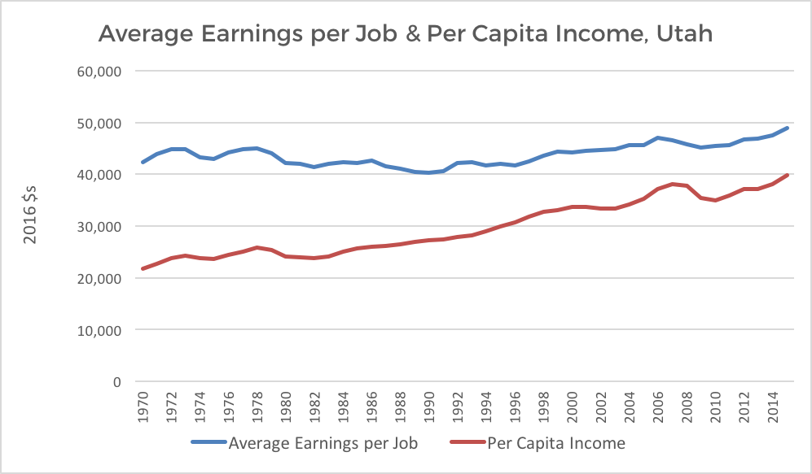

Chart 2, US Department of Commerce
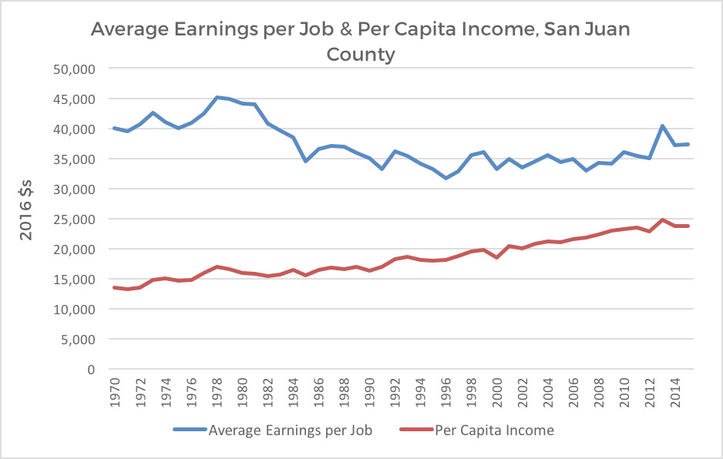

AIR QUALITY
Definition
The degree to which the ambient air is pollution-free, measured by a number of indicators of pollution.
Related Resources
Fire Management, Energy, Mining, Mineral Resources, Land Use, Agriculture
Findings
Overview
Air pollutants are those substances present in ambient air that negatively affect human health and welfare, animal and plant life, property, and the enjoyment of life or use of property. Ambient pollutant concentrations result from interaction between meteorology and pollutant emissions. Because meteorology can’t be controlled, emissions must be managed to control pollutant concentrations.
“The Clean Air Act (CAA) requires the Environmental Protection Agency (EPA) to set National Ambient Air Quality Standards (NAAQS) for pollutants considered harmful to public health and the environment. The CAA establishes two types of air quality standards: primary and secondary. Primary standards are set to protect public health, including the health of sensitive populations such as asthmatics, children, and the elderly. Secondary standards are set to protect public welfare, including protection against decreased visibility and damage to animals, crops, vegetation, and buildings... The EPA has established health-based NAAQS for six pollutants known as criteria pollutants. These are carbon monoxide, nitrogen dioxide, ozone, particulate matter, sulfur dioxide, and lead... The Division of Air Quality (DAQ) monitors each of these criteria pollutants, as well as several non-criteria pollutants for special studies at various monitoring sites throughout the state” (Utah Division of Air Quality 2015).
The Clean Air Act (1970) and its amendments set the laws and regulations regarding air quality, give authority to the US Environmental Protection Agency to set standards and rules, and delegate regulatory authority to individual states with EPA oversight, provided certain standards are met. The purpose of air quality conformity regulations, enforced by the EPA and the DAQ in Utah, are to protect public health and welfare by decreasing pollutant concentrations through emissions reduction. Construction and mining projects require assessment of air quality impacts and may require an emissions permit and/or a fugitive dust control plan from the DAQ. Utah’s Smoke Management Plan requires that efforts on wildfires and prescribed fires be coordinated with Federal agencies so that these fires do not result in decreased air quality.
“San Juan County air quality is generally very good with minimal negative auto or industrial emissions. Occasionally, spring winds and resulting wind erosion increases particulates to unacceptable levels. Air quality may also be slightly decreased during wildland fires. The county has very few confined animal feeding operations and limited complaints of odors. In the winter months, temperature inversions can cause air quality issues for short periods of time” (San Juan County Conservation District 2011). Canyonlands National Park is the only Class I air quality area (40 CFR Section 51.307 of the Clean Air Act) in San Juan County. All other areas in the county are Class II.
Economic Considerations
Maintaining air quality is important to San Juan County because of the related economic and health consequences:
• Increased time away from work and health care costs associated with stroke, heart disease, chronic and acute respiratory diseases, including asthma, and premature death.
• Decreased appeal of tourism.
• Deterring new businesses and industries from moving to the area.
• Increased operating expenses for significant pollutant sources due to pollution control measures as required by air quality management plans.
• Stunted growth and yield of agricultural crops.
• Threat of additional federal regulation and potentially reduced highway funding.
Custom + Culture
The County has always valued clean air and expansive viewsheds.

Objectives
a. The area attains reasonable air quality standards of federal, state and local laws and regulations for the health and benefit of the public.
Policies
1. Federal agencies should continue to work cooperatively with county, state, federal, and tribal entities in developing air quality assessment protocols to address cumulative impacts and regional air quality issues.
2. The best available control technology, recommended by
the Utah Division of Air Quality (UDAQ), should be applied as needed to meet air quality standards.
3. Prescribed fires should be coordinated with the State Smoke Coordinator prior to ignition and follow the requirements of the State’s Enhanced Smoke Management Plan.

CULTURAL, HISTORICAL, GEOLOGICAL + PALEONTOLOGICAL
Definition
Generally speaking, this refers to remains of human activity and natural resources which have intrinsic value because of their age, anthropological, heritage, scientific or other intangible significance.
Cultural: of or relating to the ideas, customs, and social behavior of a society
Historic: of, or pertaining to, history or past events
Geological: of or pertaining to naturally occurring rock formations and features
Paleontological: pertaining to non-human fossils
Related Resources
Recreation and Tourism, Land Use, Land Access, Energy, Law Enforcement, Mining, Mineral Resources, Energy. Air Quality, Water Quality and Hydrology, Agriculture, Livestock Grazing, Fire Management
Cultural and Historical
As the largest county in Utah, San Juan County is known for its beauty and diversity. It offers colorful slickrock canyons and deserts, ancient Anasazi ruins, unbelievable geological formations, Lake Powell, beautiful mountains, creeks and lakes, as well as three major rivers (San Juan County 2008).
Cultural resources are those non-renewable remains or evidences of past human activity. These remains take the form of sites, artifacts, buildings, structures, ruins, features, and natural landscapes with particular cultural importance. With a few exceptions, these remains (or in the case of natural landscapes, the period of traditional use of that landscape) must be at least 50 years old. Cultural resources also include places identified by traditional groups (e.g., Native American tribes) as sacred or otherwise important to the maintenance of group identity even if no physical manifestation of past activities are present at that location. Such locations are frequently referred to as Traditional Cultural Properties (TCPs) (Bureau of Land Management 2005).
Cultural resources also includes the sum total of ways of life built up by a group of human beings and transmitted from one generation to another. This includes the Native American and pioneer heritages in the county.
Many historical and cultural resources are fragile and are protected by law. The Antiquities Act (1906) was the first law that provided general protection of cultural resources. The Archaeological Resources Protection Act (1979) provided for more effective enforcement of protection. The National Historic Preservation Act, as amended, expanded protection of historic and archaeological properties to include those of national, state, and local significance, and directed federal agencies to consider the effects of proposed actions on properties eligible for or included in the National Register of Historic Places.
The National Historic Preservation Act (1966) created the National Register of Historic Places, the list of National Historic Landmarks, and the State Historic Preservation Offices (SHPO). The National Register of Historic Places, managed by the National Park Service, is the nation’s official list of buildings, districts, sites, structures, and objects worthy of preservation, and are officially designated “historic properties”, either archaeological or historic (National Parks Service n.d.). The State Historic Preservation Office (SHPO) and Officer was created in order to coordinate a statewide inventory of historic properties, nominate properties to the National Register, manage the statewide preservation plan, and educate and consult locals (Utah Department of Heritage & Arts 2016).
As of 2016, there are more than 32,000 cultural and historic sites recorded in San Juan County. Recent years’ inventories have added about 1000 sites per year (Monticello BLM Field Office staff, personal communication). A majority of these sites are considered eligible for listing on the National Register. Eligible, as well as listed sites, receive the same protection under the law.
In 2016, San Juan County had 36 sites listed on the National Register of Historic Places, including historic cabins and cowboy camps, pioneer homes, trading posts, prehistoric ruins, petroglyph sites, and archaeological and historic districts.
San Juan County has areas with some of the highest cultural site densities in the United States. Some areas have site densities as high as 100 or more sites per section. Because of such high site densities and the legal requirement to consider the potential impact of proposed projects on sites, cultural resources are an important consideration in any project planning within the County.
Geological
Overview
Geological features or resources can be defined as any physical feature of the earth’s surface, or of the rocks exposed at the surface, that is formed by a geologic process (erosion and seismic movements).
“Wind, water, temperature, and chemical activity have combined to flake, crack, scour, melt, and create some of the most picturesque scenery in the world. Lone sandstone spires protrude from a desert floor; a roiling, silt-laden river courses through a narrow floodplain before passing between canyon walls hundreds of feet high; cedar-covered mesas give way first to ponderosa pine, next aspen, and finally the naked rocks of a towering peak, while grass- and sagebrush- clad plateaus serve as home to herds of sheep and cattle. The land is as diverse as the geological prehistory that helped to create it” (McPherson 1995).
“San Juan County lies in the Canyonlands portion of the Colorado Plateau, in what is known as the Upper Sonoran ecological zone. It is high desert country, ranging through an elevation of 4,000 to 6,000 feet. But that is an average. The highest peak in the county, Mount Peale in the La Sals, stands at an elevation of 12,700 feet, while Abajo Peak on Blue Mountain reaches 11,360 feet. If a person traveled to the top of Abajo Peak from Monument Valley (4,900 feet) that person would experience approximately 6,500 feet of elevation change in two hours. He or she also would have traveled through five different ecological zones…” (McPherson 1995).
“Underlying San Juan County are vast stretches of sandstone and limestone beds resting in horizontal layers that tilt slightly north. The development of these strata started four and a half billion years ago during the Precambrian period” (McPherson 1995).
Seismicity
The main seismic risk in Utah comes from the Wasatch Fault, stretching 240 miles along the Wasatch mountain range. Utah experiences approximately 13 earthquakes a year with a magnitude over 3.0. The state is predicted to experience a large earthquake within the next fifty years that could cause significant damage. Southeastern Utah has recorded earthquakes in the past, but San Juan County’s risk is low because there are no major faults nearby.
According to the USGS, there have only been 14 earthquakes, above 2.5 magnitude, since 1931. The largest quake in recent history was a 4.0 magnitude near Halls Crossing in 1986 (U.S. Geological Survey n.d.).
Earthquakes in the state could certainly impact the people, economy, and infrastructure of San Juan County. Roads, pipelines, power lines, water resources, telecommunications, and food systems could all be disrupted in the event of a natural disaster.
Building codes that meet seismic standards are controlled by the County, and in some places by the individual municipalities.
Paleontological
Paleontological resources are the fossilized remains of animals (vertebrates and invertebrates) and plants, or traces or evidence of prehistoric animals.
Both the Federal Government and State Government have laws and rules regarding the collection, preservation, and curation of fossils. In general, personal hobby collecting of invertebrate and plant fossils (for example, clams and leaves) is legal on many State and Federal lands, but collection of vertebrate fossils (for example, dinosaurs) requires that a detailed permit be issued by the land’s governing agency.
Utah State Code (63-73-11 through 63-73-19) currently states that paleontological resources are important and requires the preservation of critical fossil resources on State lands. The Code mandates that those removing or excavating critical fossils on State lands be qualified and permitted under joint jurisdictional cooperation from: the Utah Geological Survey (UGS), Utah Museum of Natural History, and the School and Institutional Trust Lands Administration. State Code (53B-17-603) also requires that important extracted fossils be curated by an approved and qualified institution.

Economic Considerations
Though unmeasured in the economy, the value brought to the County by cultural and paleontological research and tourism is important.
Cultural, historical, geological, and paleontological resources are often connected with tourism and recreation. For example, the Utah Geological Survey has created a GeoSites online interactive map to help people explore Utah’s geological sites.
Historic buildings and districts provide character, a sense of stability, and a unique marketing angle for businesses; thus, community planners can draw upon local historic resources to stimulate economic development
A study by the Utah Heritage Foundation (2013) found that, “Utah benefited by $717,811,000 in direct and indirect spending by visitors to Utah heritage sites and special events, and $35,455,268 in investment that stayed in Utah rather then sent to Washington, D.C. because of projects that utilized the Federal Rehabilitation Tax Credit”.
“Historic preservation in Utah is not about putting a fence around monuments. The historic resources of Utah are part of the daily lives of its citizens. However, the historic resources of Utah are also providing a broad, significant contribution to the economic health of this state” (Utah Heritage Foundation 2013).
Many individuals travel to experience someone else’s landscape, heritage, and way of life. The Utah Department of Community and Economic Development (DCED) defines these individuals as “cultural heritage tourists”. Cultural heritage tourism is a growing segment of the traveling public and often provides local communities with travel-related economic development while perpetuating local lifestyles and quality of life.
Custom + Culture
“Prior to Euro-American settlement, the Great Basin- Colorado Plateau region was inhabited by Native American Indians. Anthropologists, archeologists, and historians have identified several Indian cultures, including the Desert, Basket Maker, Pueblo, Fremont, Ute, Paiute, Goshute, Shoshoni, and Navajo (Tyler, 1989). The earliest known inhabitants were primitive nomadic hunter-gatherers of the Desert (Desert Archaic or Paleo and Archaic) Culture who occupied the region between 10,000 B.C. and A.D. 400 (Lewis, 1994)” (Utah State University 2009).
“The Ancestral Pueblo people lived in this area for hundreds of years, until about A.D. 1300. At first, they built pithouse structures; later they built rock structures on the ground and high up in the cliffs. Their cliff houses, pictographs, and petroglyphs continue to baffle and fascinate visitors. A few white residents lived along the San Juan River before 1879. In that year, Mormon scouts who were exploring a route for the famous Hole-in-the-Rock Expedition began the full- scale settlement of San Juan County. The 180 pioneers who left Escalante in the fall of that year arrived at the present site of Bluff on April 6, 1880—after harrowing months on what may have been the roughest emigrant trail in the West. After a decade of fighting the elements many of the Bluff settlers discovered that life was somewhat easier in higher country around the Abajo Mountains, and the towns of Blanding and Monticello replaced Bluff as San Juan’s main focal points” (Utah Division of State History n.d.).
In 1868, the Navajo Indian Reservation was established in the southern portion of San Juan County as well as in Arizona and New Mexico. The reservation was based on a treaty with the United States; however, the first allotment for the reservation lands was only half of what was promised in the treaty. Between 1878 and 1934 the boundaries were expanded 13 times more times through acts of Congress as well as executive order.
The Ute Mountain Ute Reservation was established in the late 1800s. Most of the reservation is in southwestern Colorado but it also includes lands in Allen Canyon, White Mesa and Cross Canyon in San Juan County.
“Many individuals in the county are of pioneer heritage, devoutly religious, and very independent. This independence can be seen as both an asset and a challenge. Sometimes this independence is viewed as community apathy regarding economic development. It also affects whether individuals needing help are able to seek the support they need. On the other hand, such independence can be the glue that keeps the communities together” (San Juan County 2008).
Many county residents (and non-residents with ties to the county) treasure and honor their pioneer and Native American heritage and cultures. Many families and extended families are large and close-knit and oftentimes renew their ties with family reunions and other gatherings. Some of these gatherings honor and remember family heritage with visits to sites in the county important to that heritage. One such location is the Hole-In-The-Rock Trail and activities include motorized and non-motorized travel and treks over parts of this historic route and visits to key sites along this route. Native Americans have close ties to the landscape and sites important in their history and culture including sites for religious, ceremonial and plant gathering purposes. Some of these gatherings can be as large as 100 to 200 or more individuals. It is important to accommodate such gatherings and maintain access to these locations and sites to maintain the culture, heritage and lifestyle of county residents.
Objectives
a. Cultural, historical, geological and paleontological resources are managed (including appropriate mitigation of impacts) so they are available for public enjoyment, and scientific and educational purposes.
b. Heritage and tourism industries are supported, including public access to sites and settings of local history.
Policies
1. Limit public lands management that restricts public access to enjoy cultural, historic, geological, and paleontological resources except as required by law or necessary for the preservation of significant cultural resources.
2. Promote special allowance for non-commercial gatherings and events such as family reunions, historic reenactments, religious and ceremonial events important to maintaining the culture, heritage and lifestyle of the county.
3. Support management that makes cultural, historic, geological, and paleontological resources available for educational purposes that can be enjoyed by the public.
4. Describe, as appropriate, high interest or unique geological, paleontological, biological, archaeological, or historical features for public information and, as appropriate, develop interpretive and educational information for these sites.
5. Support the development of reasonable solutions to resolve conflicts between strict protection of cultural, historical, geological and paleontological resources and existing or proposed land uses.

LAW ENFORCEMENT
Definition
The designated personnel group who has federal, state, or local authority within a jurisdiction to enforce the law or respond to an emergency.
Related Resources
Recreation and Tourism, Land Use, Land Access, Fire Management, Water Rights
Findings
Overview
Law enforcement on public lands in San Juan County includes many jurisdictions. As of 2016 there are BLM- administered lands, US Forest Service lands, SITLA lands one National Park, one National Recreation Area, and four National Monuments in the County all with their attendant law enforcement authorities in addition to the authority of the County Sheriff. Outdoor recreation activities have put stress on emergency service units. These efforts have been and are being strengthened through cooperative efforts and the upgrading of a search and rescue unit in the county.
Most residents believe that San Juan County is a relatively safe place to live and raise their families. Because of the size, remoteness and complexities of dealing with the multi- jurisdictional boundaries of the reservation, many challenges have to be overcome. The County Sheriff is working with Tribal leaders to develop cross deputization to provide for quicker response time in dealing with emergencies. In some cases, emergency services are stretched to the limit, however much is being done to improve the situation.
An example of law enforcement coordination involving public lands is livestock theft. The Livestock Inspection Bureau at the Utah Department of Agriculture and Food deals with cases of livestock theft, in close coordination with county sheriff ’s offices. Cases of livestock theft are eventually prosecuted through the county attorney. Additionally, in situations of disease outbreak, the Livestock Inspection Bureau works with Sheriff ’s offices to help enforce livestock quarantines. Brand Inspection and Registration Program, Livestock Inspection Bureau Information (UDAF 2017).
The increasing incursion of federal agency law enforcement presence and influence has overlapped the authority of the County Sheriff and caused friction in county and federal relations. San Juan County believes the County Sheriff is the primary law enforcement official in the county and that authority must be recognized by the federal government (San Juan County, personal communication).
Economic Considerations
An appropriate level of service for law enforcement is essential for all levels of government to protect the health, safety, and welfare of the County, which will in turn positively impact the local economy. Benefits are direct and indirect.
Annual operating costs for local law enforcement (County Sheriff ’s departments) are influenced by public lands law enforcement activities, including coordination activities with state and federal law enforcement agencies. Costs associated with search and rescue operations are increasing in many areas of the state, particularly with increased recreation use of remote lands. Utah counties have the option to charge people who are rescued and/or can receive reimbursement through the state’s Search and Rescue Financial Assistance Program.
The Utah Search and Rescue Assistance Card (USARA Card) offers expense-paid rescue to individuals (hunters, hikers, other backcountry enthusiasts) for an annual fee. Money raised by the program will support the State’s Search and Rescue Financial Assistance Program. County Search and Rescue teams will receive reimbursement for equipment, training and rentals from the program. Such expenses are often borne by the counties.
Custom + Culture
Because of its remote location, law enforcement has always been handled locally, as described in A History of San Juan County, “Besides delivering mail, the government provided law enforcement as a service. Part of the mystique about San Juan County is the idea that the Mormon settlers were called to this region to wrest it from the grasp of a lawless element inhabiting its canyons and secluded places. If the pioneers’ mission was, in the words of one writer, to serve as a “point of interception of bank robbers, horse thieves, cattle rustlers, jail breakers, train robbers and general desperadic [sic] criminals . . . terrorizing and plundering inland settlements,” then they were woefully unprepared for the undertaking.”
“The first decade was more a desperate attempt to control the tough cowhands brought in by the various cattle companies to tend the herds. The general policy of the Mormons was to sit passively by until a situation became intolerable, at which time they were forced to take some type of action. When something was done, it took the form of an impromptu law- abiding vigilance committee composed of church members, who administered justice until the particular problem was solved” (McPherson 1995).
Objectives
a. Public lands are managed under law and regulation for orderly use and management.
Policies
1. Federal and state law enforcement actions in the County should be coordinated through the County sheriff ’s office.
2. Promote federal agency recognition of the County Sheriff as the primary law enforcement official in the County.
3. Maintain law and order to protect the health and safety of persons using the public lands.
4. Control litter, discourage vandalism, and perform search and rescue operations as appropriate.
5. The Sheriff ’s Office will be notified immediately when there is a life-threatening situation, criminal act, project structure failure, resource contamination, natural phenomenon (landslide, flood and fire), cultural resource site disturbance and/or discovery of human remains.

UTILITY CORRIDORS
Definition
Linear tracts of land set aside for the placement of above and below-ground infrastructure that transports and conveys raw materials, processed materials, and energy.
Related Resources
Energy, Mining, Cultural, Historical, Geological and Paleontological, Land Access, Water Rights, Land Use, Air Quality, Water Quality and Hydrology, Economic Considerations
Findings
Utility corridors on federal lands are usually identified in agency land use plans. These land use plans may also identify areas where utility ROWs are to be avoided or excluded. On BLM administered lands, avoidance and exclusion areas are based on resource needs and policy. Such areas include lands with sensitive natural resources such as wilderness values, cultural resources, riparian and relict vegetation and high-quality scenery. Similar policy is used in land use plans on USFS and NPS lands. Since 62% of San Juan county is federally administered land (BLM, USFS and NPS), these land use plan designations for utility corridors are a significant factor in any utility corridor planning.
Establishing a new utility corridor on or through federal land for electrical transmission, pipelines, and other utility infrastructure is a major undertaking that may require years to complete. The design, analysis, public involvement, and documentation required by federal regulations are very complicated.
Recognizing the complex nature of placing utility corridors on public lands, and in light of the growing need for energy grid improvements, Congress passed the Energy Policy Act of 2005. Section 368 of the act directs federal agencies to: (1) designate energy corridors on federal lands in 11 western states; (2) establish procedures to ensure that additional corridors are identified and designated as necessary; and (3) expedite applications to construct or modify oil, gas, and hydrogen pipelines and electricity transmission and distribution facilities. These corridors are referred to as “Section 368” energy corridors.

San Juan County’s segment of the Section 368 corridor follows along US 191 in the northern part of the county until it veers off to the SE and follows East Canyon before entering Colorado (see Maps page 14). While this corridor is useful for the north and northeastern portions of the county, it is too far away from other areas in the county to be of much use.
Economic Considerations
Power generation in the western United States is transitioning from carbon-based fossil fuels to renewable energy. Additionally, policies to increase the component of renewable energy coming from the federal, state, and local governments as well as consumer demands, are likely to increase the demand of renewable energy over the coming decade.
San Juan County has abundant potential for renewable energy generation (solar and wind), as identified in the Utah Renewable Energy Zone study. However, these resources are not always near existing transmission infrastructure. As power generators move to develop these resources, there is a need to simultaneously develop the transmission infrastructure needed to convey power to the electric grid.
Primary economic consideration for utility corridors is the lengthy time periods and high costs required to navigate the federal permitting and compliance processes to place utilities on federal lands. Such long time periods reduce the ability of utility companies to respond to rapidly changing energy policies, such as carbon reduction goals and development of Utah’s renewable energy.
Objectives
a. Existing and future utility corridors are adequate to meet current and future demand.
Policies
1. Protect access for utility companies to maintain and improve infrastructure and utility corridors.
2. Support and promote expeditious federal approval processes and policies for the maintenance of utility corridors and new construction projects.
3. Work with federal and state agencies and tribes to identify utility corridors needed to access and deliver all forms of traditional mineral resources, critical minerals, and renewable energy resources.
4. Support federal agencies to ensure that sufficient utility corridors are available to provide essential utilities to rural areas including areas with current or future federal designations (e.g. national monuments and roadless areas).
5. Support federal agencies to provide access to fiber optic resources to rural Utah and Tribal communities.

Pipelines and Infrastructure
Definition
Pipelines, electrical power and communication lines and associated structures that carry petroleum products, water and electricity.
Related Resources
Energy, Mining, Cultural, Historical, Geological and Paleontological, Land Access, Water Rights, Land Use, Air Quality, Irrigation, Water Quality and Hydrology, Economic Considerations
Findings
Electrical Transmission
Electrical transmission infrastructure is used to convey high-voltage electricity from a generation source to load-center substations, where it’s transformed into lower-voltage electricity for distribution to end-users. Major components of electrical transmission infrastructure include transformers, towers, foundation materials, and conductors (transmission lines). High-voltage transmission can be either alternating current (AC) or direct current (DC). Alternating current, the most commonly used form of transmission, has the ability to convert to different voltages using a transformer, whereas DC is not easily converted. Typical voltage for transmission in the county ranges from 69 Kilovolt (kV) up to 345 kV. Existing electrical transmission lines and substations are shown on the map on page 13 of Maps.
When planning for new utility-scale solar developments, considerations should be made for the inversion of DC power generated from solar array prior to connection to the AC bulk power grid.
Another consideration for the planning of electrical transmission in Utah includes future chokepoints or bottlenecks in transmission-line capacity. This issue has been studied with respect to electrical transmission in the 2021 Utah Transmission Study, which determined that (under scenarios of high renewable energy buildout in southern Utah) electrical transmission needs might exceed capacity (Energy Strategies 2021).
Resilience and redundancy of electrical transmission are issues that have been identified by stakeholders. Many rural locations in Utah are served by single transmission lines, referred to as “radial transmission lines.” Radial transmission lines are the least costly option for providing some remote locations with electrical power, but they also leave those areas vulnerable to utility disruptions because of their lack of redundancy. Additional transmission connections are costly not only because of their construction costs, but also due to the expense and time required to place utility corridors on federal lands. Refer to the Utility Corridor section for more information.
Natural Gas Pipelines
Natural gas pipelines are constructed by private utility companies to move natural gas from production areas to end users. Gathering pipelines move extracted raw materials from wellheads to processing plants, where natural gas is separated from other gases, hydrocarbon gas liquids, and water. The refined natural gas is then pressurized and added to the mainline transmission system, which consists of large-diameter, high-pressure pipelines. Compressor stations along the network maintain pressure and move product down the line to storage areas, major industrial consumers, power plants, shipping ports, and distribution companies. From there, distribution transmission systems operate with smaller-diameter lines and lower pressure. Finally, service lines transport natural gas to the end users.
The Lisbon Valley Gas Plant located approximately 20 miles north of Monticello processes natural gas collected from sources in Utah, Colorado and New Mexico. The La Sal Junction Compressor Station is part of the Northwest Pipeline transporting natural gas through the intermountain region and the Pacific Northwest. Major natural gas pipelines are shown in the map on page 10 of Maps.
Oil Pipelines
According to the Utah Geologic Survey (UGS), Utah is consistently one of the top 15 oil-producing states in the United States (Chidsey 2021). In their recent circular, Utah’s Energy Landscape, the UGS reported the majority of oil production in Utah is occurring in Duchesne, Uintah, and San Juan Counties. Crude oil produced in San Juan County is transported in pipelines south to refineries in New Mexico. The two major pipelines are the CCI and Questar Pipelines. The CCI Pipeline transports crude oil from the Lisbon Field area approximately 20 miles north of Monticello to the Greater Aneth Field in the southern part of the county and thence SE into Colorado and New Mexico. The Questar Pipeline transports oil from the Greater Aneth area south into Arizona.
Water Pipelines
The main water pipelines in the county transport water for communities and irrigation. The main water pipelines for community use include collection and transport pipelines for Monticello, Blanding and Spanish Valley. The largest irrigation pipeline transports water from Recapture Reservoir to agricultural lands in the Blanding area.
Telecommunications
Telecommunications refer to the infrastructure used to transmit and distribute electronic information. This discussion of telecommunications will focus on broadband infrastructure, typically transmitted through fiber optic cable, used by service providers to connect consumers to the Internet, which allows large quantities of digital information to be transmitted at high speeds.
The State of Utah is committed to deploying and expanding broadband and making it accessible across the entire state. To this end, the 2020 Utah Broadband Plan identifies a series of goals to meet that goal. As of June 2021, 94 percent of Utah has access to broadband Internet service with speeds of 100 mbps or faster. Approximately 68 percent of Utahns have access to fiber-optic services with a State Broadband Access Ranking of 29th in the United States (BroadbandNow 2021).
Most communities in the county are now served with a fiber optic network from Spanish Valley to Bluff. These include the main communities along US 191 and US 491 as well as La Sal, Eastland, Montezuma Creek and Aneth. A project is currently underway to connect Mexican Hat from Bluff with plans to continue on to Monument Valley and Oljeto. See map on page 12 of Maps.
Other Infrastructure
Most communities in the county have water treatment plants to supply culinary water to community residents. Most are located on municipal property but the water may be supplied from sources on public lands. Examples are the culinary water pipelines from springs on the Monticello Ranger District supplying Monticello and the Blanding Tunnel on the Monticello Ranger District supplying Blanding. Many communities also have wastewater treatment plants which are also on municipal lands.
Culinary water treatment and wastewater treatment facilities on public lands include those of Mexican Hat, the National Park Service at Natural Bridges National Monument, Hovenweep National Monument (septic system for waste), Halls Crossing, Hite, Needles District of Canyonlands National Park (septic system for waste) and those of the State Parks and Recreation at Dead Horse Point State Park (septic system for waste).
Transportation Infrastructure
The planning, construction, and maintenance of US interstate highways, state highways, and some local roads in Utah are completed through collaboration with UDOT. Roadway planning occurs during the compilation of the Unified Transportation Plan. Construction of new federal and state roadways and bridges as well as upgrades to existing infrastructure is prioritized in this plan.
The Utah Freight Plan addresses issues and needs specific to the statewide highway and multimodal freight networks. In San Juan County, US 191 from the northern county line to Monticello and US 491 from Monticello to the state line are classified as ‘Critical Rural’ highways in this plan. A ‘Critical Rural’ highway provides access and connection to the Primary Highway Freight System and the Interstates with other important ports, public transportation facilities, or other intermodal freight facilities. Both of these highways are also rated as ‘High Volume’ highways in UDOT’s ‘Pavement Management’ system. This designation means that Average Annual Daily Traffic (AADT) is greater than 1,000 vehicles and Average Annual Daily Truck Traffic (AADTT) is greater than 200. See map on page 11 of Maps.
Economic Considerations
Water Pipelines
According to the 2020 Statewide Water Infrastructure Plan, over the next 50 years, the State of Utah and municipal water providers in San Juan and Grand Counties (Southeast Colorado River Basin Water Plan) will need to spend $97.8 million to repair and replace existing infrastructure and another $4 - 18 million for new infrastructure and to develop new water supplies for future growth (BRWCD et al. 2020).
Objectives
a. Pipelines, powerlines, communication lines and other infrastructure are present to provide for transport and delivery of petroleum products, water, electric power and telecommunications services to meet current and future needs of the county.
Policies
1. Support a network for the transport and distribution of natural gas, crude oil and refined petroleum products.
2. Support a network for the collection and delivery of electrical power and communications to County residents.
3. Support the investigation and research for additional water collection, storage and delivery opportunities to supply current and future community needs.
4. Support local community and water conservation districts in applying for grants for additional water collection, storage and delivery systems.
5. Support active management of forests to increase watershed yields.
6. Support programs such as Shared Stewardship and the Watershed Restoration Initiative to enhance water yields
7. Support innovation to make existing and future water collection, storage and delivery systems more efficient, reliable, safe, climate-friendly and sustainable.

APPENDICES
- Works Cited
- Citizen Input
- Maps

WORKS CITED
Aguero, J. 2014. Utah’s water dependent economy. Prepare60. <http://prepare60.com/Content/EconomicsWater.pdf>. Accessed 5 Jan 2017.
Anderson, R. C., J. S. Fralish, and J. M. Baskin, editors. 1999. Savannas, barrens, and rock outcrop plant communities of North America.
Cambridge University Press, Cambridgeshire, England Animal and Plant Health Inspection Service [APHIS]. 2009. Partnerships and progress. U.S. Department of Agriculture. <https://www. aphis.usda.gov/wildlife_damage/downloads/partnerships%20in%20progress.pdf>. Accessed 5 Jan 2017.
Bear River Water Conservancy District, Cache Water District, Central Iron County Water Conservancy District, Central
Utah Water Conservancy District, Jordan Valley Water Conservancy District, Utah Division of Water Resources,
Washington County Water Conservancy District, & Weber Basin Water Conservancy District. 2020.
StatewideWaterInfrastructure Plan. Prepare 60. Technical Report, 16pg.
Bellison, N., R. Whitesides, S. Dewey, J. Merritt, S. Burningham. 2009. Noxious weed field guide for Utah. Utah State University Cooperative Extension. <http://extension.usu.edu/files/publications/publication/pub 8746541.pdf>. Accessed 9 Jan 2017.
Berry, J., D. Hurlbut, R. Simon, J. Moore, and R. Blackett. 2009. Utah renewable energy zones task force phase I report. Utah Geological Survey Miscellaneous publication 09-1. <https://energy.utah.gov/wp-content/uploads/UREZ-Phase-I.pdf>. Accessed 15 Oct 2016.
Blue Ribbon Fisheries Advisory Council [BRFAC]. 2009. Blue ribbon fisheries advisory council handbook. <https://wildlife.utah.gov/ blueribbon/pdf/council_handbook.pdf>. Accessed 15 Oct 2016.
Boden, T., K. Krahulec, D. Tabet, A. Rupke, and M. Vanden Berg. 2014. Utah’s extractive resource industries. Utah Geological Society Circular 120. <http://files.geology.utah.gov/online/c/c-120.pdf>. Accessed 3 Nov 2016.
Bon, R. L., and K. Krahulec. 2010. Summary of mineral activity in Utah. Utah Geological Survey. Circular 111. <http://files.geology.utah. gov/online/c/c-111.pdf>. Accessed 28 Jan 2017.
Bureau of Land Management [BLM]. 2005. Analysis of management situation (AMS) for the Monticello Planning Area. U.S. Department of the Interior. <https://eplanning.blm.gov/epl-front-office/projects/lup/68097/85765/102955/Chapter_04_-_Cultural.pdf>. Accessed 29 Oct 2016.
Bureau of Land Management [BLM]. 2007. Draft resource management plan and environmental impact statement: Monticello field office.
U.S. Department of the Interior. <https://permanent.access.gpo.gov/gpo11793/full_copy/awarchive.pdf>. Accessed 5 Jan 2017.
Bureau of Land Management [BLM]. 2008a. Moab Field Office record of decision and approved resource management plan. U.S. Department of the Interior. <https://www.blm.gov/style/medialib/blm/ut/moab_fo/rmp/rod_approved_rmp.Par.24543.File.dat/ Moab%20Final%20Plan.pdf>. Accessed 30 Oct 2016.
Bureau of Land Management [BLM]. 2008b. Monticello Field Office record of decision and approved resource management plan. U.S. Department of the Interior. <https://eplanning.blm.gov/epl-front-office/projects/lup/68097/85493/102694/Monticello_Final_Plan. pdf>. Accessed 20 Aug 2017.
Bureau of Land Management [BLM]. 2009. Wild and scenic river eligibility report. U.S. Department of the Interior. <https://www. blm.gov/style/medialib/blm/co/field_offices/grand_junction_field/RMP_Library.Par.47348.File.dat/Final%20Wild%20and%20 Scenic%20Eligibility%20Report%20original%20signature%20web.pdf>. Accessed 30 Oct 2016.
Bureau of Land Management [BLM]. 2011. The Taylor Grazing Act. U.S. Department of the Interior. <https://www.blm.gov/wy/st/en/ field_offices/Casper/range/taylor.1.html>. Accessed 5 Jan 2017.
Bureau of Land Management [BLM]. 2012. Manual transmittal sheet 6400 – wild and scenic rivers – policy and program direction for identification, evaluation, planning, and management (public). U.S. Department of the Interior. <https://www.blm.gov/style/medialib/blm/wo/Information_Resources_Management/policy/blm_manual.Par.76771.File.dat/M6400_WildScenicRivers_ Final%20071312.pdf>. Accessed 30 Oct 2016.
Bureau of Land Management [BLM]. 2016. Connecting with Utah communities; BLM-Utah’s recreation and visitor services strategy 2016- 2020. U.S. Department of the Interior. <https://www.blm.gov/style/medialib/blm/ut/natural_resources/recreation/frontpagephotos. Par.73300.File.dat/CWUCstrat2016.pdf>. Accessed 18 Jan 2017.
Bureau of Land Management [BLM]. 2016. Record of decision and Moab master leasing plan/approved resource management plan amendments for the Moab and Monticello field offices. U.S. Department of the Interior. <https://eplanning.blm.gov/epl-front-office/ eplanning/planAndProjectSite.do?methodName=dispatchToPatternPage&currentPageId=99718>. Accessed 28 Mar 2017.
Council on Environmental Quality. 2007. A citizen’s guide to the NEPA. Executive Office of the President. <https://www.blm.gov/style/ medialib/blm/nm/programs/planning/planning_docs.Par.53208.File.dat/A_Citizens_Guide_to_NEPA.pdf>. Accessed 18 Jan 2017.
Davis, R. C., editor. 1983. Encyclopedia of American Forest and Conservation History. Macmillan Publishing, New York, USA. Department of the Interior. 2010. Salazar lays groundwork for Utah pilot project to resolve old road claims on public land [Press release].
Retrieved from <https://www.doi.gov/news/pressreleases/Salazar-Lays-Groundwork-for-Utah-Pilot-Project-to-Resolve-Old-Road- Claims-on-Public-Land>. Accessed 2 Jan 2017.
Dinkins, J. B., M. R. Conover, C. P. Kirol, and J. L. Beck. 2012. Greater sage grouse (Centrocercus urophasianus) select nest sites and brood sites away from avian predators. The Auk. <http://www.bioone.org/doi/full/10.1525/auk.2012.12009>. Accessed 2 Feb 2017.
Donaldson, F. J. 2007. Farmer beware: water rights enforcement in Utah. Journal of Land, Resources, and Environmental Law 27:367-385.
<http://www.epubs.utah.edu/index.php/jlrel/article/viewFile/56/49>. Accessed 30 Oct 2016.
Economic Profile System. 2017a. A profile of development and the wildland-urban interface (WUI). Headwaters Economics. <https:// headwaterseconomics.org/tools/economic-profile-system/>. Accessed 10 Nov 2016.
Economic Profile System. 2017b. A profile of non-labor income. Headwaters Economics. <https://headwaterseconomics.org/tools/ economic-profile-system/>. Accessed 14 Apr 2017.
Economic Profile System. 2017c. A profile of socioeconomic measures. Headwaters Economics. <https://headwaterseconomics.org/ tools/economic-profile-system/>. Accessed 14 Apr 2017.
Energy Fuels. “Energy Fuels Hits Critical Minerals ‘Trifecta’ in Rare Earths, Uranium and Vanadium; Now Performing Commercial-Scale partial Rare Earth Separations”. April 13, 2022 Energy Fuels News Release.
Felker D., J. McIntyre, T. Burke, and T. Czapla. 2012. The razorback sucker: back from the brink. U.S. Fish & Wildlife Service. <https:// www.fws.gov/endangered/news/bulletin-spring2009/the-razorback-sucker.html>. Accessed 15 Oct 2016.
Gloyn, R. W., C. D. Morgan, D. E. Tabet, R. E. Blackett, B. T. Tripp, and M. Lowe. 1995. Mineral, energy, and ground-water resources of San Juan County. Utah Geological Survey Special Study 86. <http://ugspub.nr.utah.gov/publications/special_studies/SS-86.pdf>. Accessed 3 Nov 2016.
Godfrey, B. E. 2008. Livestock grazing in Utah: history and status. Utah State University, Logan, Utah.
Governor’s Office of Energy Development. 2014. Utah’s 10-year strategic energy plan 2.0. <http://energy.utah.gov/download/ reports/10%20Year%20Strategy_2.0_03042014.pdf>. Accessed 9 Jan 2017.
Governor’s Office of Energy Development. 2015. Energy and energy-related mining in Utah. <https://energy.utah.gov/wp-content/ uploads/UtahsEnergyEconomy_EconomicImpactAssessment.2015.compressed.pdf>. Accessed 9 Jan 2017.
Gunnison Sage-grouse Rangewide Steering Committee. 2005. Gunnison sage-grouse rangewide conservation plan. Colorado Division of Wildlife, Denver, Colorado. <https://www.fws.gov/ecos/ajax/docs/plan_documents/tcca/tcca_671.pdf>. Accessed 5 Jan 2017.
Gurrister T. 2014. Ravens ravaging sage grouse in Box Elder. Standard Examiner. <http://www.standard.net/Environment/2014/05/29/ Ravens-harassing-sage-grouse-in-Box-Elder-elsewhere>. Accessed 2 Feb 2017.
Hylland M. D., and W. E. Mulvey. 2003. Geologic hazards of Moab-Spanish Valley, Grand County, Utah. Special Study 107. Utah Geological Survey. <http://www.riversimulator.org/Resources/farcountry/Geology/GeoHaz/SS-107.pdf>. Accessed 15 Oct 2016.
Iverson, G. C. La Sal Mines Complex Plan of Operations POA Objections Response. Letter to Roger Flynn. 20 March 2015. <https:// www.biologicaldiversity.org/programs/public_lands/mining/pdfs/USFS_Objection_decision_document_3-20-15.pdf>. Accessed 25 Oct 2016.
Keith J., P. Jakus, J. Larsen, S. Burr, D. Reiter, and J. Zeitlin. 2008. Impacts of wild and scenic rivers designation. Utah State University.
<http://digitallibrary.utah.gov/awweb/awarchive?type=file&item=27530> . Accessed 15 Oct 2016.
Kem C. Gardner Policy Institute. 2016. Utah travel & tourism profile: state and counties. University of Utah. <http://gardner.utah.edu/ wp-content/uploads/2016/10/profiles_2015.pdf>. Accessed 18 Jan 2017.
Kim, M., and P. M. Jakus. 2013. The economic contribution and benefits of Utah’s blue ribbon fisheries. Utah State University. <http:// csee.usu.edu/files/uploads/CSEE_RR_4_Kim_and_Jakus_Feb_2013.pdf>. Accessed 15 Oct 2016.
Krannich, R. S. 2008. Public lands and Utah communities: a statewide survey of Utah residents. Utah State University. <http:// apecextension.usu.edu/files/uploads/Environment%20and%20Natural%20Resources/Public%20Lands/General%20Population%20 Final%20Report.pdf>. Accessed 30 Oct 2016.
Krannich, R. S., Lilieholm, R. J., and Unger J. 2012. Utah angler survey. Utah State University. <https://csee.usu.edu/files/uploads/CSEE_ RR_1_Krannich_et_al_Nov_2012.pdf>. Accessed 15 Oct 2016.
Leaming, G. F. 1990. The adverse economic impacts of wilderness land withdrawals on Utah. Western Economic Analysis Center, Marana, AZ, USA.
McPherson, R. S. 1995. A history of San Juan County: in the palm of time. Utah State Historical Society, San Juan County, Utah.
Miller, R. F., and R. J. Tausch. 2000. The role of fire in juniper and pinyon woodlands: a descriptive analysis. Tall Timbers Research Station Miscellaneous Publication 11:15–30. <http://oregonstate.edu/dept/eoarc/sites/default/files/publication/460.pdf> Accessed 18 Jan 2017.
National Agricultural Statistics Service. 2016. Utah annual statistics bulletin. U.S. Department of Agriculture. <https://www.nass.usda. gov/Statistics_by_State/Utah/Publications/Annual_Statistical_Bulletin/>. Accessed 21 Jan 2017.
National Interagency Fire Center. 2015. Federal firefighting costs (suppression only). U.S. Department of the Interior. <https://www.nifc. gov/fireInfo/fireInfo_documents/SuppCosts.pdf>. Accessed 18 Jan 2017.
National Mining Association. 2016. The economic contributions of U.S. mining (2015 update). <http://nma.org/wp-content/ uploads/2016/09/Economic-Contributions-of-Mining-in-2015-Update-final.pdf>. Accessed 3 Apr 2017.
National Network to End Domestic Violence [NNEDV]. 2010. The impact of the economy on domestic violence. <http://nnedv.org/ downloads/Stats/NNEDV_DVandEconomy.pdf>. Accessed 3 Apr 2017.
National Oceanic and Atmospheric Administration [NOAA]. 2009. State of the science fact sheet: air quality. <https://esrl.noaa.gov/csd/ factsheets/airqualitysos.pdf>. Accessed 27 Feb 2017.
National Parks Service. n.d. National register of historic places. Digital Archive on NPGallery. <https://npgallery.nps.gov/nrhp>. Accessed 18 Oct 2016.
National Parks Service. n.d. Visitor use statistics. U.S. Department of the Interior. <https://irma.nps.gov/Stats/>. Accessed 30 Nov 2016. National Park Service. 2010. Partnership wild & scenic rivers. <https://www.nps.gov/pwsr/index.htm> Jan 3 2016.
National Resource Conservation Service [NRCS]. 2005. San Juan County resource assessment. U.S. Department of Agriculture. <https:// www.nrcs.usda.gov/Internet/FSE_DOCUMENTS/nrcs141p2_032730.pdf>. Accessed 3 Nov 2016.
National Wild and Scenic Rivers System. 2017. A compendium of questions and answers relating to wild & scenic rivers. <https://www. rivers.gov/documents/q-a.pdf>. Accessed 17 Jan 2017.
Pope, C. A., J. Schwartz, and M. R. Ransom. 1992. Daily mortality and PM10 pollution in Utah Valley. Archives of Environmental Health: A International Journal 47(3).
Powell, A. K., editor. 1994a. Utah history encyclopedia. Wildlife management in Utah. The University of Utah Press. Salt Lake City. Powell, A. K., editor. 1994b. Utah history encyclopedia. Glen Canyon of the Colorado River. The University of Utah Press. Salt Lake City.
San Juan Conservation District. 2011. San Juan County resource needs assessment. Utah Association of Conservation Districts. <http:// media.wix.com/ugd/9bdf1b_2fd20da59da547ef93a723f5e5dfaa7b.pdf>. Accessed 4 Jan 2017.
San Juan County. 2008. San Juan County master plan. Monticello, Utah.
San Juan County. 2014. San Juan County transportation plan. Monticello, Utah.
San Juan County. 2015. San Juan County “B” road map. County GIS Department. Monticello, Utah.
San Juan County Gunnison Sage-grouse Working Group [SWOG]. 2003. Gunnison sage-grouse (Centrocercus minimus) conservation plan update. San Juan County, Utah. <http://extension.usu.edu/files/publications/publication/pub 1434296.pdf>. Accessed 4 Jan 2017.
Southeastern Utah Association of Local Governments. 2003. Natural hazard pre-disaster mitigation plan. <http://wfrc.org/programs/pdmplans/SE/Part%2010.%20San%20Juan%20County.pdf>. Accessed 3 Nov 2016.
Southeastern Utah Economic Development District. 2015. Comprehensive economic development strategy. Southeastern Utah Association of Local Governments. <http://www.seualg.utah.gov/2015-2019_SEUEDD_CEDS-Web_Version.pdf>. Accessed 3 Nov 2016.
Southwick Associates. 2013. The economic contributions of outdoor recreation. Outdoor Industry Association. <https://outdoorindustry. org/images/ore_reports/oia-state-recreation-economy-technical-report-2013.pdf>. Accessed 10 Nov 2017.
Sutter, J. V., M. E. Andersen, K. D. Bunnell, M. F. Canning, A. G. Clark, D. E. Dolsen, and F. P. Howe. 2005. Utah comprehensive wildlife conservation strategy (CWCS). Utah Division of Wildlife Resources Publication Number 05-19. <http://iwjv.org/sites/default/files/ utah_strategic_wildlife_action_plan.pdf>. Accessed 7 Jan 2017.
Tamarisk Coalition. n.d. Southeast Utah riparian partnership. <http://tamariskcoalition.org/events/southeast-utah-riparian- partnership>. Accessed 3 Nov 2016.
University of Utah, Bureau of Economic and Business Research. 2014. An analysis of a transfer of federal lands to the state of Utah. <http:// publiclands.utah.gov/wp-content/uploads/2014/11/1.%20Land%20Transfer%20Analysis%20Final%20Report.pdf> Accessed Jan 18 2017.
U.S. Department of Agriculture [USDA]. 2007. Eligible wild and scenic rivers for the Manti-La Sal National Forest. U.S. Forest Service. GIS Data. <https://www.fs.usda.gov/detailfull/mantilasal/landmanagement/gis/?cid=STELPRDB5292391> Accessed 30 Oct 2016.
U.S. Department of Agriculture [USDA]. 2011. Cattle and calves nonpredator death loss in the United States, 2010. USDA–APHIS– VS–CEAH. Fort Collins, CO. #631.1111. <https://www.aphis.usda.gov/animal_health/nahms/general/downloads/cattle_calves_ nonpred_2010.pdf>. Accessed 5 Jan 2017.
U.S. Department of Agriculture [USDA]. 2012. The four corners timber harvest and forest products industry. Forest Service. Rocky Mountain Research Station. <https://www.fs.fed.us/rm/pubs_series/rmrs/rb/rmrs_rb021.pdf>. Accessed 20 Aug 2017.
U.S. Department of Agriculture [USDA]. 2012. San Juan County profile. Census of Agriculture. <https://www.agcensus.usda.gov/ Publications/2012/Online_Resources/County_Profiles/Utah/cp49037.pdf>. Accessed 1 Jan 2017.
U.S. Department of Agriculture [USDA]. 2015. Sheep and lamb predator and nonpredator death loss in the United States. USDA– APHIS–VS–CEAH–NAHMS Fort Collins, CO. #721.0915.. <https://www.aphis.usda.gov/animal_health/nahms/sheep/downloads/ sheepdeath/SheepDeathLoss2015.pdf>. Accessed 7 Jan 2017.
U.S. Department of Agriculture [USDA]. 2015. Wildlife services protects resources. Animal and Plant Health Inspection Service. <https:// www.aphis.usda.gov/aphis/ourfocus/wildlifedamage/SA_Protected_Resources>. Accessed 7 Jan 2017.
U.S. Department of Agriculture [USDA]. 2016. November 2016 crop acreage data. Farm Service Agency. <https://www.fsa.usda.gov/ news-room/efoia/electronic-reading-room/frequently-requested-information/crop-acreage-data/index>. Accessed 29 Nov 2016.
U.S. Department of Commerce. 2016. County Business Patterns. Census Bureau. Washington, D.C.
U.S. Department of the Interior, U.S. Fish and Wildlife Service, and U.S. Department of Commerce, U.S. Census Bureau. 2011. National survey of fishing, hunting, and wildlife-associated recreation. <https://www.census.gov/prod/2012pubs/fhw11-nat.pdf>. Accessed 18 Jan 2017.
U.S. Energy Information Administration. n.d. U.S. energy mapping system. <http://www.eia.gov/state/maps.cfm?src=home-f3>. Accessed 18 Jan 2017.
U.S. Environmental Protection Agency. 2015. What are wetland functions? <https://www.epa.gov/wetlands/what-are-wetland-functions>. Accessed 21 Oct 2016.
U.S. Fish & Wildlife Service. 2015. Endangered species act: overview. U.S. Department of the Interior. <https://www.fws.gov/endangered/ laws-policies/>. Accessed 7 Jan 2017.
U.S. Fish & Wildlife Service. 2016. National wetlands inventory. U.S. Department of the Interior. <https://www.fws.gov/wetlands/data/ Mapper.html>. Accessed 12 Oct 2016.
U.S. Forest Service. n.d. Manti-La Sal National Forest visitor guide. U.S. Department of the Interior. <https://www.fs.usda.gov/Internet/ FSE_DOCUMENTS/stelprdb5428118.pdf>. Accessed 18 Jan 2017.
U.S. Forest Service. 1986. Land and resource management plan: Manti-La Sal National Forest. U.S. Department of Agriculture. <https:// www.fs.usda.gov/Internet/FSE_DOCUMENTS/stelprdb5383373.pdf>. Accessed 18 Jan 2017.
U.S. Forest Service. 2016. Wildland fire touches every part of the nation. <http://www.fs.fed.us/fire/management/index.html>. Accessed 12 Oct 2016.
U.S. General Accounting Office. 1992. Wilderness: effect of designation on economy and grazing in Utah. <http://www.gao.gov/ assets/220/217154.pdf>. Accessed 18 Jan 2017.
U.S. Geological Survey [USGS]. n.d. Earthquake hazards program: catalog. <https://earthquake.usgs.gov/earthquakes/search/>. Accessed 12 Oct 2016.
Utah Broadband Advisory Council. 2020. Utah Broadband Plan. Salt Lake City, UT. Technical Report, 12pg.
Utah Department of Agriculture and Food [UDAF]. n.d. Animal agriculture. <http://ag.utah.gov/animal.html>. Accessed 3 Nov 2016. Utah Department of Agriculture and Food [UDAF]. n.d. Century Farm registration. <http://ag.utah.gov/licenses-registrations/41-licenses-regulations-and-registration/201-century-farm-registration.html>. Accessed 4 Jan 2017.
Utah Department of Agriculture and Food [UDAF]. 2012. Planning for agriculture. Utah Agriculture Sustainability Task Force. <http:// ag.utah.gov/documents/Agtaskforce.pdf>. Accessed 4 Jan 2017.
Utah Department of Agriculture and Food [UDAF]. 2015. Annual report. <http://ag.utah.gov/documents/annualreport2015web.pdf>. Accessed 3 Nov 2016.
Utah Department of Agriculture and Food [UDAF]. 2017. Band inspection & registration. <http://ag.utah.gov/animal/animal- identification.html>. Accessed 17 Jan 2017.
Utah Department of Environmental Quality [UDEQ]. 2006. Recapture lake report. <http://www.deq.utah.gov/ProgramsServices/ programs/water/watersheds/watersheds/docs/2006/08Aug/RECAPTUR.pdf>. Accessed 15 Oct 2016.
Utah Department of Environmental Quality [UDEQ]. 2016. Utah’s final 2016 integrated report. <https://documents.deq.utah.gov/water- quality/monitoring-reporting/integrated-report/DWQ-2017-004941.pdf >. Accessed 20 Aug 2017.
Utah Department of Transportation, Cache Metropolitan Planning Organization, Dixie Metropolitan Planning Organization, Mountainland Association of Governments, Utah Transit Authority, & Wasatch Front Regional Council. 11/4/21. Funding our Transportation Future. Utah’s Unified Transportation Plan. https://unifiedplan.org/funding-our-transportation-future/
Utah Department of Transportation. Utah Freight Plan 2017
Utah Division of Air Quality [UDAQ]. 2012. It’s up to all of us (Video File). <https://www.youtube.com/watch?v=Vi9WF1FptG4>. Accessed 27 Feb 2017.
Utah Division of Air Quality. 2015. Annual report. Utah Department of Environmental Quality. <http://www.deq.utah.gov/Divisions/ daq/info/annualreports/docs/2015/02Feb/Final_Annual_Report_2015.pdf>. Accessed 17 Jan 2017.
Utah Division of Forestry, Fire, & State Lands [FFSL]. 2013. Master cooperative wildland fire management and Stafford Act response agreement. Utah Department of Natural Resources. <https://www.fs.usda.gov/Internet/FSE_DOCUMENTS/stelprdb5409791.pdf>. Accessed 18 Jan 2017.
Utah Division of Forestry, Fire & State Lands. 2014. Utah forest health highlights. Utah Department of Natural Resources. <http://www. ffsl.utah.gov/images/forestry/health/StateHighlights2014.pdf>. Accessed 18 Jan 2017.
Utah Division of Forestry, Fire, & State Lands. 2015. Utah wildland fire policy. Utah Department of Natural Resources. <http://le.utah. gov/interim/2015/pdf/00005301.pdf>. Accessed 30 Oct 2016
Utah Division of Oil, Gas, and Mining [DOGM]. 2017. Live data statistics. Utah Department of Natural Resources. <http://www.oilgas. ogm.utah.gov/Statistics/Statistics.cfm>. Accessed 3 Nov 2016.
Utah Division of State History. n.d. San Juan County. <http://ilovehistory.utah.gov/place/counties/san_juan.html>. Accessed 3 Nov 2016. Utah Division of State History. 2016. SHPO compliance. Utah Department of Heritage & Arts. <https://heritage.utah.gov/history/shpo-compliance>. Accessed 10 Oct 2016.
Utah Division of Water Resources. 2000. Utah State water plan: Southeast Colorado river basin. Utah Department of Natural Resources.
<http://www.water.utah.gov/planning/SWP/seastcol/SeCol2000.pdf>. Accessed 15 Oct 2016.
Utah Division of Water Rights [UDWRi]. 2011. Water right information. Utah Department of Natural Resources. <http://www. waterrights.utah.gov/wrinfo/>. Accessed 15 Oct 2016.
Utah Division of Water Rights [UDWRi]. 2014. Canal companies and contact information. Utah Department of Natural Resources.
<https://www.waterrights.utah.gov/canalinfo/canal_owners.asp>. Accessed 15 Oct 2016.
Utah Division of Water Quality. 2013. Nutrient pollution in Utah. Utah Department of Environmental Quality. <http://www.deq.utah. gov/Topics/FactSheets/docs/handouts/nutrients.pdf>. Accessed Jan 9 2017.
Utah Division of Wildlife Resources [UDWR]. n.d. Participating CWMU properties. Utah Department of Natural Resources. <https:// wildlife.utah.gov/maps/public/list_cwmus.php>. Accessed 18 Jan 2017.
Utah Division of Wildlife Resources [UDWR]. n.d. Goals and objectives. Utah Department of Natural Resources. <http://wildlife.utah. gov/about/goals.php>. Accessed 15 Oct 2016.
Utah Division of Wildlife Resources [UDWR]. 2009a. Utah aquatic invasive species management plan. Utah Department of Natural Resources Publication No. 08-34.. <https://wildlife.utah.gov/pdf/AIS_plans_2010/AIS_mgt_plan_full.pdf>. Accessed 15 Oct 2016.
Utah Division of Wildlife Resources [UDWR]. 2009b. Pronghorn statewide management plan. Utah Department of Natural Resources. <https://wildlife.utah.gov/hunting/biggame/pdf/Statewide_prong_mgmt_2009.pdf>. Accessed 7 Jan 2017.
Utah Division of Wildlife Resources [UDWR]. 2011. Utah black bear management plan v. 2.0 2011-2023. Utah Department of Natural Resources. <https://wildlife.utah.gov/bear/pdf/2011_bear_plan.pdf>. Accessed 7 Jan 2017.
Utah Division of Wildlife Resources [UDWR]. 2013. Bighorn statewide management plan. Utah Department of Natural Resources. <https://wildlife.utah.gov/hunting/biggame/pdf/bighorn-plan.pdf>. Accessed 7 Jan 2017.
Utah Division of Wildlife Resources [UDWR]. 2014. Utah’s predator control program summary: Program activities and data from July 1, 2013 through June 30, 2014. Utah Department of Natural Resources. <https://wildlife.utah.gov/pdf/predator_program_summary_2014.pdf>. Accessed 7 Jan 2017.
Utah Division of Wildlife Resources [UDWR]. 2015. Utah cougar management plan v. 3; 2015-2025. Utah Division of Wildlife Resources and the Cougar Advisory Group. DWR Publication No. 15-28. <https://wildlife.utah.gov/pdf/cmgtplan.pdf>. Accessed 7 Jan 2017.
Utah Division of Wildlife Resources [UDWR]. 2015. Deer herd unit management plan: unit #14. <https://wildlife.utah.gov/hunting/ plans/deer_14.pdf>. Accessed 7 Jan 2017.
Utah Division of Wildlife Resources [UDWR]. 2015b. Utah’s state listed species by county. <http://dwrcdc.nr.utah.gov/ucdc/ViewReports/ sscounty.pdf>. Accessed 7 Jan 2017.
Utah Division of Wildlife Resources [UDWR]. 2015c. Utah wildlife action plan; 2015-2025. Utah Department of Natural Resources. DWR publication 15-14. <https://wildlife.utah.gov/wap/Utah_WAP.pdf>. Accessed 3 Nov 2016.
Utah Division of Wildlife Resources [UDWR]. 2017. Bear Mountain CWMU. <https://wildlife.utah.gov/maps/public/details_cwmu. php?cwmu_id=2008101>. Accessed 12 Jan 2017.
Utah Economic Council. 2014. Utah economic outlook. <http://www2.eccles.utah.edu/sites/default/files/media/outlook.pdf>. Accessed 27 Feb 2017.
Utah Geological Survey. n.d. Wetland information center. Utah Department of Natural Resources. <http://geology.utah.gov/resources/ wetlands/>. Accessed 12 Oct 2016.
Utah Geological Survey. Utah Department of Natural Resources. Critical Minerals of Utah, Circular 129. 2020.
Utah Heritage Foundation. 2013. Profits through preservation: executive summary. <http://www.utahheritagefoundation.com/ preservation-resources/econstudy#.WH7MV1UrKpo>. Accessed 3 Nov 2016.
Utah Office of Energy Development. Energy Strategies. 2021. Utah Transmission Study: A Study of the Options and Benefits to Unlocking Utah’s Resource Potential. Energy Strategies for the Utah Office of Energy Development. Salt Lake City, Utah. Technical Report, 84pg
Utah Native Plant Society. n.d. Rare plants introduction. <http://www.unps.org/index.html?PAGES/rare.html>. Accessed 10 Jan 2017. Utah Office of the Attorney General. 2014. Revised statute 2477: frequently asked questions. <https://attorneygeneral.utah.gov/r-s-2477- frequently-asked-questions>. Accessed 18 Jan 2017.
Utah Renewable Energy Zone (UREZ) Task Force, Phase II Zone Identification and Scenario Analysis, Final Report. Black & Veatch Corporation. September, 2010
Utah Seismic Safety Commission. 2008. Putting down roots in earthquake country. Utah Geological Survey. <https://www.utah.gov/ beready/documents/roots_earthquake_low.pdf>. Accessed 3 Jan 2017.
Utah State Historical Society. 1989. Beehive history 14. Beehive History Series. <http://digitallibrary.utah.gov/awweb/main. jsp?flag=browse&smd=1&awdid=3>. Accessed 30 Oct 2016
Utah State Parks. 2013. Utah state comprehensive outdoor recreation plan. Utah Department of Natural Resources. <http://static. stateparks.utah.gov/docs/SCORP2014.pdf>. Accessed 18 Jan 2017.
Utah State University [USU]. 2005. San Juan County agricultural profile. USU Cooperative Extension Service. <https://extension.usu. edu/files/publications/publication/AG_Econ_county-2005-22.pdf>. Accessed 4 Jan 2017.
Utah State University [USU]. 2009. Rangeland resources of Utah. USU Cooperative Extension Service. <https://extension.usu.edu/ utahrangelands/files/uploads/RRU_Final.pdf>. Accessed 3 Nov 2016.
Utah Weed Control Association. 2017. Cooperative weed management areas. <http://www.utahweed.org/cwma.htm>. Accessed 4 Apr 2017.
Whitesides, R. E. 2004. The Utah strategic plan for managing noxious and invasive weeds. Utah Weed Advisory Council and The Utah Weed Control Association. <http://www.utahweed.org/PDF/strategic_plan.pdf>. Accessed 31 Jan 2017.
Ward, R. A. and K. Salisbury. 2016. The economic contribution of agriculture to the Utah economy in 2014. Utah State University. Economic Research Institute Report #2016-01. <http://www.ag.utah.gov/documents/Economic%20Contribution%20of%20 Agriclture%20to%20the%20Utah%20Economy%202014.pdf>. Accessed 27 Jan 2017.
Ward, S. and T. A. Messmer. 2005. San Juan County gunnison sage-grouse working group (SWOG) annual progress report. Utah State University. <http://www.utahcbcp.org/files/uploads/SWOGAnnualReport2005.pdf>. Accessed 18 Jan 2017.
Western Forestry Leadership Coalition. 2009. The true cost of wildfire in the Western US. Lakewood, Colorado. <https://www.blm.gov/ or/districts/roseburg/plans/collab_forestry/files/TrueCostOfWilfire.pdf>. Accessed 18 Jan 2017.
World Health Organization. 2014. Ambient (outdoor) air quality and health: fact sheet N°313. <http://who.int/mediacentre/factsheets/ fs313/en/>. Accessed 25 Feb 2016.
World Wildlife Fund. 2004. The economic values of the world’s wetlands. <http://d2ouvy59p0dg6k.cloudfront.net/downloads/ wetlandsbrochurefinal.pdf>. Accessed 4 Jan 2017.
Yonk, R., B. C. Steed, and R. Simmons. 2010. The local impact of wilderness: an overtime analysis of wilderness designation. Utah State University. <http://www.usu.edu/ipe/wp-content/uploads/ipePublications/Local-Impact-of-Wilderness.pdf>. Accessed 30 Oct 2016.

CITIZEN INPUT
A total of 394 responses were received via the online public survey which was available between January 4th and January 25th, 2017. Of those, 298 were determined to be current residents of the county, and are included in the results. The results of each question, as well as the additional comments received are shown below.
Resource Priorities
Residents were asked, “Which of the following resources or uses on public lands (BLM and USFS) in San Juan County are important or very important to you?” Residents indicated the top three most important resources were Land Access - Motorized, Livestock & Grazing, and Wildlife.
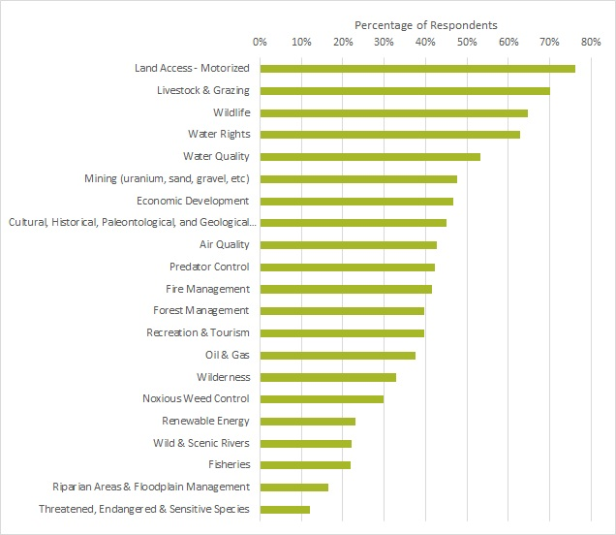

Residents were asked, “Which of the following resources or uses are given too much emphasis or priority in current resource management on public lands in San Juan County?” Residents indicated that too much emphasis or priority during planning is placed on Cultural/Historical/Paleontological/Geological, Threatened/Endangered/Sensitive Species, and Wilderness resources.
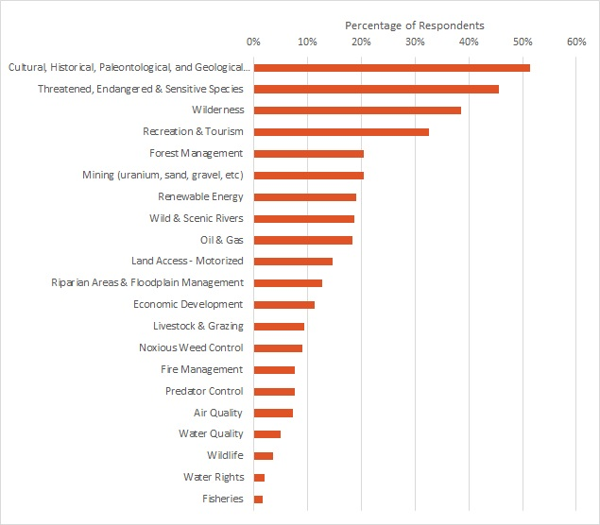

Residents were also asked, “Which of the following resources or uses are given too little emphasis or priority in current resource management on public lands in San Juan County?” Residents indicated that too little emphasis or priority during planning is placed on Land Access - Motorized, Livestock & Grazing, Mining, and Economic Development.
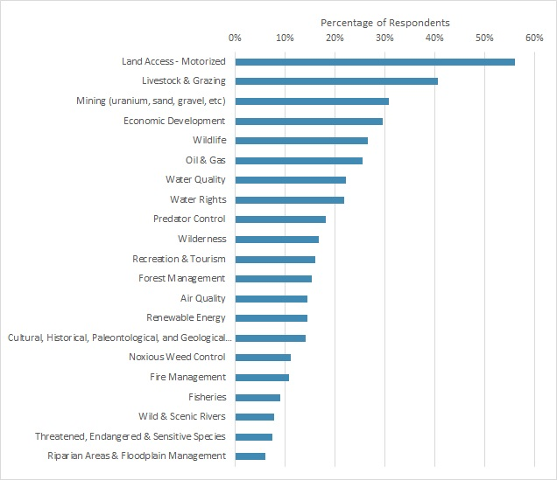

Management Agency Preference
Residents were asked, “What is your preferred management for natural resources on public lands in San Juan County?” Respondents could pick one or more options, given Federal, State, or County-level management and financial responsibility, or Other.
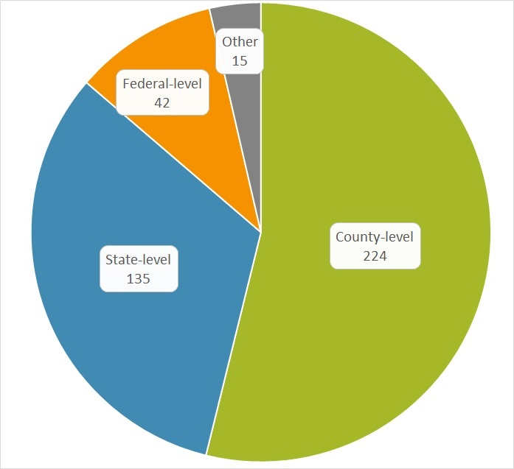
Those that indicated “Other” wrote in the following:
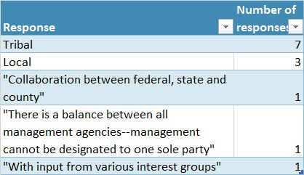

Additional Comments
Respondents were given the opportunity to add additional comments “related to management of these resources on public lands in San Juan County.” 35% of respondents left additional comments, which are listed below in the order they were received. Response length was limited to 140 characters.
There needs to be a MUCH better working relationship with the BLM, Forest service, and any other government agencies involved. They need to communicate regularly with city councils, face to face.
Man cannot manage Nature...man just wants to control others by using Nature as the scapegoat. If we don’t log the forest, it burns.
We need to be able to make enough money for our schools by using the resources put on our lands. We shouldn’t be restricting so many uses
Our way of life is being challenged. I believe our economic development (Delorme) has turned a blind eye to real economic growth and put the county’s eggs in the basket of tourism. Seasonal jobs.
It frustrates me that, in he past, the forest service would hire seasonal employees to take down old trees and to clean up the forest instead of letting locals go out and get the wood for free.
I noticed that you were not considering NPS public lands in the survey but areas of GLCA are very signficant to San Juan County, like Muley Point, which is likely the most visited place on Cedar Mesa.
I would like to see the money currently spent on public lands lawsuits, used for general infrastructure projects and tourism based infrastructure developments. This would reduce the tax burden.
Minerals/ gas industries are boom or bust. Tourism is the future.
Grazing and ranching should be priorities. .
Stop SITLA from selling school trust lands. Once the school land is sold that land and future revenue is gone forever.
There needs to be a balance between “old” practices and future resource management; one that allows the lands to thrive and be available for now and the future. “Using up” the land is a loss for all.
Countywide sustainable resources for recreation are important for the future investment and businesses. We have an oppertunity to modeling other successful communities through tourism.
Prohibit or limit oil & gas drilling on the Bluff Bench, directly north of the community of Bluff. The Navajo Sandstone aquifer is our sole source of drinking water.
Please help us protect the wild character of this area that so many of us place a high value on. Keep it in the public hands, not private.
I am a business owner in bluff for 15yrs. most tourists are coming to the area for its natural beauty.no gravel pits and oil and gas developments.. protect the viewshed... map the viewshed.
There is too much attention paid to mineral development, which provides jobs for a limited time period and has the potential for damaging the aquifer that we all share.
We sure don’t need more oil and gas drilling. Even less do we need going through uranium on the cranium again. We very much need to protect our archeological sites--not loot them, as locals do
Help the locals have more of a say on what goes on.
I feel to many people outside SJC have a say in how things are managed in SJC
Keep the balance, cattle grazing is important for keeping fire hazard weeds down, as is firewood collection. All hunting is necessary as well.
Please keep it for the residents to enjoy and use No monument
I like to ride my dirt bike on public land. All the trails are already to limited.
I feel there should b management, but not over management.In the past 10 years a number of previously ope areas have been closed off or blocked to locals that take care of the land.
San Juan County is full of resources and need to be accessible to residents to maintain livelihood and cultural traditions always.
The land must be used to support the people who live here. Those from outside the area want to lock up the land and then go back to where they came from.
The county consensus today will determine the quality of future we leave our progeny. Mineral extraction and finite resource exploitation at the expense of short-term gain is both reckless and selfish
Needs to be Multiple use
Locals who live here and love it must have a say in how this land is managed. Please hear us! Outsiders have brought many people here and problems as well. Others have hurt it, we have protected it!
We are part of the ecosystem.It does not belong to us. We belong to Nature.We need renewable resources instead of drilling oil & gas.Animals need space to thrive.We need spaces without human impact.
The federal land managers only pretend to listen to the locals and go thru the public comment process. They have already made up their minds and follow the extreme environmentalist.
Tell Hunt to take down the gate to his newly aquired SITLA land in Comb Ridge to allow access to BLM land as required by the law.
I believe that things happen man is very well up to this point. I feel that most of all this land should continue to be managed by state and local authorities and not federally managed.
San Juan County is doing great in my opinion. It is the Federal Programs and King Barack Obama that have no interest in the concerns of the local people.
Information on resources and management plans need to be up to date and more readily accessible.
Multiple use is just that-not tie it up for only the elect super athletes who can afford to and are physically able to hike great distances for weeks to see the area
San Juan County does a fantastic job in consulting all residents within its borders. Please continue to keep Native American citizens and native access to lands we share with all county residents.
Access for all to the PUBLIC land is vital to the sustainability of the communities involved.
Protect them. San Juan country needs to protect the lands from San Juan county
Lands are better managed by those most affected by management regulations. Those who love nearest the lands should be heard and involved more than those who live far away and spend little time here.
The monument is a wonderful attribute to San Juan County No more Utah monuments. Trump bears ears. Monument!
It is important that current access is not further restricted for those who live in or near these lands in San Juan County and rely on the area for their livelihood such as grazing rights.
Management of the land should not be denying access. Has to much control over the land
Things are good the way they are. The locals value the land and do everything they can to protect it. Their rights have already been limited/taken from them.
I grew up logging, but the Forrest service now lets all our timber waste and burn. I grew up mining but Federal agencies won’t let us mine. I grew up deer hunting but there are very few deer left.
In Utah, we have a culture and an economy built on public lands. I want them to stay public lands and be multiple use. The land should be managed by people closest to the land.
Big city people just need to leave small towns alone.
Local planning needs to supercede the opinions of environmentalist groups. They do not get a say in how our land is managed.
I’m worried that increased tourism will cause increase in traffic/ vandalism to archeological sites, resulting in a lock down of the land that we need to survive. Our needs will get lost in the proces
We need more common sense economic devopement and allow the people to use the land as intended. Keep it beautiful and pristine but explore the possibilities of drilling, etc Listen to the locals!
I don’t want to see San Juan County become Grand county. I moved there for 20 years and the emphasis on getting tourists there ruined the area. It was no longer pristine. No monument, no tourists.
I think there is too much emphasizes by the BLM, USFA and environmentalist to limit the general public’s use of public lands. Public lands need to be used for recreational, oil and gas, mining.
I support total control and management by local city and county representatives.
The environmentalist assault against the productive usage of the land for the emphasis of reduced access is ignorant to the land’s value and resiliency. Quit being bullied into less usage.
A management plan needs to be put in place that fairly addresses all issues. There is a middle ground to be met to protect the lands while still allowing for use (i.e. rec, grazing, etc).
We need to develop the economic aspects of the land in order for our children to have access to better educational opportunities within the county.
Does it really matter what we think??
I would like for this land to be multiple use. That includes extracting minerals and oil through mining and drilling. We need the revenue these resources bring to our county, classrooms, employment.
Please allow multiple use on these lands. Including mining and oil and gas extraction. The funding is extremely important to out education system. Thank you.
County residents and what the majority vote is inside the county should always be given first consideration when making a change to their county. Who better knows the area and what the people need?
San Juan County residents are aware of the land around them and take good care of it and it’s resources. They do not need extra government control.
The process for planning and management us too obscure. Greater lengths need to be taken to inform people of planning meetings, and to be clear on the purposes of each.
Local management from local residents. No one loves this land and it’s resources more than the people who have lived here for generations.
Continued access for fire wood, hunting, grazing. Veto the monument!
Let us keep our local land local.
I feel that the land has been managed very well to date. If any changes need to be made they can be done without the current monument.
I believe in a multi-use asthma for most of the county m not so many restricted areas that restrict our livelihood and effect or restrict the SITLA lands
Let us use the land that we have taken care of, and keep tourists who destroy away.
The only people qualified to manage any area are the local people who are most familiar with it.
Most now believe comments are a waste of time. The county needs to plan an action agenda, then ask us to do something in person out on the ground.
Public access is important to me. If it is public lands, keep it public, don’t restrict access.
The Public Lands need to be managed for the majority of the people and not the few that want to control it
always consider long range consequences instead of short term gain
Thank you for trying but this survey is an embarrassing attempt. Public lands should remain multi-use.
The county should insist and offer to help in building access roads to all state lands in the county so they could be of more benefit to the local schools
All state lands in county should retained in the county. All roads should stay open. All state section should have road access.
We need to focus more on renewable resources and economic development. Now that we have a new monument, it is time to show it off to America as the crown jewel of San Juan County. Tourism + $ = jobs
The less Federal government interference the better. We can and do take care of our own.
Recreation and Tourism should be separate categories.
I feel we need to control the lands and waters of our state, and get the over controlling federal government out of it.
Lifetime resident of San Juan County
Born and raised in SJC-native american Dine SJC lifetime resident
ATV & UTV trails need to be made into loop where possible to reduce the temptation to ride off trail. You need to get a handle on noxious weed control.
I am a citizen of SanJuan County and I do not support the monument I think its a waste of government money and its not going to help the land is wanything tis going to destroy the land.
San Juan County Lifetime Resident lifetime resident
San Juan County resident
I don’t know all the ins and outs of land management in San Juan County, but we are good stewards of the land. There needs to be a balance of multi-use groups, access for all. Not a monument.
Please keep involving the people as well as science.
I am much too old to do much walking to places in our county, so access by some type of vehicle is very important to me. I would hope the county has full control over all these programs.
Federal public lands should remain in federal control.
I see no significant need for additional management as the current processes and management is maintaining access to these areas for the recreation activities, animal grazing rights and access for
The public lands in San Juan County will be better managed and maintained if interested parties are allowed access, to maintain roads, to clear deadwood, to protect interests like mining and ranching
We do not want the Bears Monument!
Make decisions at local level – not state or Washington. Determine significance/importance of cultural resources and protect those significant. Litigation is a hindrance to sound decision making.
We are not zoo animals. I do not want any federal control. I want to utilize the land with freedom
I HAVE LIVED IN MONTICELLO FOR 27 YEARS
The government does not need to own the whole state

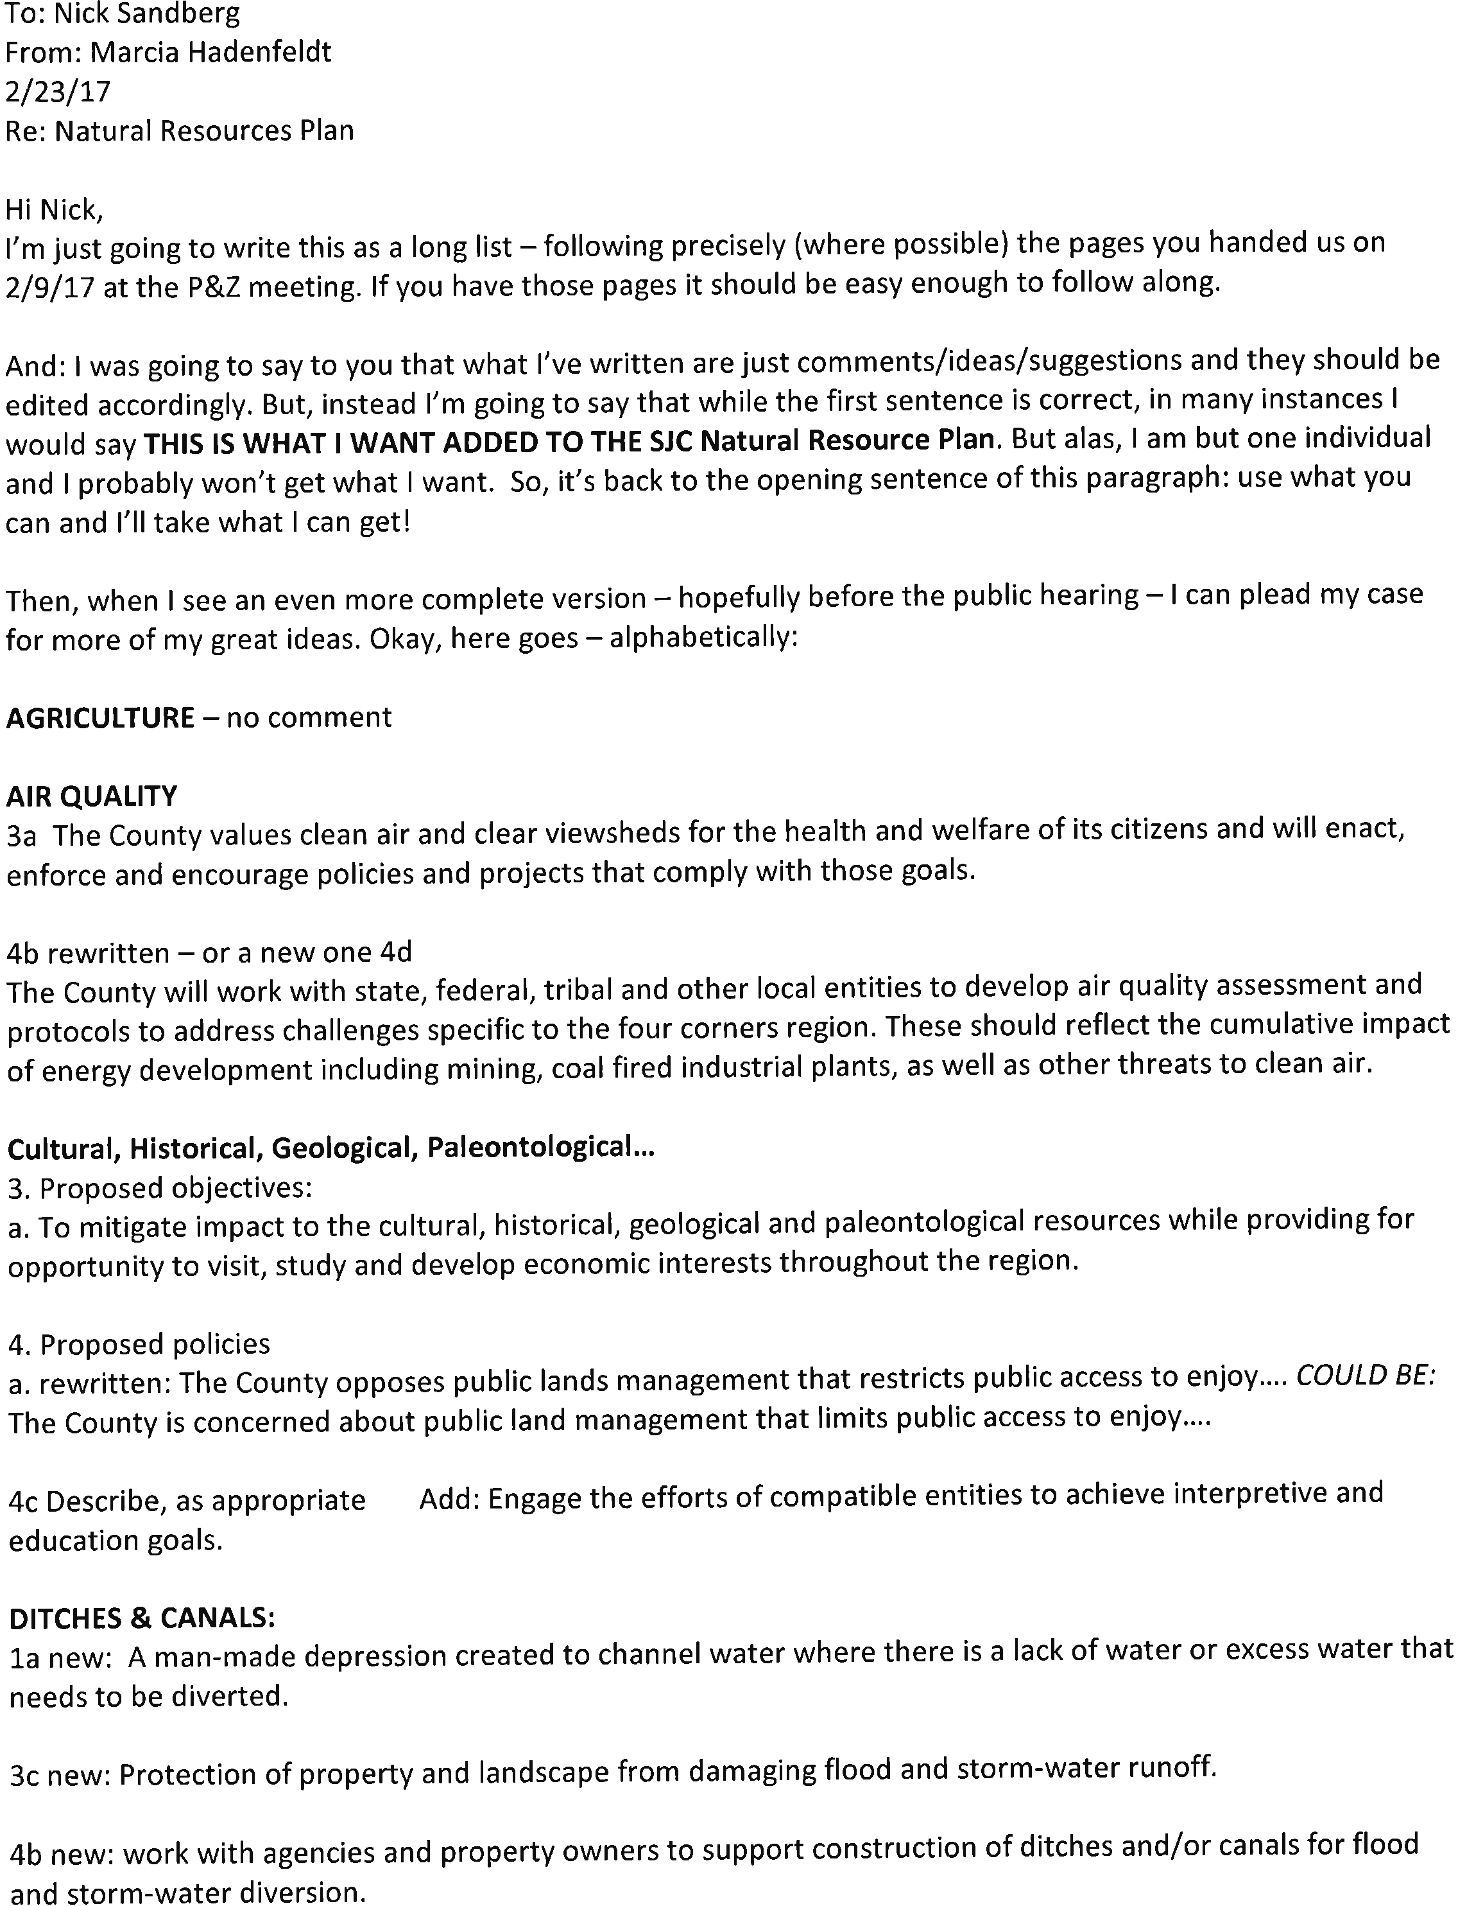
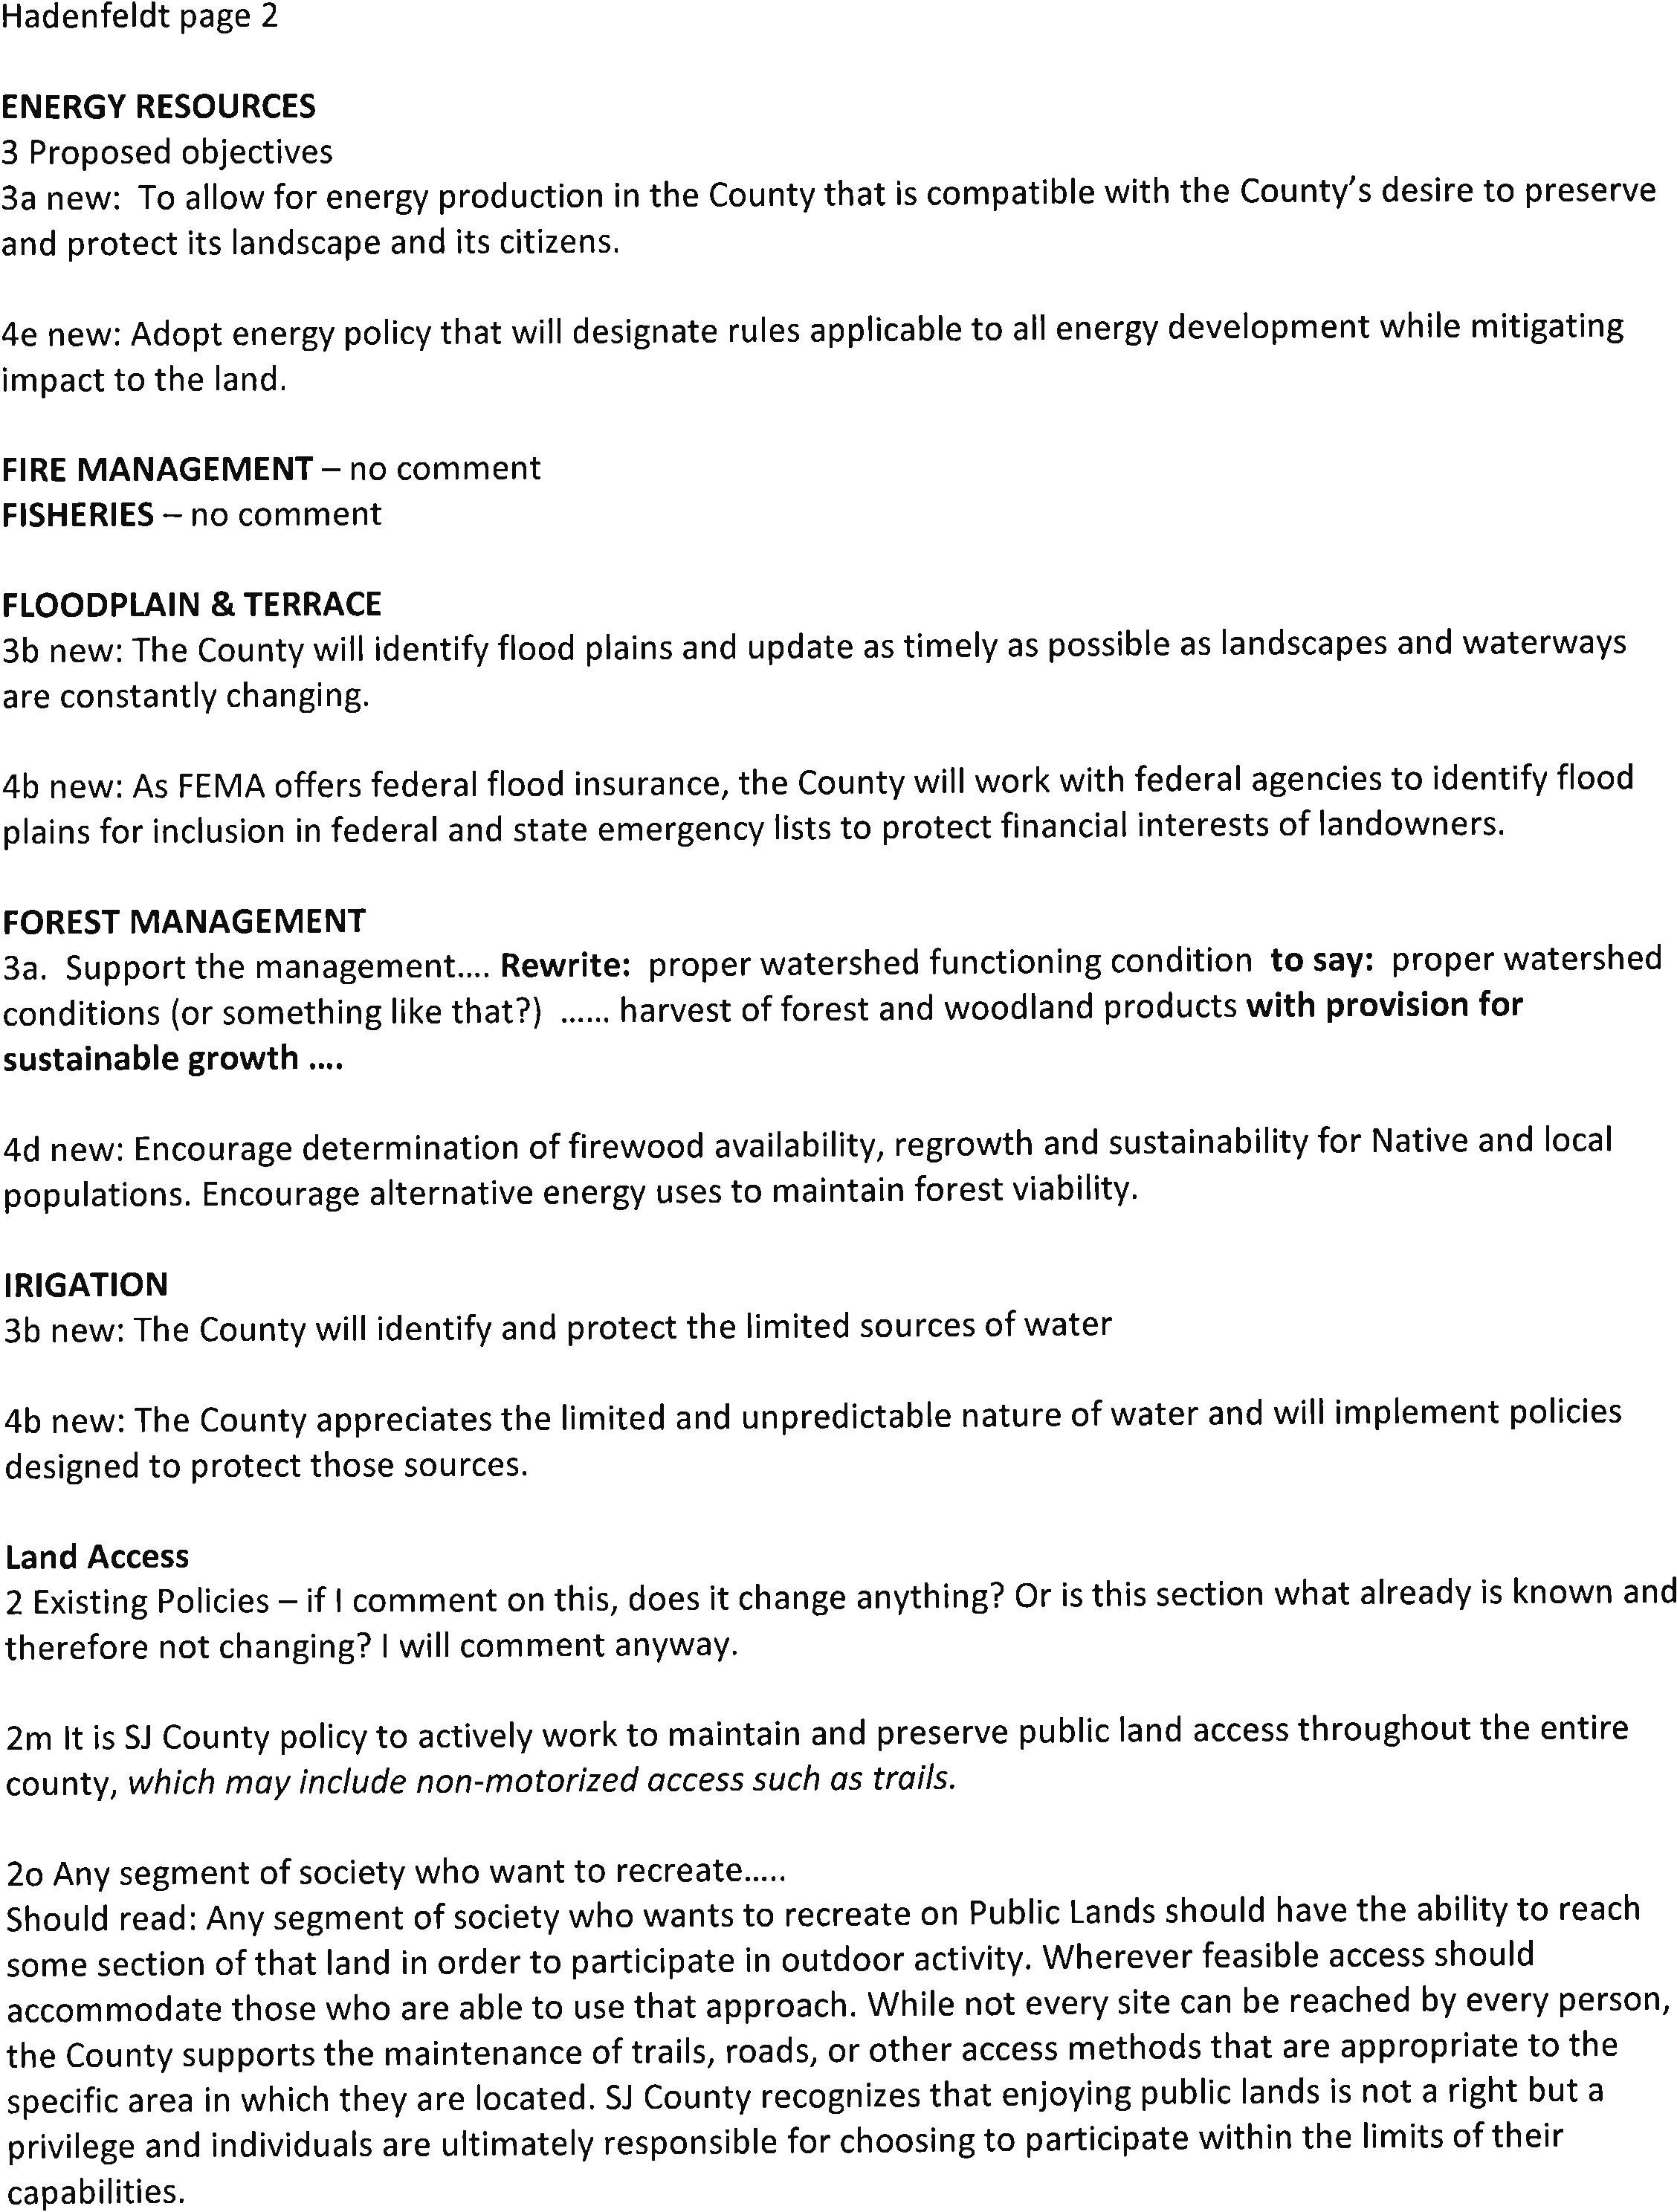
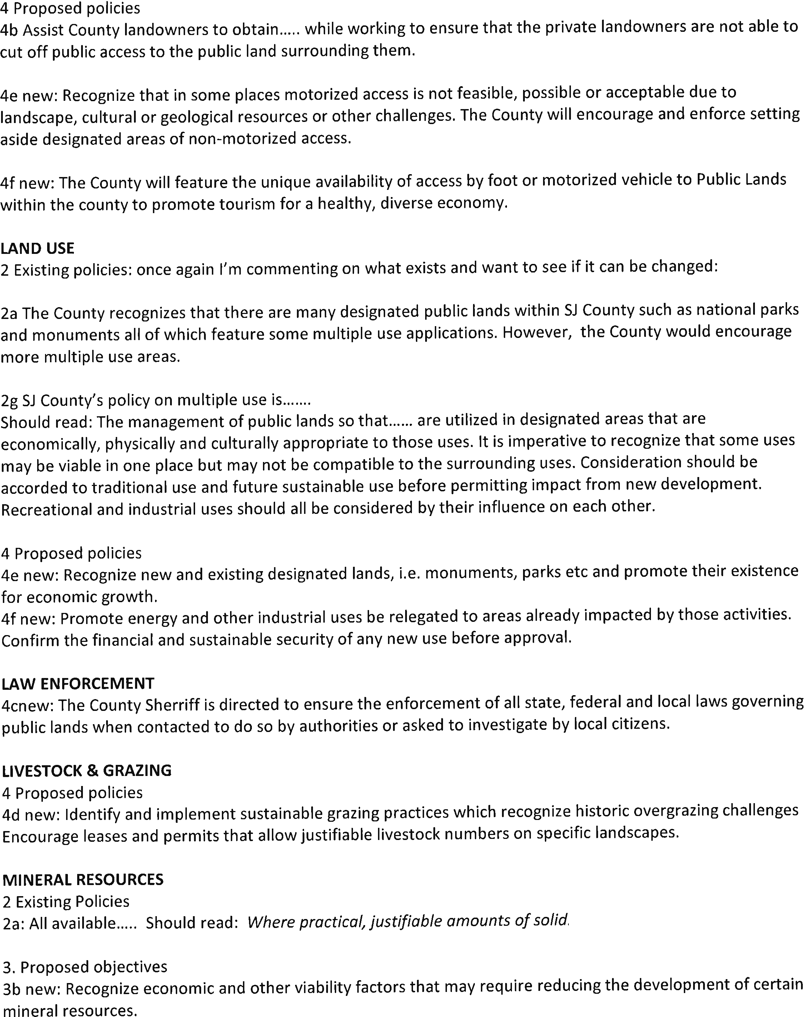
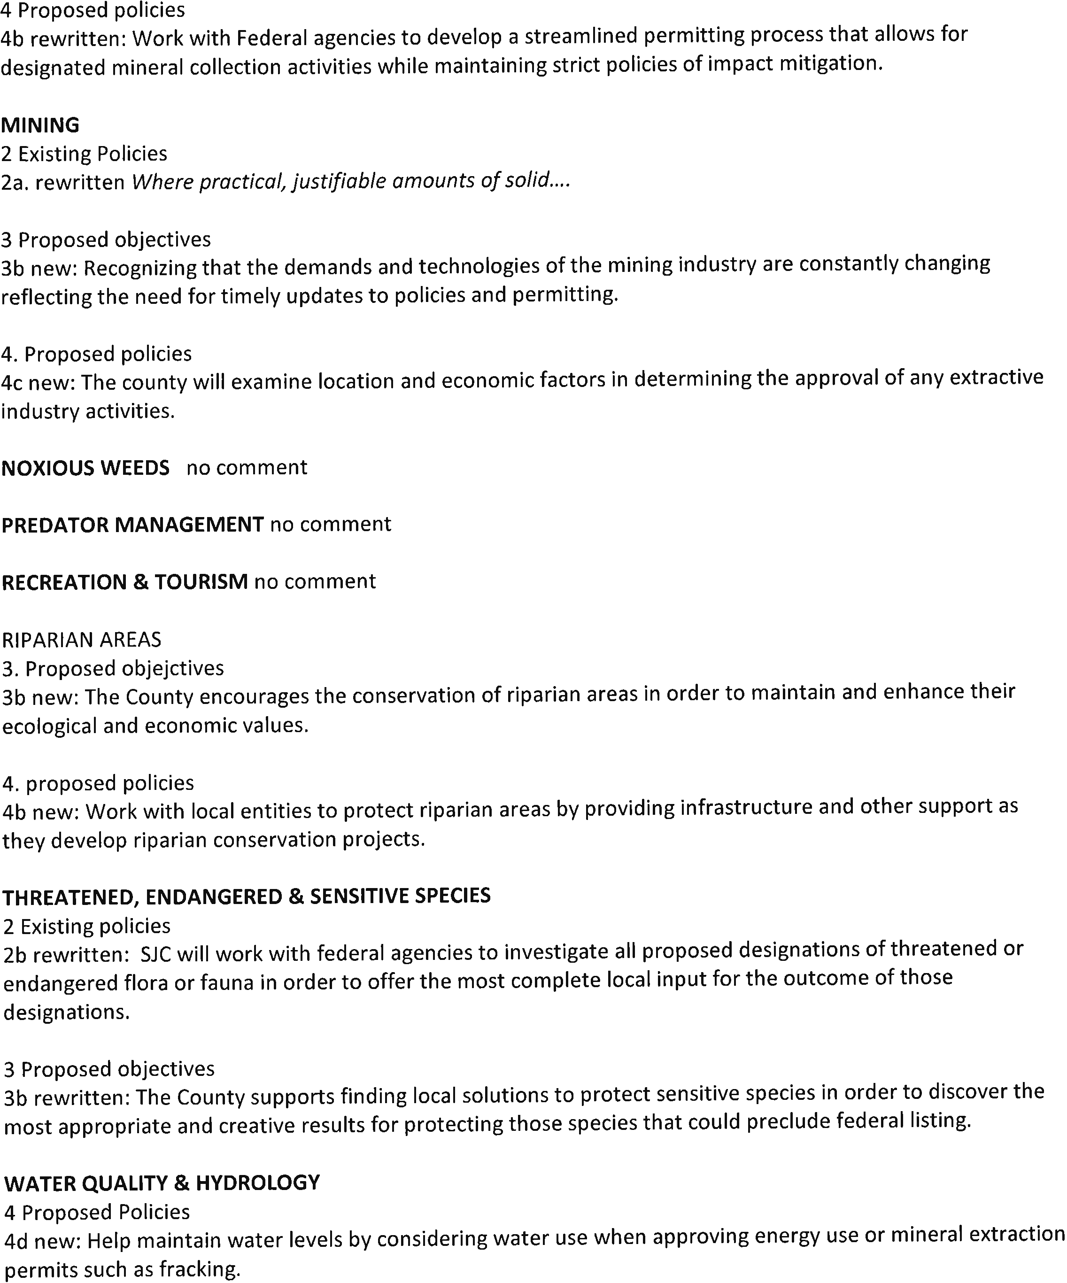
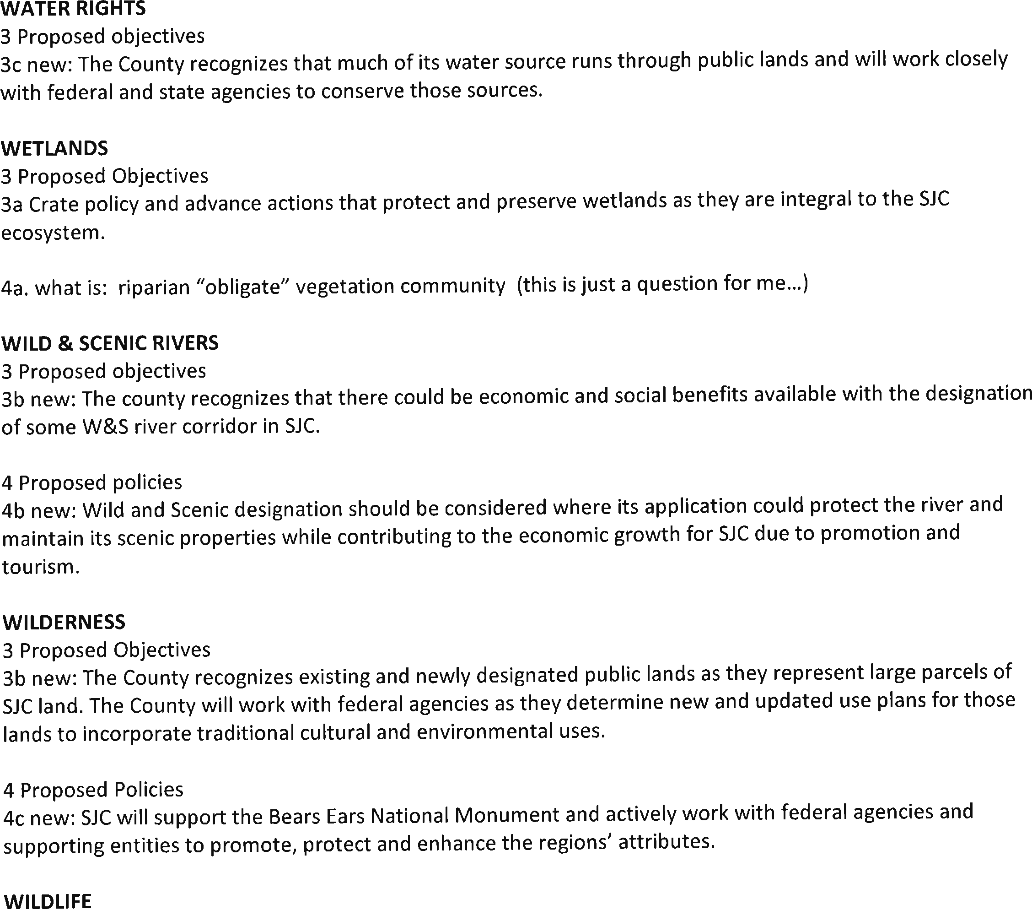
From: Sandberg, Nick nsandberg@sanjuancounty.org
Subject: Fwd: Resource Management Plan
Date: April 6, 2017 at 4:14 PM
To: Shannon Ellsworth shannon@rural-community.com

Shannon:
This is a comment letter to be added to the record. Nick
---------- Forwarded message ---------- From: <g.dorgan@wildblue.net> Date: Fri, Feb 24, 2017 at 5:59 PM Subject: Resource Management Plan
To: "nsandberg@sanjuancounty.org" <nsandberg@sanjuancounty.org>

Nick,

Just a couple of the thoughts about some wording on two topics.

For the Mineral section. "Highest reasonably sustainable levels" I do not not believe there is such a thing as sustainable levels. Mineral resources are ﬁnite by their nature.(unlike timber for example) Despite the development of new technologies, these resources will play out. Perhaps you could give me the perspective/deﬁnition of the County's view of sustainable.

For the Forest management section. I have worked with a consensus range management group in Northern Arizona for apprx 24 years. We have often discussed mechanical treatments for grassland/range restoration. We have concluded that these types of traditional mechanical treatments are only temporary actions. These treatments must be repeated again and again. It is treating the symptom of a problem, but not the cause. Mechanical treatments require tremendous amounts of hydrocarbon energy inputs to perform,and then need to be repeated. Management practices need to be adjusted to consider and then address the cause(s) of the problem(s). Less intensive management strategies include but are not limited to holistic range rotation theory (Savory) ﬁre (prescribed and let burn) and reevaluation of allotments boundaries based on watersheds. I would need to know the county's deﬁnition of historic levels. Pre-chaining, post chaining, anglo settlement, long-term precipitation cycle considerations?

Sorry this is so late, I hope you can still consider my thoughts. Gary Dorgan

Nick Sandberg
Public Lands Coordinator 435-587-3223 ext 4146
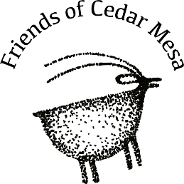
PO Box 338, Bluff, UT 84512

San Juan County Planning and Zoning Attn: Nick Sandberg
PO Box 9
Monticello, UT 84535
February 25, 2017
Dear Mr. Sandberg,
Friends of Cedar Mesa is the oldest conservation organization focused uniquely on the public lands in San Juan County. We work to ensure that the public lands of San Juan County, with all their cultural and natural values, are respected and protected. We have long believed in collaboration, inclusiveness, and adaptive and realistic strategy when it comes to managing the unique portfolio of public lands in southeast Utah. Our organization has used these values in responding to land and resource planning efforts undertaken by the various land management agencies in San Juan County.
We offer the following comments on the draft San Juan County Resource Management Plan received from you February 7, 2017 at the public meeting. After providing overall comments, we have restricted our resource-specific comments on the proposed objectives and policies of resources that best match our organization’s mission and areas of expertise.
Overall, we encourage the county to use a consistent and redefined definition of “multiple use” in its existing and proposed policies. The definition in Land Use 3.b. “Multiple use is generally described as the harmonious and coordinated management of a combination of balanced and diverse resource uses without permanent impairment of the productivity of the land and quality of the environment” can have the added goal of “[promoting] economic potential, cultural and natural resource protection, and resource development.” Adding cultural and natural resource protection demonstrates that the County values more than maximizing the economic output of the land and is more in-line with widely accepted definitions of multiple use for sustained yield.
We noted that the existing policies inconsistently referenced policies relating to the National Park Service, SITLA and Utah State Parks. These lands are outside the scope of the RMP process but they are nonetheless referenced in existing policies. We encourage consistency in the final plan as to whether NPS, SITLA, and State Park policies are covered in the RMP.

The draft plan would benefit greatly from the inclusion of landscape-level planning for many of the resources. Landscape-level planning as a concept has the ability to increase long-term certainty and decrease conflict and litigation for the diverse land users of San Juan County.1
From: Shannon Ellsworth shannon@rural-community.com
Subject: Comments Back
Date: February 25, 2017 at 6:17 PM
To: Sandberg, Nick nsandberg@sanjuancounty.org

Nick,
I closed the comments portal on the website. These were the only comments we received. Thanks,
Shannon Ellsworth
Rural Community Consultants

Utah Diné Bikéyah
- a non-profit supporting Native Tribes working together to Protect Bears Ears -

www.utahdinebikyah.org info@utahdinebikeyah.org
(385) 202-4954
FB @UtahDineBikeyah | Twitter @UtahDineBikeyah | Instagram @ProtectBearsEars

March 31, 2017

Nick Sandberg County Planner San Juan County
P.O. Box 9
Monticello, UT 84535
Sent via electronic mail to nsandberg@sanjuancounty.org

Re: County Resource Management Plan

Dear Mr. Sandberg,

I understand that your office is completing a Resource Management Plan for San Juan County. I am writing to submit Navajo cultural use and resources data that our organization collected over the past several years under a Memorandum of Understanding to carry out planning efforts in cooperation with the Navajo Nation Department of Natural Resources. This information should already be in your possession; however, some boundaries have been updated to reflect recent decisions. The enclosed cultural atlas is a visual depiction of cultural use and resources in the area that are significant to San Juan County citizens. It is important for the County to understand the types of cultural uses occurring in the area so that these interests can be preserved when possible, or mitigated as necessary. These maps are only a representation of some of the types and variety of uses of Navajo residents. A great deal of additional information exists and UDB is available to help collect this information upon request and if appropriate.

Additionally, we are aware that the 2008 San Juan County Master Plan is deficient in addressing the views and priorities of local residents and Chapter Houses and would appreciate the opportunity to suggest amendment to that document when appropriate. For example, it fails to highlight the rich Native American history and archeological intactness of land in San Juan County.

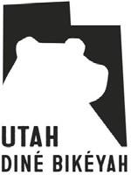

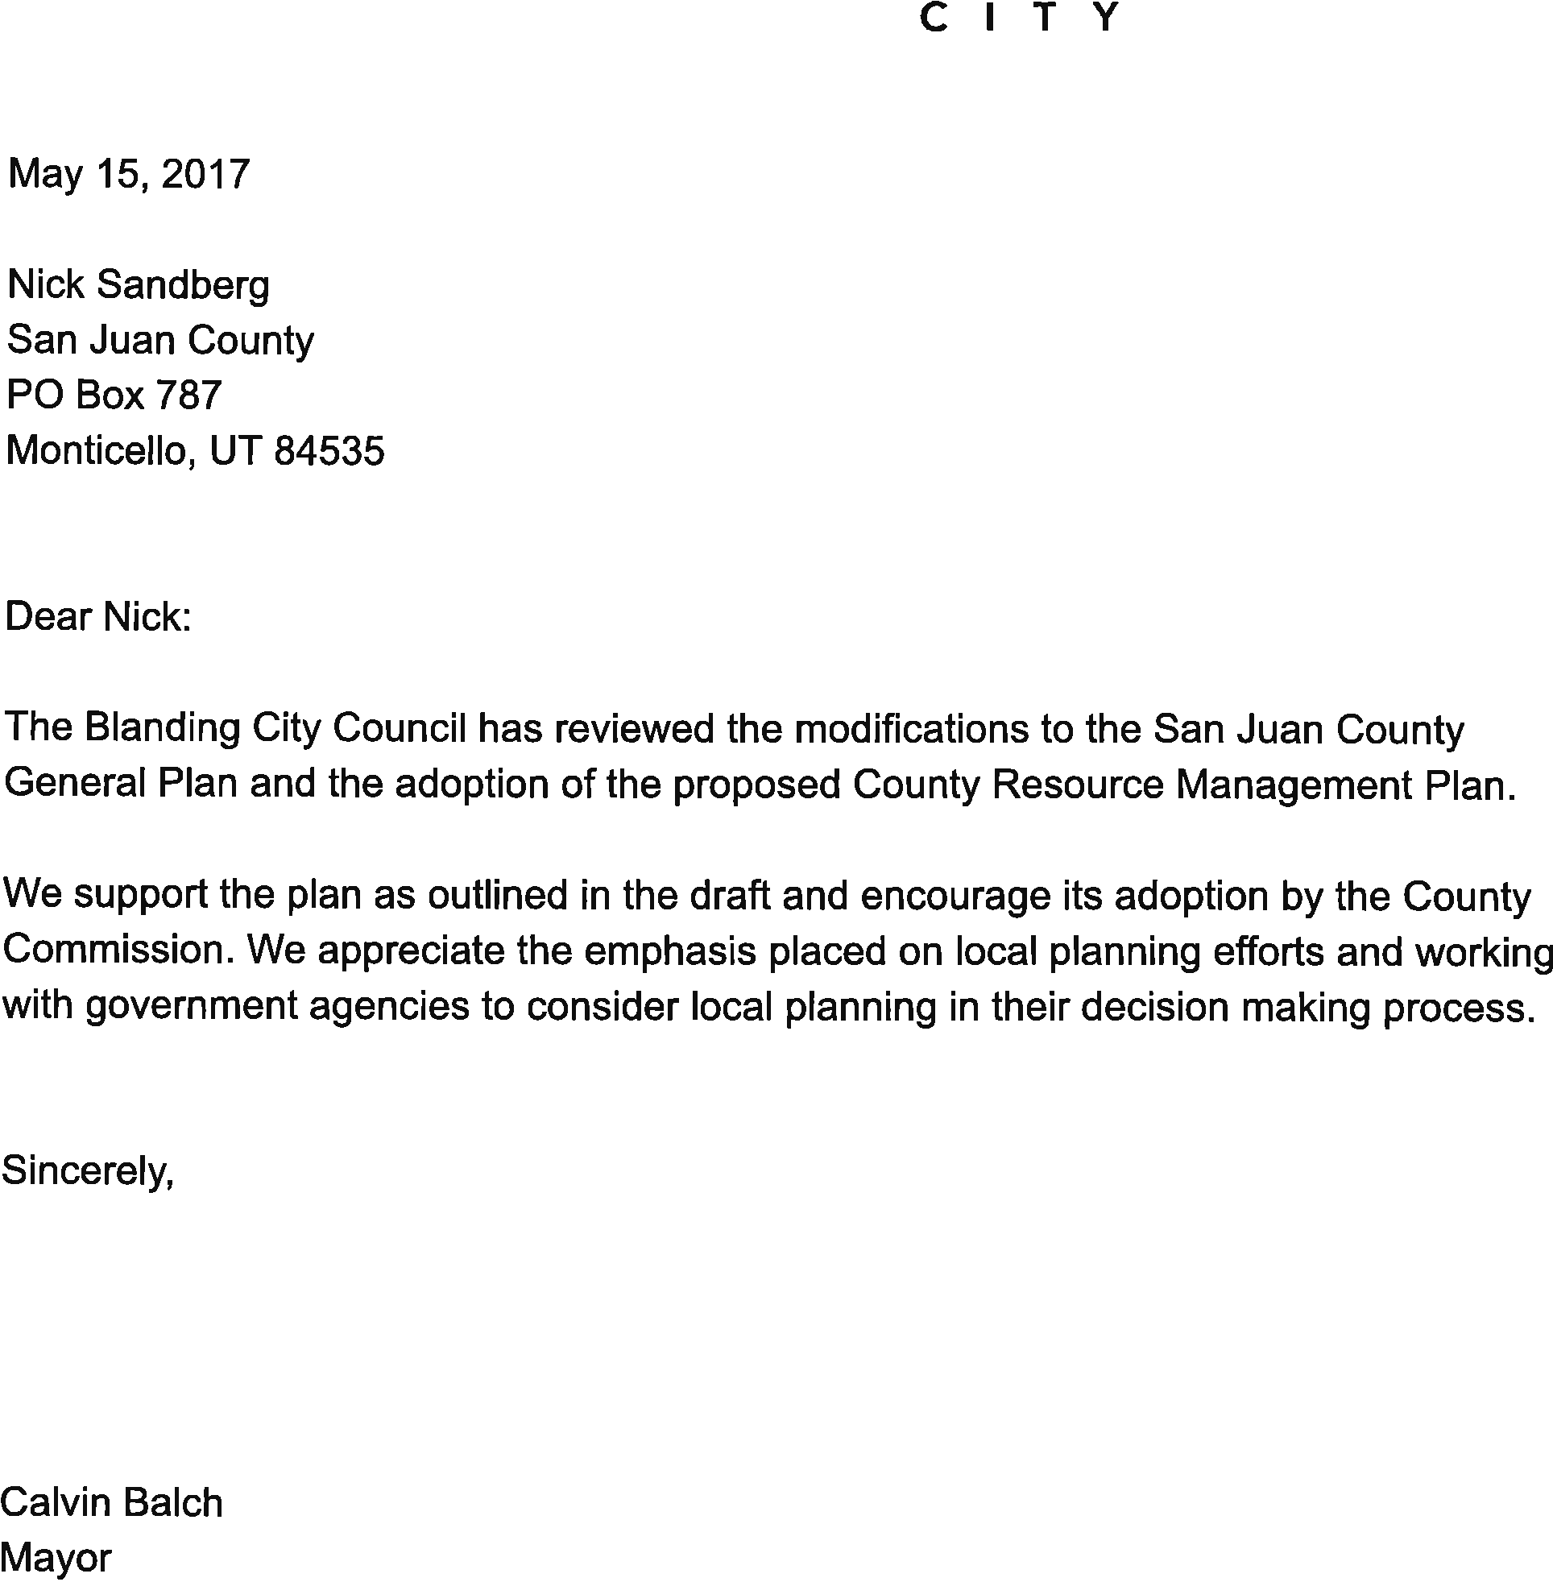
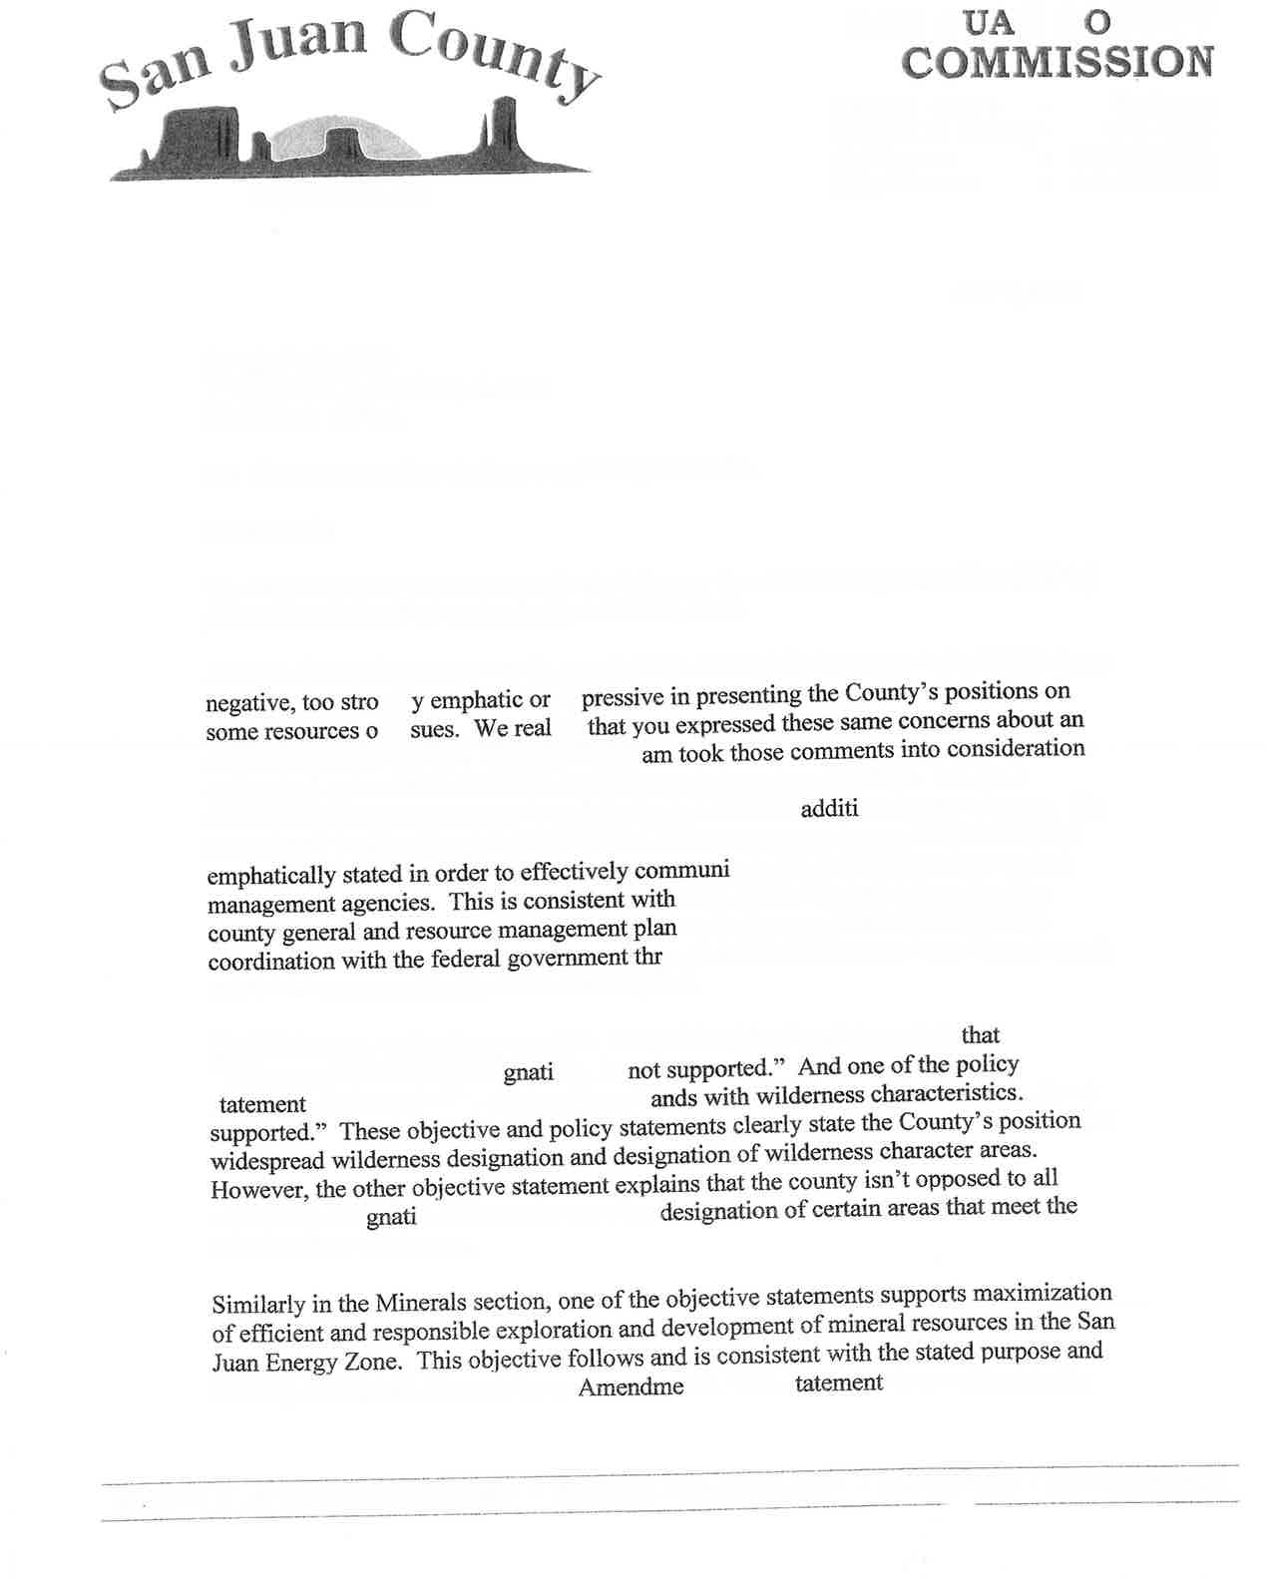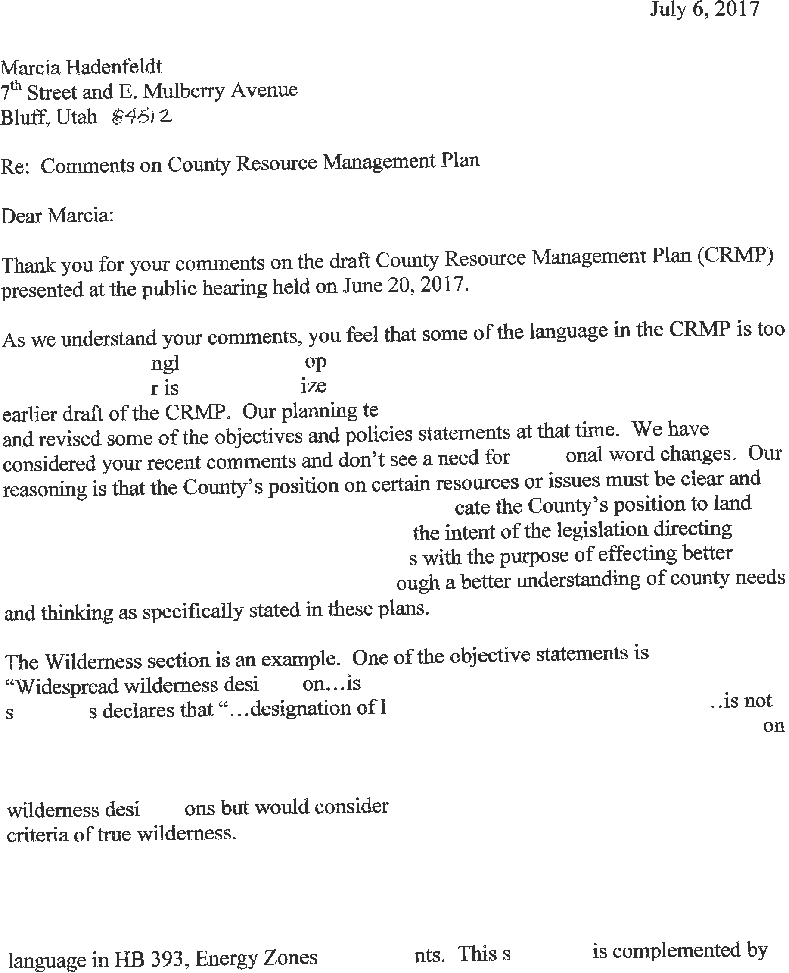
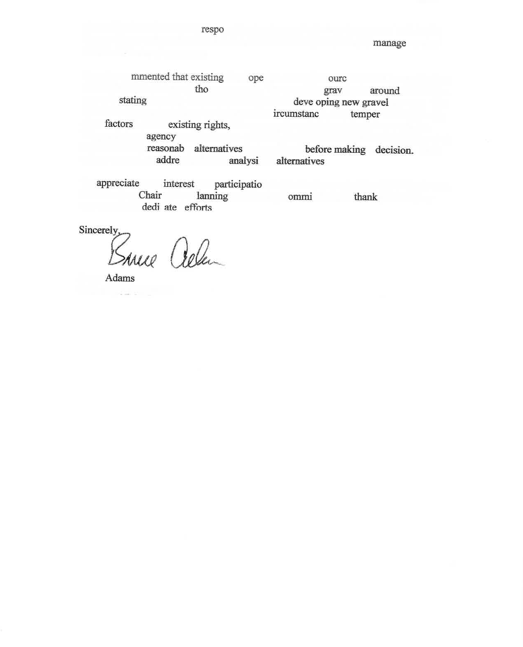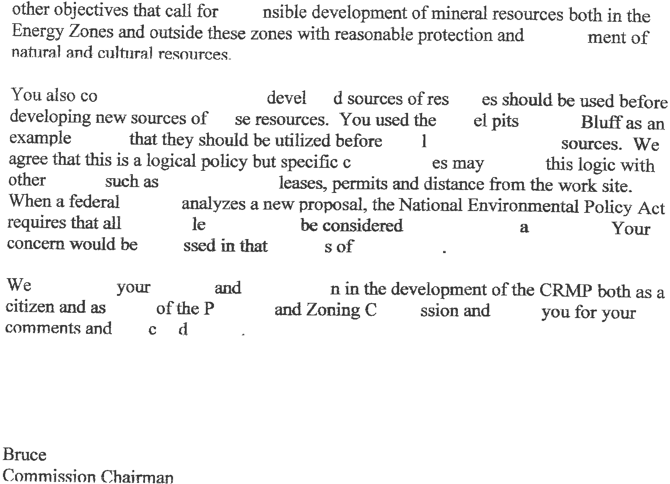

MAPS
- Energy Zones
- Federal Agency Special Designations
- Vegetation
- Water Resources
- Land Access
- Hydrocarbon Gas Liquid Petroleum
- Natural Gas Pipelines
- Highway Functional Classes
- Fiber Priorities
- Electrical Transmission

